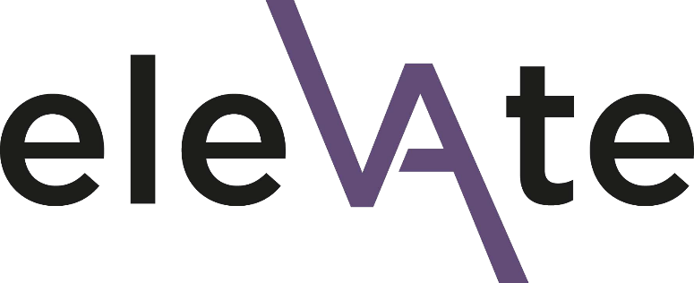

Elevate 2023 Application Form

Section 1: Applicant form
Introduction text
Thank you for your interest in the Elevate programme. Please complete this form in full. Kindly note that completing this form does not guarantee a place on Elevate.
Once you have completed the form you will need to have a conversation with your line manager about your application and then ask your line manager to complete section 2, to support your application.
We will not share any of the details you provide in this application form with your line manager. However, you can share your completed application form with your line manager if you wish.
The deadline for your application and the line manager endorsement form is 23:59 on Sunday 23 October 2022. You will be informed of the outcome by the end of November 2022.
If you have any questions about the application process, need support in completing it or are experiencing any technical difficulties, please contact: edi@exeter.ac.uk
Many thanks

EDI Team
Data protection
All information you provide in this application form will be treated as confidential and will be held in accordance with GDPR regulations. Please see the University’s privacy notice for further information. Your data will be shared with the selection panel (details available on request) and thereafter used for reporting purposes only.
☐ I consent to my data being used in this way

About the applicant
Title
First name
Surname
Job title
Contact email
Your grade
Faculty / Department
Academic / Professional Services

Please answer the following questions
About the programme
- What attracted you to this programme and what do you hope it will offer you, personally and professionally? (up to 250 words)
- Please share with us a time (at work or outside) where you have led, motivated, or engaged others? (up to 250 words)
- In your career, share your experience/s of applying for leadership and other development programmes. (Optional) (Subtitle) Elevate aims to address the underrepresentation of Black, Asian and minority ethnic women at more senior levels in the sector. This question will not be included in the selection process. Instead, it will help us to understand applicants’ experiences so we can improve processes and widen access.

Programme dates
If your application is successful, you are required to attend all the Elevate programme dates on the University Elevate webpage. Please contact us to discuss any queries related to this.
☐ By ticking this box I confirm that I am available to attend all dates.

Closing text
Almost done!
Please remember to provisionally add the programme dates into your calendar.
Please now ask your line manager to complete the short endorsement form to complete your application. We will not share any of the information from your application form with your line manager.
The deadline for your application and endorsement form to be submitted is 23:59 on Sunday 23 October 2022.

