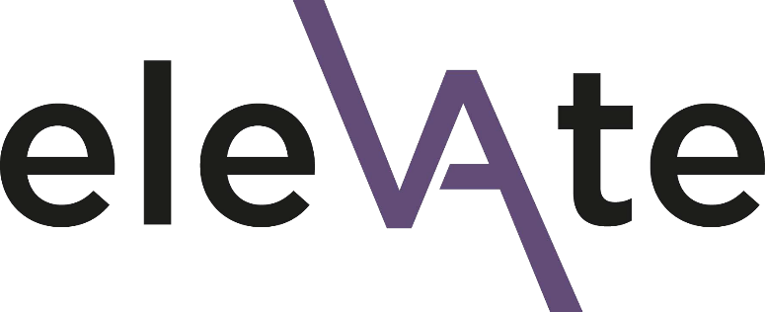

Elevate 2023 Endorsement Form

Section 2: Line Manager Endorsement form
Thank you for taking the time to complete this short form for your member of staff who has applied for a place on the Elevate programme. Your endorsement and active support of the applicant, if they are successful in gaining a place on Elevate, will be essential.
Please complete the form by 23:59 on Sunday 23 October 2022 at the latest.
Candidates will be informed of the outcome of their application by the end of November 2022. If they are unsuccessful, you will be expected to have a conversation about other development opportunities. They will be provided with supportive and constructive feedback from the selection panel, which can feed into your development conversation.
If you have any questions about the application process, need support in completing it or are experiencing any technical difficulties, please contact the team via edi@exeter.ac.uk

Data protection
All information you provide in this application form will be treated as confidential and will be held in accordance with GDPR regulations. Please see the University’s privacy notice for further information. Your data will be shared with the selection panel (details available on request) and thereafter used for reporting purposes only.
☐ I consent to my data being used in this way

Applicant and line manager details
Applicant first name
Applicant surname
Applicant email address
Your title
Your first name
Your surname
Your job title
Your email

Applicant endorsement
Applications will be scored anonymously so please avoid using the applicant's name in your answers to the below questions. Instead, you can say e.g. "this individual".
Please outline your reasons for supporting the individual in this application (up to 350 words)

Please tick the box to confirm that the above individual can attend all the programme dates and that you will be actively supporting them throughout the programme. This includes support and time to participate in all programme components.
☐ I confirm the commitment of time, resource and support for participation in this programme

The deadline for your line manager to complete the endorsement form is 23:59 on Sunday 23 October 2022.

