Creating Small Group Chats

Contents
Creating your Chat Group 1
What can you do in the Group Chat 3

Creating your Chat Group
Create a New Chat by:  Selecting the “New Chat” Icon  OR | 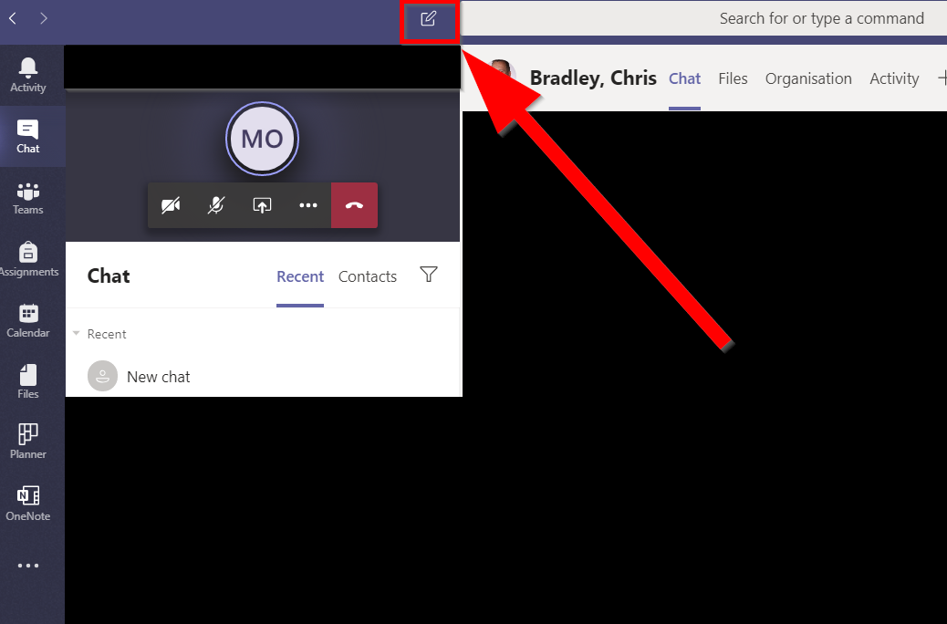
Right Click the “Chat” Icon in the App Bar.  Select “New Chat” to create a group chat prompt | 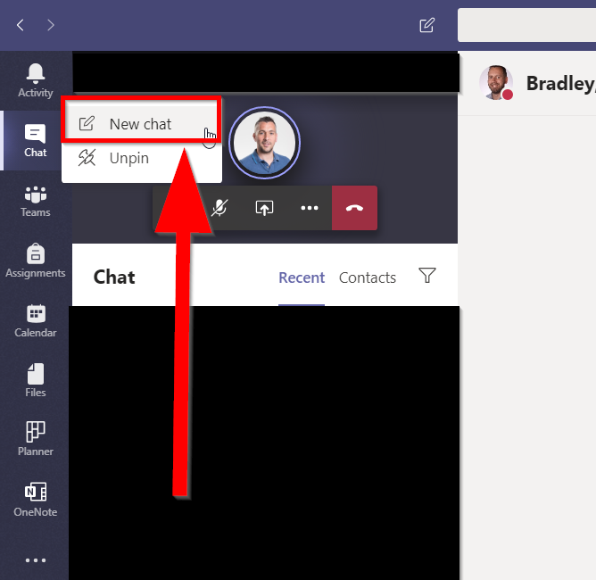
Select the drop-down menu icon to expand the following options:
- Group Name:
  - In this dialog you can give your Group chat a unique name to make it more easily locatable via the search options
- To:
  - This is where you enter those you wish to invite to the group chat

- You can use their email or address book name (last-name, first-name)  Note: You cannot paste in lists of names or mail addresses in this interface | 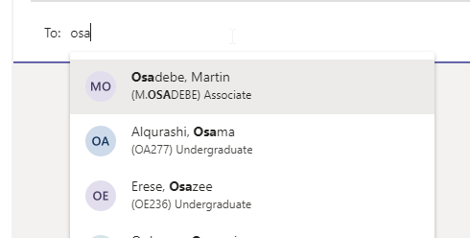
From the main chat window once you click into the Message field the added chat members will be added | 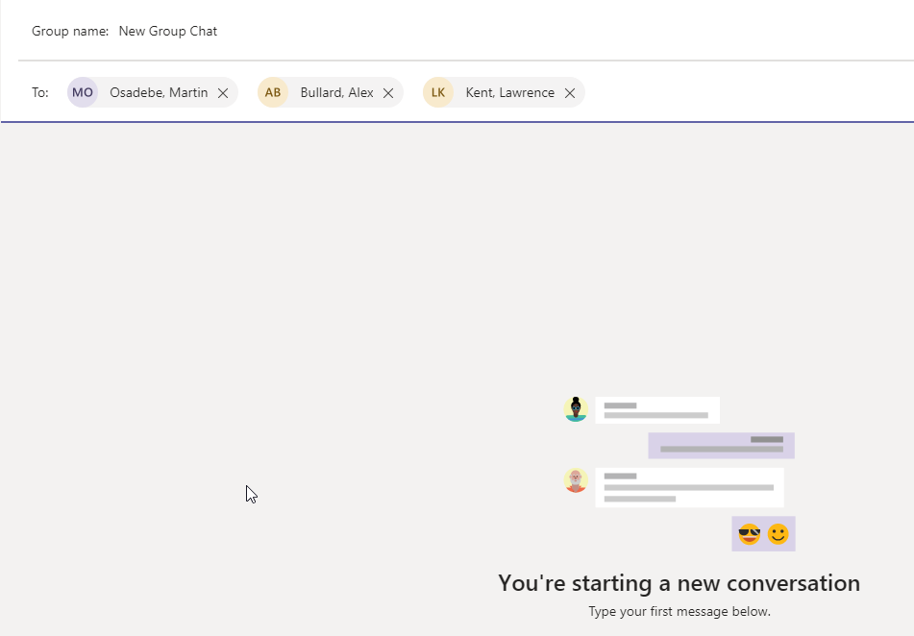

What can you do in the Group Chat
From the Chat Window you can:  - Attach documents to share  - Video Call  - Audio Call  - Screen Share (Inc. Presentations)  - Invite additional members to the chat | 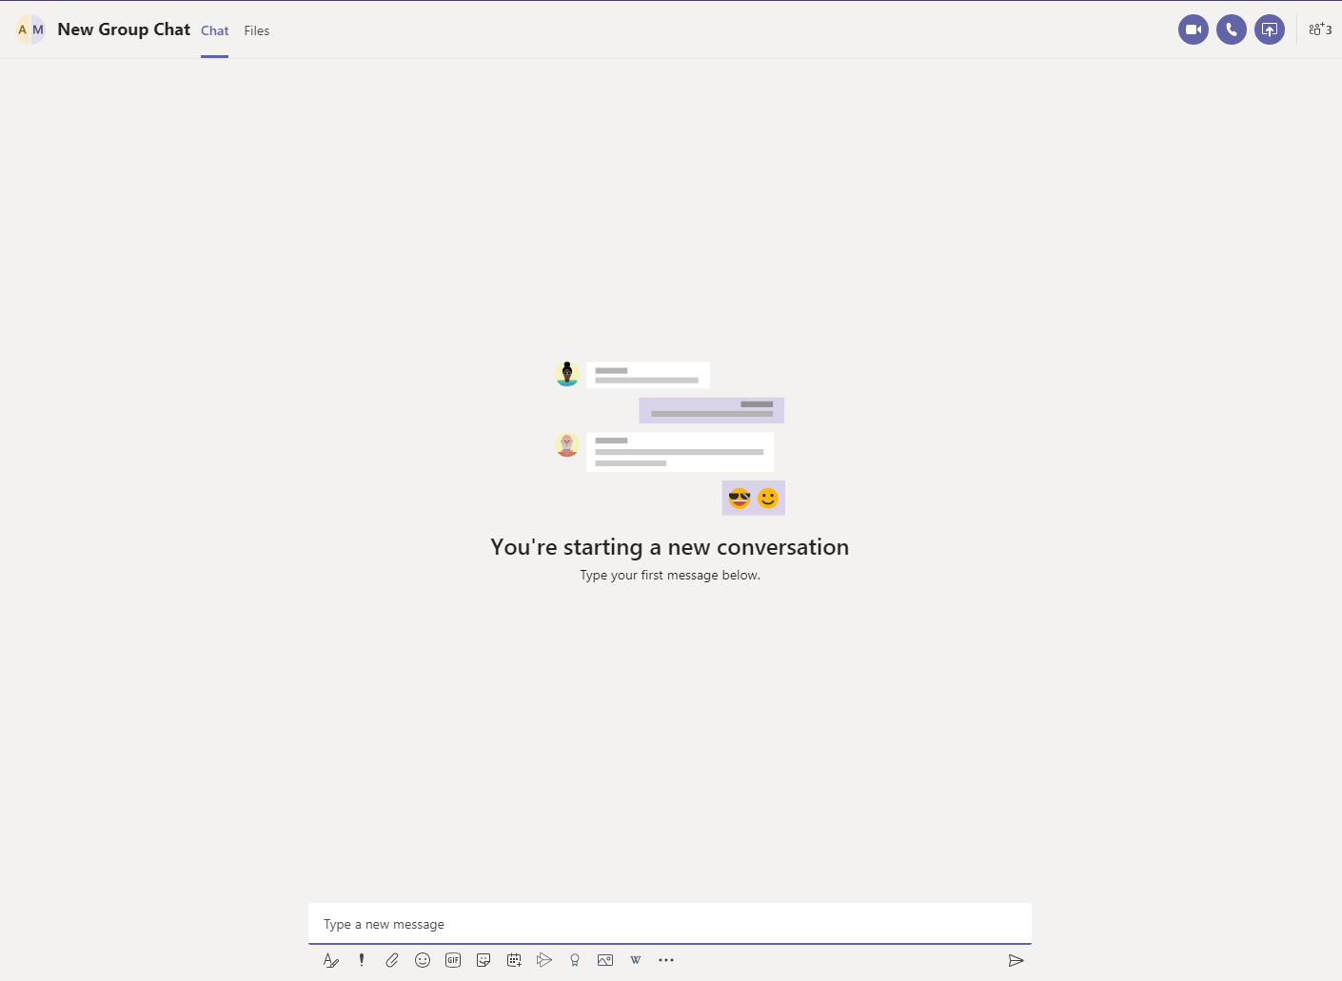
- “Chat” – This takes you to the conversation window to display the full chat history
- “Files” – Allows you to upload files to share in the chat group.
Selecting this opens a library store that only exists for this group chat.  You can drag documents directly in the store  Or  Click the Share Icon to:  - Add from OneDrive  - Upload from Desktop | 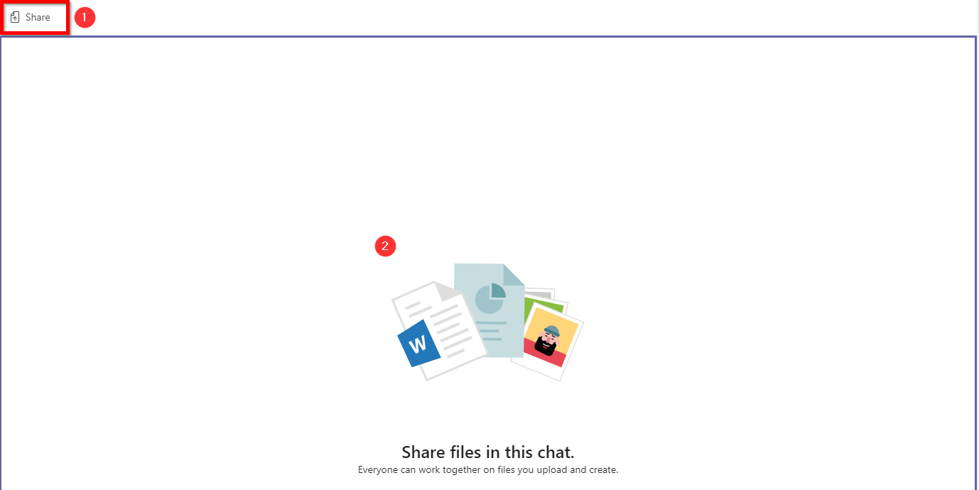
In the top right of the chat window you will also have the following icons available:

- Video Call
- Audio Call
- Screen Share
- Add People
If you select “Add People” you will be given a list of the current Group Chat members AND  “Add People” | 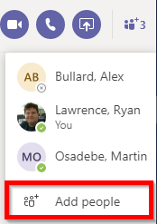
This will enable you to invite additional people to the group chat. | 