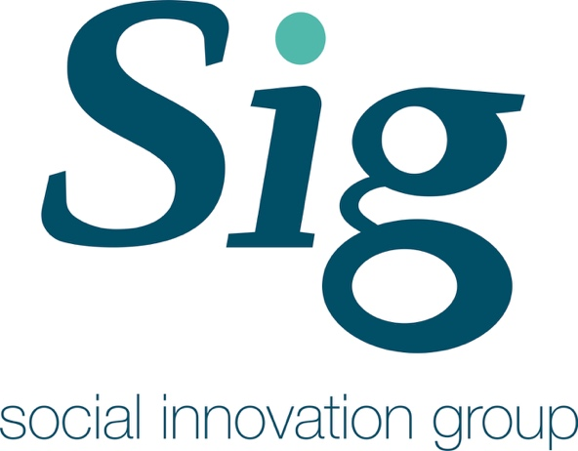

Written by:

Alexandra Hatton, Dr Timothy Walker,

Dr Michael Leyshon

<http://geography.exeter.ac.uk/cges/>

**Community Connect**

A Review of the Community Connect Project and the impact its currently making

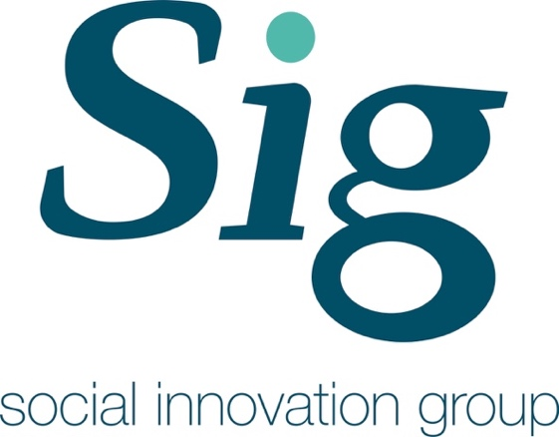

SIG Reports and Policy Papers

Community Connect

Author(s):

Alexandra Hatton, Dr Timothy Walker, Dr Michael Leyshon, University of Exeter.

This publication may be reproduced by any method without fee for teaching or non-profit purposes, but not for resale. The papers should be citied with due acknowledgment.

This publication may be cited as:

Alexandra Hatton, Dr Timothy Walker, Dr Michael Leyshon, 22nd May 2019, Community Connect, SIG Reports and Policy Paper Series, Centre for Geography and Environmental Science, University of Exeter, UK

Contact: Dr Timothy Walker

Email: [t.walker@exeter.ac.uk](mailto:t.walker@exeter.ac.uk)

Social Innovation Group

Centre for Geography and Environmental Science

College of Life and Environmental Sciences

University of Exeter, Penryn Campus

TR10 9FE

Telephone: +44 1326 371867

ISSN/ISBN XXXXXXXXX

Funded by: Economic and Social Research Council – Impact Acceleration Account.

http://www.esrc.ac.uk/funding/funding-opportunities/impact-acceleration-accounts/

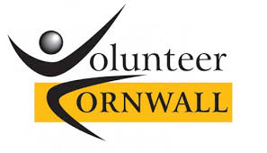



Table of Contents

1.0: Introduction 5

1.1: What is Community Connect? 5

1.2: Purpose of this Report 5

1.3: Background of Social Prescribing 5

1.4: Aims and Methods 5

2.0: Demographic of the Cohort 6

3.0: Issues Experienced 7

4.0: Individual Action 8

5.0: Wellbeing Score Analysis 10

6.0: Key Findings 10

7.0: Recommendations and Issues Outside the Scope of this Report 11

**List of Figures**

**Figure 2.1.** The Gender Demographic of those individuals interviewed by the community navigator for the community connect project. Sourced from Community Connect Data provided by Sharon Nettleton.

**Figure 2.2.** The Age Demographic of those individuals interviewed by the community navigator for the community connect project. Sourced from Community Connect Data provided by Sharon Nettleton.

**Figure 2.3.** The Location spread of those individuals interviewed by the community navigator for the community connect project. Sourced from Community Connect Data provided by Sharon Nettleton.

**Figure 3.1.** The various Issues Experienced by those interviewed and the number of different people who experienced them. Sourced from Community Connect Data provided by Sharon Nettleton.

**Figure 3.2.** The Number of Different Issues Experienced by those interviewed and the number of different people who experienced them. Sourced from Community Connect Data provided by Sharon Nettleton.

**Figure 4.1**. List of all the different organisations that individuals were signposted to. Sourced from Community Connect Data provided by Sharon Nettleton.

**Figure 4.2.** Number of actions each individual received from the community navigator. Sourced from Community Connect Data provided by Sharon Nettleton.

**Executive Summary**

This report is an evaluation of the current effectiveness of the Community Connect programme, Feock Parish. The findings below explore the emerging practice of social prescribing within the community through examining a range of factors: the demographic properties of those using the programme, issues experienced by individuals in the community and their bespoke social prescriptions.

Key findings illustrate that the programme was mainly used by an elderly population, of which 72% of individuals using the programme were female. We suggest this gender bias may reflect issues of stigma surrounding males asking for help as well as the location of the programme. The most significant issue we identified was that individuals who experience social isolation were effected by loneliness and a reduced mental health. These issues are often linked to a lack of transport and finance concerns (e.g. being able to afford to attend ‘events’). Another major finding identified the key role and function of the Community Navigator in providing/enabling social prescriptions. This role is central to the programme as many individuals were experiencing multiple issues and therefore needed assistance from the Community Navigator in coordinating the help of several organisations.

We conclude this report by making a series of recommendations. First, that the Community Connect project applies for Smartline funding in order to further evaluate the impact of the project and to test and trial the University of Exeter Guided Conversation. Second, that a substantive Community Asset Analysis is undertaken to further improve the knowledge base and effectiveness of the project. Finally, that a new wellbeing score system is utilised in order to measure the difference the bespoke social prescriptions are having on the individuals overtime.

# 1.0: Introduction

# 1.1: What is Community Connect?

Community Connect is a Cornwall Link organisation based in Feock Parish that connects members of the community with appropriate services as well as providing information to those experiencing a range of wellbeing issues *(Cornwall Link, 2019)*. These social prescribing tasks are facilitated by the Community Navigator (CN), Sharon Nettleton.

# 1.2: Purpose of this Report

The purpose of this report is to analyse data from the Community Connect programme. This includes analysis of the local population who are part of the programme, the issues that they are experiencing, what support they are being signposted to, and their wellbeing scores throughout the programme. To conclude the report we make a series of recommendations as to how the community connect programme should proceed in order to ensure the programme continues to run efficiently and makes a tangible difference to the wellbeing of the members of the community.

# 1.3: Background of Social Prescribing

Social prescribing is a way of linking patients in primary care with sources of support within a community to help improve their health and wellbeing *(Bickerdike, 2017).* One in four people in the UK suffer with mental health issues *(Kimberlee, 2015).* This is placing a strain on already financially stretched GP services. As early as 1999 it was suggested that the NHS should make better use of community support structures and voluntary organisations in order to reduce the number of patients increasingly dependent on GP services *(South et al., 2008)*. Therefore, social prescribing has the potential to reduce demand on GPs surgeries by signposting individuals who present with social needs to organisations outside of the NHS *(South et al., 2008).* However, links between primary care services and the voluntary/community sector are often undeveloped. Bickerdike et al. (2017) have argued that the employment of a link worker is an essential component of any social prescribing programme. Their role as a fulcrum between GPs, individuals, and voluntary organisations can only be realised through the development of community relations, building local knowledges and understandings of the possibilities of places, i.e. what services are or might be available in an area. Hence, social prescribing is most effective where there are clear partnerships between GPs, the community and the voluntary sector *(South et al., 2008).* Within the community connect programme the CN’s role should be seen as essential in building these partnerships.

# 1.4: Aims and Methods

The data presented below represents an initial, and thereby partial, review of the effects of the Community Connect project on the physical and mental health, as well as social wellbeing of individuals in Feock Parish. The primary focus of this report provides insight into the demographic of individuals involved in the Community Connect programme, as well as discussing the issues that they were experiencing. Drawing from this analysis we highlight the link between various issues individuals are experiencing and the need for bespoke signposting.

# 2.0: Demographic of the Cohort

In order to develop a range of social prescriptions into various organisations requires an initial analysis of the cohort of individuals utilising the programme. An analysis of the first set of community connect data illustrates that the programme is utilised much more by females than males (Figure 2.1.). We can speculate that this may result from male stereotypes surrounding embarrassment and/or stubbornness to ask for ‘a little’ help. As the CN commented, “[M]y second call Mr W agreed to me calling in and meeting him and his wife but said, You can come, but I don’t see how you can help us”.

When looking at the age demographic of those using the programme (Figure 2.2) there was a large range from 20—100, however, the highest frequency of age bracket was 80—84 with most individuals being 55+. The Community Connect programme is spread across four locations (Chacewater, Feock, Perranwell and Truro), but it is used in the main in Foeck Parish rather than in the other locations where the CN attends (Figure 2.3).



*Figure 2.1. The Gender Demographic of those individuals interviewed by the community navigator for the community connect project. Sourced from Community Connect Data provided by Sharon Nettleton.*



*Figure 2.2. The Age Demographic of those individuals interviewed by the community navigator for the community connect project. Sourced from Community Connect Data provided by Sharon Nettleton.*



*Figure 2.3. The Location spread of those individuals interviewed by the community navigator for the community connect project. Sourced from Community Connect Data provided by Sharon Nettleton.*

# 3.0: Issues Experienced

Through conversations lead by the CN a range of issues experienced by members of the community have been identified, as illustrated in Figure 3.1. The most significant being a ‘lack of social opportunities’, followed by issues of ‘emotional wellbeing’ and family concerns.



*Figure 3.1. The various Issues Experienced by those interviewed and the number of different people who experienced them. Sourced from Community Connect Data provided by Sharon Nettleton.*

The data illustrates that within a relatively small sample area and population there are a significant number of social/wellbeing issues being reported. To ensure that an individual’s needs are addressed requires a responsive system of bespoke signposting. This is important as many individuals were experiencing multiple issues as shown in Figure 3.2. For example, those who experienced emotional wellbeing issues also tended to experience a lack of social opportunities. As the CN reflected, “increasing withdrawal from the community is resulting in depression and heightening I.S’ perception for being generally unwell”. Being unable to socialise is resulting in some individuals reporting low emotional wellbeing. The benefit of social opportunities in reducing isolation is axiomatic in improving an individual’s wellbeing. As the CN stated, “Mr T and I attended lunch club together where he met an old friend. He enjoyed himself so much he has decided to go again and donate one of his paintings to the raffle”.

A lack of transport was another key issue reported by the cohort. Importantly it was frequently reported alongside low emotional wellbeing resulting from social isolation. Predominantly these co-joined issues were caused by financial concerns. For instance, “I.S is in receipt of Pension Credit and unsure if she receives Attendance Allowance but has very little money to pay for ‘Extras’ such as community transport or taxis”. Hence, through understanding how multiple issues commonly manifest, the CN will be better placed to coordinate and signpost specific support in a way that will address the underlying problems.



*Figure 3.2. The Number of Different Issues Experienced by those interviewed and the number of different people who experienced them. Sourced from Community Connect Data provided by Sharon Nettleton.*

# 4.0: Individual Action

As individuals in the cohort often experienced multiple issues, there are not simple solutions to address their concerns. Ameliorating multiple issues requires bespoke ‘social prescriptions’, i.e. signposting to different organisations to meet different needs. The current projects focus on providing community led solutions appears to be generating some success. As Mr T commented after having attending a lunch group he was signposted to, “Some men choose to stay in mourning when their wife dies and never come out of it, but I’m determined to not let that happen to me...I’ve really enjoyed myself here today. Where shall we go next week?” Other successes have been with the volunteer transport scheme with one individual stating, “I don’t know what I would have done without the volunteer car scheme, they’ve been a God send”.

Figure 4.1 illustrates the variety of organisations that individuals were signposted to and thereby reflects the diversity of different individual’s needs. Due to the individualistic nature of the issues people were experiencing they naturally react to different social prescriptions in different ways. The data illustrates that the majority of individuals were prescribed more than one action in an attempt to address their range of issues. As shown in Figure 4.2. 42% of the individuals required two actions and 9% required four actions. This shows how complex issues experienced by individuals requires a multi-agency response in order to improve their quality of life.

*Figure 4.1. List of all the different organisations that individuals were signposted to. Sourced from Community Connect Data provided by Sharon Nettleton.*



*Figure 4.2. Number of actions each individual received from the community navigator. Sourced from Community Connect Data provided by Sharon Nettleton.*

# 5.0: Wellbeing Score Analysis

The adaptation of the survey (wellbeing) instrument during the course of this project means that robust data analysis over the period cannot be undertaken. Wellbeing surveys are a useful way, however, to determine the impact that projects like Community Connect are having on individuals.

**6.0:** **Key Findings**

The key message from this report is that social prescriptions cannot be generalised and require bespoke signposting and support. This reflects how the complex needs of individuals often require a multi-prescription (including but not exclusively, a range of services) response. When looking at the issues individuals were experiencing there were a number of key themes that presented frequently (Figure 3.1.). However, there is a huge range in social prescriptions that are bespoke to each individual (Figure 4.1.), this demonstrates the importance of employing a CN in order to action these unique social prescriptions. Through examining the cohort data of individuals needing support it was clear that females utilise the service far more than men (Figure 2.1.). This could be due to a number of reasons such as men being more unlikely to seek support due to the social construction of masculinity often leading to the avoidance of preventative mental and physical healthcare services *(Millegan et al., 2013),* coupled to longer life expectancy of women leading to them becoming more isolated following their partners passing *(Millegan et al., 2013; Wang et al., 2012).* The age demographic findings showed that the project is mainly used by the elderly (Figure 2.2.). This reflects the wider aging population of Cornwall with 44.3% of the population being over 50 *(Plumplot, 2017)*. However, and Importantly, many younger individuals may not be aware of the project and are as likely to benefit from its prescriptions as it has been shown that young and middle-aged people also experience a range of similar social issues *(Victor and Yang, 2012; Luhmann and Hawkley, 2016)*.

**7.0: Recommendations and Issues Outside the Scope of this Report**

1. It is recommended that staff from the Community Connect project attend the Smartline evaluation workshop and pursue a Smartline ‘in residency’. This would enable the use of the University of Exeter Guided Conversation tool to better understand the needs of the projects clients.
2. It is also recommended that a further depth analysis of the cohort is required in order to show the project’s full strengths and weaknesses. This would allow analysis of multiple datasets over time detailing the impact the project. Although currently beyond the scope of this report, it is recommended that a rich community asset analysis should be carried out such as the Cormac Russell Community Asset method *(Mcknight and Russell, 2018).*
3. Following wellbeing score analysis, it is recommended that the project chooses an appropriate wellbeing scoring system such as the Warwick and Edinburgh Mental Wellbeing Scale. This wellbeing evaluation should be supported with qualitative analysis and be conducted in a systematic way in order to capture real impact in changes to issues such as social isolation.

Further analysis that could be included but is not within the scope of this report include impacts to the community and a process evaluation of the delivery of services.

**8.0: Bibliography**

Bickerdike, L.., Booth, A., Wilson, P.M., Farley, K., Wright, K. (2017) Social Prescribing: less rhetoric and more reality. A systematic review of the evidence, *BMJ Open*, Volume 7(4): p1-17.

Cornwall Link (2019) Community Connect Feock, last accessed on 19/05/19, https://cornwall-link.co.uk/listing/community-connect-feock/.

Kimberlee, R. (2015) What is social prescribing?, *Advances in Social Sciences Research Journal*, Volume 2(1): p102-110.

Luhmann, M., Hawkley, L. (2016) Age Differences in Loneliness From Late Adolescence to Oldest Old Age, Developmental Psychology, Volume 50(6): p943-959.

Mcknight, J.L., Russell, C. (2018) The Four Essential Elements of an Asset-Based Community Development Process, ABCD Institute, DePaul University.

Millegan, C., Dowrick, C., Payne, S., Hanratty, B., Neary, D., Irwin, P., Richardson, D. (2013) Men’s Sheds and other gendered interventions for older men: improving health and wellbeing through social activity: A systematic review and scoping of the evidence base, *Lancaster University Centre for Ageing*, Lancaster.

Plumplot (2017) *Cornish Population statistics*, last accessed on 19/05/19, https://www.plumplot.co.uk/Cornwall-population.html. South, J., Higgins, T.J., Woodall, J., White,

S.M. (2008) Can social prescribing provide the missing link? *Primary Health Care Research and Development*, Volume 9: p310-318.

Victor, C.R., Yang, K. (2012) The Prevalence of Loneliness Among Adults: A Case Study of the United Kingdom, The Journal of Psychology, Volume 146(1-2): p85-104.

Wang H, Dwyer-Lindgren L, Lofgren K, Knoll Rajaratnam J, Marcus J, Levin-Rector L, Levitz C, Lopez A, Murray C. (2012) Age-specific and sex-specific mortality in 187 countries, 1970–2010: a systematic analysis for the Global Burden of Disease Study 2010, *Lancet,* Volume 380: p2071-2094.



Research Team Contact Details:

Prof Catherine Leyshon [cbrace@exeter.ac.uk](mailto:cbrace@exeter.ac.uk)

Dr Michael Leyshon [mleyshon@exeter.ac.uk](mailto:mleyshon@exeter.ac.uk)

Dr Timothy Walker [t.walker@exeter.ac.uk](mailto:t.walker@exeter.ac.uk)

Acknowledgements:

The Social Innovation Group (SIG) would like to acknowledge the ESRC for funding this project through an Impact Acceleration Award. Thanks to Ian Jones (CEO Volunteer Cornwall) and Nigel Clark (Director of Care Age UK Cornwall and Isles of Scilly) for their input and guidance; Andy Brelsford (Support and Development Manager) Volunteer Cornwall and everyone who has provided information and advice.



Peter Lanyon Building

University of Exeter

Penryn Campus

Treliever Road

Penryn

Cornwall

TR10 9FE

UK