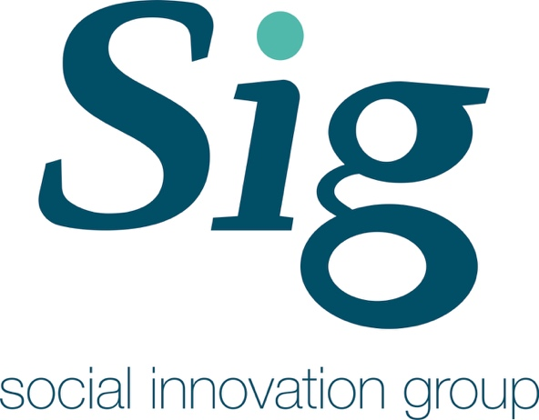
Developing social networks and community group engagement in Living Well
Written by:
Alex Robinson, Prof Catherine Leyshon, Dr Michael Leyshon, Dr Timothy Walker; University of Exeter.
http://geography.exeter.ac.uk/cges/

A Review of Best Practice

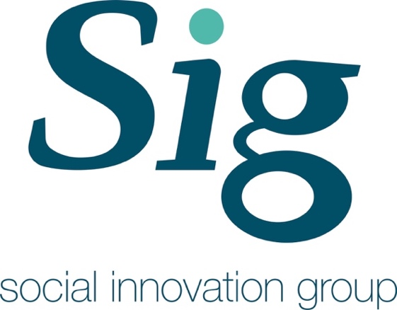

SIG Reports and Policy Papers
Developing social networks and community group engagement in Living Well

Author(s):
Alex Robinson, Prof Catherine Leyshon, Dr Michael Leyshon, Timothy Walker; University of Exeter.

This publication may be reproduced by any method without fee for teaching or non-profit purposes, but not for resale. The papers should be citied with due acknowledgment.

This publication may be cited as:
Alex Robinson, Prof Catherine Leyshon, Dr Michael Leyshon, Timothy Walker, (2016), Developing social networks and community group engagement in Living Well, SIG Reports and Policy Paper Series, Centre for Geography and Environmental Science, University of Exeter, UK

Contact: Prof Catherine Leyshon
Email: cbrace@exeter.ac.ukƒ
Social Innovation Group
Centre for Geography and Environmental Science
College of Life and Environmental Sciences
University of Exeter, Penryn Campus
TR10 9FE
Telephone: +44 1326 371867

ISSN/ISBN XXXXXXXXX
Funded by: Economic and Social Research Council – Impact Acceleration Account.
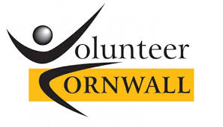
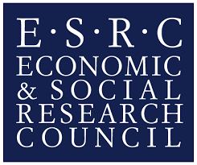
http://www.esrc.ac.uk/funding/funding-opportunities/impact-acceleration-accounts/

Funded by:
Economic and Social Research Council – Impact Acceleration Account.
http://www.esrc.ac.uk/funding/funding-opportunities/impact-acceleration-accounts/

Written by:
Alex Robinson, Prof Catherine Leyshon, Dr Michael Leyshon, Timothy Walker, University of Exeter.

http://geography.exeter.ac.uk/cges/

Table of Contents
Recommendations 4
1.0: Introduction 4
1.1: Rationale 4
2.0: How it works currently 5
2.1: West – Carolyn Trevitick 5
Raw Data 5
2.2: Central – Sharon Nettleton 6
Raw Data 6
2.3: East – Dianne Newman 6
Raw Data 6
2.4: Summary Points 7
3.0: Review of community group engagement elsewhere 7
4.0 Conclusions 7

Recommendations
Recommendations in numbered bullet points

1.0: Introduction
One way to overcome some of the volatility in volunteering capacity is to achieve a greater engagement with local volunteer-run community groups. Lessons learned from Living Well East Cornwall show that actively engaging and enlisting existing community groups works well to offer a range of activities and opportunities to older people.

- Frame in light of Living Well principles
- Importance of guided conversation
- Frame around life stories
- How living well has manifested/been tailored in practice in the different areas
- Need a transition out of living well – onto being a happy and healthy member of society
- Lack of links to and involvement with community groups
- The main idea of Living Well is to reintegrate older people within their local communities.
- Few links with people and organisations other than the Living Well partners, GP surgeries and volunteers.
- There is a clear lack of involvement with existing local community groups.

1.1: Rationale
The VIC team made a number of observations and recommendations about the role of community groups with regard to the resilience of the Living Well programme. These are set out in NESTA report ‘How does change happen? A qualitative process evaluation’ (2015):

Observation: Actively engaging and enlisting existing community groups works well to offer a range of activities and opportunities to older people.
Recommendation: Living Well Coordinators need to further engage and better enlistment methods.

Observation: Overall, in the Living Well programme, there is a clear lack of links and involvement with existing local community groups.
Recommendation: In order to reduce volatility in volunteering capacity Living Well should achieve a greater engagement with local volunteer-run community groups.

2.0: How it works currently
- Talk about as process
- Frame in context of cultural catchments – referring to cultures of volunteering paper

2.1: West – Carolyn Trevitick

Raw Data

- Didn’t do very well overall with community group engagement
- Invited everyone – but didn’t need to invite everyone – more important that know the right people
- Didn’t have resources to properly follow through
- Community map was main output – but too hectic – no phone numbers – instantly out of date – audience of map
- “What the LW coordinators really needed was more robust information” – specific information about the service users and know about the particular type of group and what their identity and what there like and character
- Needs to be tailored to Mrs jones – this is the importance of guided conversation - “the teams needed more time to establish relationships with ‘Mrs jones’ before considered and mobilised community groups”
- Role of the LW team “important that it is Carolyn who knows and connects”. For example, I know Margaret in St Ives and she is Mrs st ives, but Carolyn needs to be making those connections” “it’s a completely different skill set”
- Didn’t invest in leadership in the west - closed and controlling taking stuff from Newquay which might not of worked so well (JA, 2015)
- Close social connections in the West
- Need a transition out of living well – onto being a happy and healthy member of society - Too much dependence in west – not moving through quick enough - See model – idea is to reduce number of steps till out
- This reduces dependence and long drawn out intermediate stage had in the west
- Scott Bennett - M No. And that's where I think the learning in East Cornwall has recognised that. Because Penwith started to grow their own groups, rather than using existing. And what is happening in East Cornwall is they're using existing, and then growing new groups if there's a gap. Which seems to be the better way of doing it.
- Jenny Atkinson - F So I think that has been taken to the West. And I think there’s, I think in the East they came in with a very clear having learned and having seen, very clear you are just connecting people and so we sort of talk about three … really. Are they connectors? Are they critical friends? What was the other one. Connectors, critical friends or coaches. And it’s like the three roles. And I asked Di and Carolyn both of those. I said what do you see your roles as because I’m trying to do some training around guided conversation. Di was very clear. She said we have to move through all three roles. Ideally it’s great if you’re just a connector. But actually most of the people on the programme need a little bit more than that.

Community Mapping
- Local people – local conversations. Community engagement workshop
- Invited less people – not everyone

2.2: Central – Sharon Nettleton

Raw Data

2.3: East – Dianne Newman

Raw Data
- After reflecting on west (JA, 2015) – benefits of learning
- More experienced manager - Learnt from previous work in penwith
- Need a transition out of living well – onto being a happy and healthy member of society - See model – idea is to reduce number of steps till out
- Rather than volunteers running the community groups, they need to be self sufficient and the volunteers need to ‘bridge the gap’ between the service users and the community groups (JF, 2015)
- East we developed training from best practice - i.e. more leadership and training
- Well defined geographies and groups in east. Cluster around: 1) saltash; 2) tor point: callington; lasssarack; looe; lauceston. Natural cultural catchment areas
- “Partly affected by physical geography but also about aspiration, but those two are linked too. If you want to go up in the world you go up to Plymouth and beyond. Where in West Pewith you go down to Penzance”. (JA, 2015)
- As result they are better off in that part of cornwall – more activated workforce – more professional capital
- Maverns – Peter and Rose. Identified two key people who are motivated and self-driven. Each did own community mapping event in the East
- We didn’t have regular meetings – less supervision needed. These meetings were issue and action focused
- Lack of resource – admin support reduction for east. Juliet had one meeting, no EU funding
- Very good engagement officers; Jenny at CRCC ‘community capacity builder’ with right community skills; VC ‘community maker’
- Scott Bennett - M No. And that's where I think the learning in East Cornwall has recognised that. Because Penwith started to grow their own groups, rather than using existing. And what is happening in East Cornwall is they're using existing, and then growing new groups if there's a gap. Which seems to be the better way of doing it.
- Jenny Atkinson - F So I think that has been taken to the West. And I think there’s, I think in the East they came in with a very clear having learned and having seen, very clear you are just connecting people and so we sort of talk about three … really. Are they connectors? Are they critical friends? What was the other one. Connectors, critical friends or coaches. And it’s like the three roles. And I asked Di and Carolyn both of those. I said what do you see your roles as because I’m trying to do some training around guided conversation. Di was very clear. She said we have to move through all three roles. Ideally it’s great if you’re just a connector. But actually most of the people on the programme need a little bit more than that.

2.4: Summary Points
- https://en.wikipedia.org/wiki/Transtheoretical_model
- Built on model – see Changing lives Declametry and Prochaska
- Changing lives – living well before pre-contemplative stage
- Community group engagement is not for everyone

Current Methods of engagement
- No need for a specific process
- A model to guide best practice
- Don’t push for referrals – allow to do slowly. Do less and do better

3.0: Review of community group engagement elsewhere
Learning from other examples
Use case studies to illustrate

4.0 Conclusions
- Unmapped need
- More complex than just where groups are – need to connect
- Rather than volunteers running the community groups, they need to be self-sufficient and the volunteers need to ‘bridge the gap’ between the service users and the community groups
- Importance of guiding conversation in identifying right community group for elderly

4.1 What happens next?
- In NE cornwall
- No coordinators
- Stretched resources
- Engagement with GP’s said they are not going to sign up unless fully funded
- Focus on doing little well

Research Team Contact Details:
Prof Catherine Leyshon cbrace@exeter.ac.uk
Dr Michael Leyshon mleyshon@exeter.ac.uk
Dr Timothy Walker t.walker@exeter.ac.uk

Acknowledgements:
The Social Innovation Group (SIG) would like to acknowledge the ESRC for funding this project through an Impact Acceleration Award. Thanks to Ian Jones (CEO Volunteer Cornwall) and Nigel Clark (Director of Care Age UK Cornwall and Isles of Scilly) for their input and guidance; Andy Brelsford (Support and Development Manager) Volunteer Cornwall and everyone who has provided information and advice.
Peter Lanyon Building
University of Exeter
Penryn Campus
Treliever Road
Penryn
Cornwall
TR10 9FE
UK

