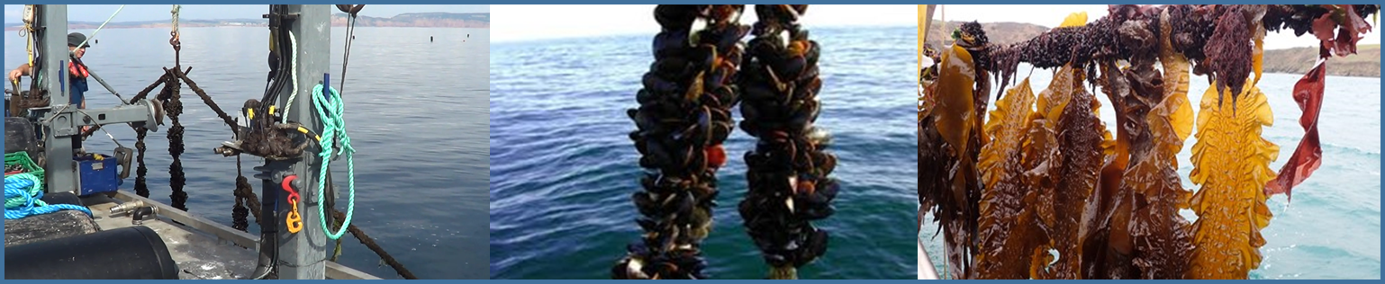

**Developing general rules to facilitate evidence-based policy for mariculture development in and around Marine Protected Areas (MPAs) in England**

**Final Report to Research England (Strategic Priorities Fund)**

**September 2020**

**Authors:**

A Ross Brown1, Carly Daniels1, Keith Jeffery2, Charles R Tyler1.

**Affiliations:**

1) Sustainable Aquaculture Futures, Biosciences, Geoffrey Pope Building, Stocker Road, Exeter, EX4 4QD.

2) Centre for Environment Fisheries and Aquaculture Science, The Nothe, Barrack Road, Weymouth, Dorset DT4 8UB.

**Suggested citation:**

BrownAR, DanielsC, JefferyK, TylerCR (2020). Developing general rules to facilitate evidence-based policy for mariculture development in and around Marine Protected Areas (MPAs) in England. Report to Research England (Strategic Priorities Fund), 30pp. [https://www.exeter.ac.uk/research/saf/projects/strategypolicyregulation/](https://eur03.safelinks.protection.outlook.com/?url=https%3A%2F%2Fwww.exeter.ac.uk%2Fresearch%2Fsaf%2Fprojects%2Fstrategypolicyregulation%2F&data=02%7C01%7CRoss.Brown%40exeter.ac.uk%7C7b643e4de91943590bb308d850354e72%7C912a5d77fb984eeeaf321334d8f04a53%7C0%7C0%7C637347537158006235&sdata=Y%2FdZg9eXHFcQX2wcDCSPS4mrHJ1NTTvnOIp5h0x1EyI%3D&reserved=0)



**CONTENTS**

**1) EXECUTIVE SUMMARY** 3

**2) OVERARCHING AIM** 3

**3) BACKGROUND** 4

**3.1) The potential for growth in aquaculture, particularly marine aquaculture in England** 4

**3.2) Key factors constraining mariculture expansion** 4

**4) METHODS** 5

**4.1) Initial consultation and scoping (Stage 1)** 5

**4.2) Literature review (Stage 2)** 5

**4.3) Case study (Stage 3)** 6

**4.4) Multi-stakeholder workshop (Stage 4)** 6

**5) RESULTS** 6

**5.1) Initial consultation and scoping** 6

**5.2) Literature review** 7

***5.2.1) Reconciling nature conservation and sustainable development of mariculture*** 7

***5.2.2) Availability of marine space for mariculture development*** 8

***5.2.3) Development of compatibility matrices for marine activities (including mariculture) and MPAs*** 9

***5.2.5) Transformative policies and approaches for enabling sustainable mariculture development in and around MPAs*** 13

**5.3) Case study** 14

***5.3.1) Mapping of existing mariculture sites in SW England*** 14

***5.3.2) Detailed mapping of areas suitable for mariculture development along the Dorset and East Devon coastline by CEFAS*** 16

**5.4) Multi-stakeholder workshop** 18

***5.4.1) Case study 1: Seafood 2040 - The English Aquaculture Strategy*** 19

***5.4.2) Case study 2: Sustainable mariculture development - sharing sea space, avoiding conflict & protecting the environment*** 19

***5.4.3) Case study 3: Mariculture developments in and around MPAs in England*** 20

***5.4.4) Case study 4: Regulatory processes for aquaculture*** 20

**6) CONCLUSIONS** 21

**7) RECOMMENDATIONS** – to facilitate marine planning and licencing of future mariculture developments in and around MPAs. 22

**ACKNOWLEDGEMENTS** 22

**REFERENCES** 23

# **1) EXECUTIVE SUMMARY**

* Marine ecosystems face ever-increasing demands from human activities and there is an urgent need for evidence-based policy and decision making to ensure sustainable management of marine resources.
* Globally, marine capture fisheries have plateaued or are in decline, driving the need for aquaculture expansion to satisfy an ever increasing demand for seafood.
* Marine aquaculture (mariculture) has considerable potential to contribute to sustainable ‘blue’ growth in the UK, particularly in England where the industry (predominantly shellfish mariculture) currently occupies a very small proportion (<0.1%) of the country’s territorial coastal waters.
* The majority (>70%) of mariculture sites in England are located within MPAs and have co-existed as such over long periods of time (for up to 100 yrs).
* We evaluate the availability of baseline data, and the development of habitat feature-specific risk assessment tools and general rules for facilitating mariculture development within MPAs.
* In the final analysis, we set out a series of recommendations for the development of MPA/marine planning assessment tools and rules and their integration within a transparent decision making framework (e.g. decision tree) for regulators and prospective mariculture licencees.

# **2) OVERARCHING AIM**

This project set out to provide a synthesis of evidence and recent developments in marine policy making and decision support tools for enabling the sustainable development of mariculture sites, species and technologies in and around marine protected areas (MPAs).

# **3) BACKGROUND**

## **3.1) The potential for growth in aquaculture, particularly marine aquaculture in England**

Aquaculture is the fastest growing food production sector globally (FAO, 2020) and unlike agriculture and capture fisheries, which are plateauing or declining (Asche and Smith, 2018; FAO, 2020), offers huge potential for future sustainable growth (DEFRA, 2015; Westbrook, 2017; Seafish, 2017). Global food fish production from aquaculture (82 million tonnes, US$250 billion per year) now exceeds capture fisheries and production is projected to rise to 109 million tonnes, by 2030 (FAO, 2020), with a significant contribution coming from marine aquaculture (mariculture) (Kapetsky et al., 2013; EEA, 2017; FAO, 2020). The UK mariculture industry generates <1% of annual global aquaculture product sales (£1.8 billion) from ~0.2 million tonnes of farmed seafood, which is dominated by Scottish salmon and shellfish (Seafish, 2016). There is significant potential to grow the UK mariculture industry (Seafish, 2016; UK Government Office for Science, 2017), particularly in England where turnover is projected to rise from 2% to 4% (£30 million to £60 million) of UK sales over the next 20 years (Seafish, 2017). A major factor contributing to the growth potential for mariculture in England is its long coastline, which is the third longest of all EU countries (UK Government Office for Science, 2017). However this coastline currently supports 20 times lower production (per km) compared to Northern France (EEA, 2017). More extensive growth in revenues and jobs are likely to be generated in coastal communities in England by an enhanced seafood value chain, including food processing, restaurant, hospitality and tourism industries (SeaFish, 2017). The increased production and consumption of seafood, rich in proteins, micronutrients and omega 3 fatty acids, is expected to bring considerable human health benefits and significant reductions in national healthcare costs (Seafish, 2017). There are also numerous ecosystem service benefits associated with some mariculture practices, in particular from shellfish and seaweed mariculture, including habitat provisioning and enhancement of biodiversity and commercial fisheries (Le Gouvello et al., 2017).

## **3.2) Key factors constraining mariculture expansion**

A broad range of factors potentially constrain mariculture expansion. Key socio-economic factors include burdensome and bureaucratic regulation (DEFRA, 2015), competition/conflict with other marine sectors for marine space (Kapetsky et al., 2013, Gentry et al., 2017), financial and technical demands associated with licencing and operation, public perception of aquaculture and dietary preferences for, finfish and crustaceans with wild provenance (Villasante et al., 2013; Gentry et al., 2017). Key environmental factors include variable water quality (Muir, 1992), climate change, ocean acidification (Clements and Chopin, 2017), and harmful algal blooms (Brown et al., 2019).

Barriers faced by the aquaculture sector in SW England have been ranked in their importance by 22 industry, academic and regulator stakeholders in the South West Aquaculture Network (**Figure 1**).

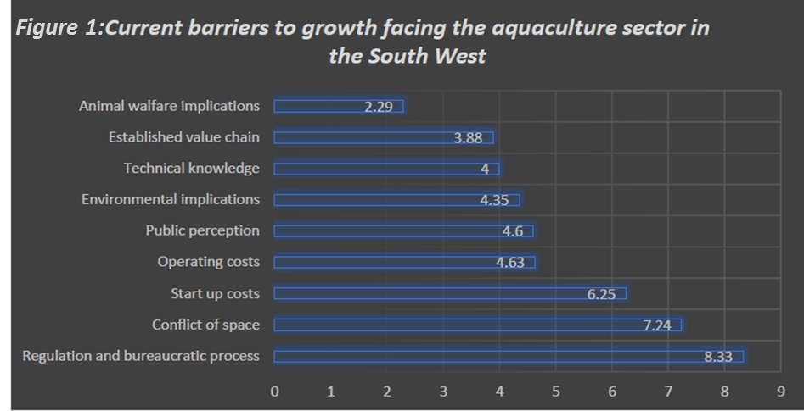

Values on bar chart represent the average importance score – averaged across 22 survey participants (importance was scored by all participants from 1 to 9, least to most important barrier).

# **4) METHODS**

In order to help overcome the key constraint of conflict for marine space we examined scientific evidence and recent developments in marine policy making and decision support tools concerning the co-location of aquaculture sites, farmed species and technologies in and around MPAs. We then used this evidence to generate a set of policy recommendations for facilitating sustainable development of mariculture in and around MPAs. The work was undertaken in four stages:

## **4.1) Initial consultation and scoping (Stage 1)**

Relevant competent authorities comprising the Centre for Environment Fisheries and Aquaculture Science (CEFAS), Natural England (NE) and the Inshore Fisheries Conservation Authority (IFCA) were consulted at the outset of the project in order identify key information sources and data gaps concerning interactions between mariculture and MPAs.

## **4.2) Literature review (Stage 2)**

A literature review was undertaken to appraise data and tools highlighted in Stage 1 (Section 4.1) and to develop a narrative concerning trends in policy development on the sustainable use of marine resources alongside nature conservation. The review considered international policy and regulatory instruments, but focused primarily on national policy and regulation relating to the management of MPAs alongside mariculture operations and also capture fisheries.

## **4.3) Case study (Stage 3)**

A case study was undertaken in SW England, along the Dorset and East Devon coast, in order to develop general rules (supported by an evidence base derived from the scientific literature, policy reviews and stakeholder consultation) for mariculture development around MPAs. In particular this study evaluated the feasibility of using available evidence and tools (identified in Stage 1) for assessing mariculture-MPA interactions and for screening the compatibility of mariculture species and technologies with specific conservation features (i.e. sedimentary or reef habitat features listed in Annex 1 of the Habitats Directive).

## **4.4) Multi-stakeholder workshop (Stage 4)**

The work presented in this report was summarised and presented to 40 regulatory, industry and academic stakeholders at a virtual workshop on ‘*Supporting Mariculture Development - Evidence for Informed Regulation*’, which addressed the key constraint of Regulation and bureaucratic process (**Figure 1**). During and after the workshop stakeholders were asked to prioritise and feedback on a range of issues, including perceived positive and negative impacts of mariculture on MPAs. The workshop was conducted and is reported separately under a parallel and complimentary SPF project (Daniels et al., 2020).

# **5) RESULTS**

## **5.1) Initial consultation and scoping**

Consultation with CEFAS, Natural England and IFCA took place on 20 February 2020 and minutes are recorded in **Appendix 1**. The consultation identified a number of key resources that provided a starting point for the literature review (Stage 2) and the case study (Stage 3). These resources included: i) Natural England’s ‘advice on operations’ in MPAs concerning mariculture species (finfish, shellfish, seaweed) and specific culture technologies (bottom culture, trestle culture, rope culture) <https://www.gov.uk/government/collections/conservation-advice-packages-for-marine-protected-areas>; ii) Natural England’s and IFCA’s geospatial maps of MPAs (and habitats and specific conservation features) <https://magic.defra.gov.uk/> and iii) CEFAS’s detailed geospatial assessment of the feasibility of aquaculture operations (based on environmental conditions and competing uses) along the Dorset and East Devon coastline out to 6 nautical miles <http://data.cefas.co.uk/>. Additional resources for informing ‘general rules’ for mariculture development in and around Marine Protected Areas (MPAs) that were identified (and evaluated in the literature review - Stage 2) included: the Marine Management Organisation’s Matrix of fisheries gear types and European Marine Site protected features <https://www.gov.uk/government/publications/fisheries-in-european-marine-sites-matrix> and Habitat Risk Assessments and Zoning under the Williamsburg Resolution relating to aquaculture and fish movements. <http://www.nasco.int/pdf/far_aquaculture/AquacultureFAR_EnglandWales.pdf>

## **5.2) Literature review**

### ***5.2.1) Reconciling nature conservation and sustainable development of mariculture***

The UK Government’s 25-year plan (DEFRA, 2019) states that “English inshore and offshore waters and Northern Ireland offshore waters will achieve good environmental status (Marine Strategy Framework Directive MSFD 2008/56/EC)…. while allowing marine industries to thrive….”, which will be achieved in part by establishing an “ecologically coherent network of well-managed marine protected areas (MPAs)”. The plan also highlights Defra’s ambition for more collaborative management by “joining forces with local stakeholders to find the most appropriate ways of drawing down the riches of the sea in a sustainable way”. The International Union for the Conservation of Nature (IUCN) also highlights potential opportunities & synergies between aquaculture (mariculture) and nature conservation in relation to meeting Aichi Targets by 2020: Target 11 - marine biodiversity protection; Target 6 - sustainable fisheries (CBD, 2010), and achieving UN Sustainable Development Goals (2030): Goal 2 - food security; Goal 14 – oceans (IUCN, 2020).

Despite international acknowledgement for the need to reconcile nature conservation and sustainable development (IUCN, 2020), nature conservation in England, the UK and EU follows a ‘precautionary approach’. Environmental Impact Assessment (EIA) screening is mandatory for shellfish and finfish mariculture developments, including in sensitive areas such as MPAs.

In the case of European Marine Sites designated under the Habitats Directive (92/43/EEC) and/or Birds Directive (79/409/EEC) an assessment is also required to demonstrate that the integrity of the sites will not be adversely impacted (EC, 2012; Möckel, 2017). In the UK, this assessment is a Habitats Regulations Assessment (HRA), performed under the Conservation (Natural Habitats &c.) Regulations (2019) by competent authorities (the authorising or consenting body) advised by Natural England. Assessments must show that designated habitat features within protected sites are maintained in favourable condition (i.e. feature extent is stable or increasing, structures and functions necessary for maintenance are likely to exist for the foreseeable future, populations of typical species associated with the habitat are viable in long-term). Despite distinctions being made for priority habitats and features, which are particularly rare or vulnerable (nationally or internationally), or which, once destroyed, cannot be replaced there is a tendency to apply the same levels of protection to all. For example, Article 6(2) and Article 6(3) of the Habitats Directive offer the same level of protection for all ‘natural habitats’ and ‘habitats of species’.

The effectiveness of ‘feature-based approaches’ for conserving marine biodiversity has been called into question, due to lack of representation of species and habitats within the MPA network, lack of reliable indicators to assess change in feature condition, inability to accurately map the distribution and extent of many features (Ware and Downie, 2020). Of further concern is the tendency for universal application of the precautionary principle to afford the highest levels of conservation protection, at the expense of sustainable development (Solandt et al., 2020). An alternative approach advocated in UK Government’s 25 year Environmental Plan is to protect whole ecosystems, ‘which are more than the sum of their parts, due to dynamic interaction of components through time’ (DEFRA, 2018a). This ‘whole site’, ‘ecosystem-based approach’ seeks to preserve structure and function, and enable the repair and renewal of marine systems, and is more consistent with the sustainable development and use of marine resources (Solandt et al., 2020; Rees et al., 2020). Regardless of the approach taken towards sustainable development, clearer specification of significant adverse effects on MPA features is required, as well as more accurate quantification of the contribution of proposed developments towards any (cumulative) adverse effects (Möckel, 2017).

### ***5.2.2) Availability of marine space for mariculture development***

Around half ~50% (25,102 km2) of English inshore waters (out to the 12 nautical mile territorial limit) is occupied by 154 MPAs, while 37% (66,504 km2) of offshore waters contain 40 MPAs (JNCC, 2019). The majority of inshore waters are also open to fishing (MMO, 2018) and a range of other marine activities. Furthermore, not all remaining available marine space will be suitable for mariculture development due to other constraints (including water quality, depth, exposure to wind and waves) and socio-economic factors (including proximity to ports and supply chains) (Ross et al. 2013). This highlights the need for multiple stakeholder engagement and multi-criteria decision analysis in marine spatial planning (Ross et al., 2013; Sanchez‐Jerez et al. 2016) including around MPAs (Rodmell et al., 2020).

In line with the UK multi-annual national plan for the development of sustainable aquaculture (DEFRA, 2015), marine plans in England identify areas for potential aquaculture development, but there is no accompanying scheme or dispensation for facilitating licencing (SPF workshop, 2020). One solution is the establishment of allocated zones for aquaculture ‘AZA’ (Sanchez‐Jerez et al., 2016), where aquaculture development could be directly aligned with MPA or other marine use objectives.

It is important to note that the establishment of many existing mariculture sites within MPAs predates the designation of many of these conservation sites, including European Marine Sites (EMSs) and Marine Conservation Zones (MCZs), which have proliferated following the Earth Summit in Rio de Janeiro, 1992 and the World Summit on Sustainable Development in Johannesburg, 2002 (FAO, 2009; Humphreys and Clark, 2020).

### ***5.2.3) Development of compatibility matrices for marine activities (including mariculture) and MPAs***

Compatibility matrices for different marine activities and different MPA categories (from category Ia Strict nature reserves and, Ib Wilderness areas to category VI Managed resource protected areas) were proposed provisionally by the IUCN (Day et al., 2012). The compatibility of different types of aquaculture has also been rated (yes, possible, no) for IUCN broad MPA categories (Le Gouvello et al., 2017; IUCN, 2020) (**Table 1**). Comparable rating of aquaculture, fishing and dredging in Table 1 seems unrealistic. More detailed assessments of the sensitivity of specific habitat features in English MPAs (e.g. Poole Harbour EMS) to pressures from these activities (e.g. abrasion/disturbance of the seabed, changes in suspended solids, nutrient enrichment) indicates that features are generally more sensitive to dredging than fishing or aquaculture (**Table 2**). This is according Natural England’s Advice on Operations <https://www.gov.uk/government/collections/conservation-advice-packages-for-marine-protected-areas>, based on Marine Evidence based Sensitivity Assessment (MarESA) (Tillin et al., 2010; Tillin and Tyler-Walters, 2014), for a range of marine activities. A similar approach has been developed in Wales (Hall et al., 2008) and in Scotland <http://www.sarf.org.uk/cms-assets/documents/167420-751752.sarf090.pdf>. These evidence-based sensitivity assessments have been benchmarked in terms of magnitude, extent, duration and frequency of the effect, so that pressures from different activities can be compared on an equal footing <https://www.marlin.ac.uk/sensitivity/sensitivity_rationale>.

Sensitivity assessments are underpinned by limited data for mariculture sites and operations. Furthermore, while feature-based sensitivity assessments can be used as preliminary compatibility screening tools for mariculture and MPAs, they may be under- or over- protective. The appraisal of sensitivity matrices for MPAs relating to different fishing gear types has also highlighted that generic matrices are no substitute for site-specific vulnerability assessments, which explicitly consider the exposure of resident biological communities within habitat features to local environmental pressures (CEFAS, 2012). Feature-based tools are also no substitute for ecosystem-based methods for assessing whole site integrity (Rees et al., 2020; Ware and Downie, 2020).

**Table 1: Compatibility matrices for different categories of protected areas and activities including aquaculture (IUCN, 2020).**

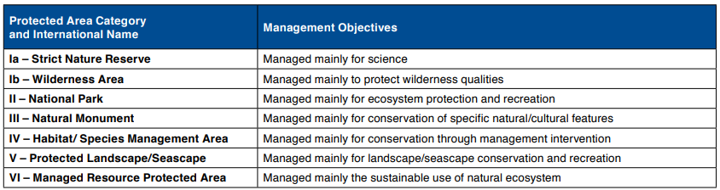

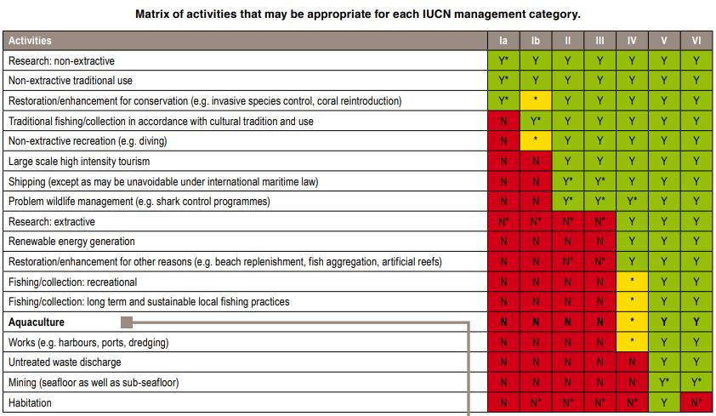

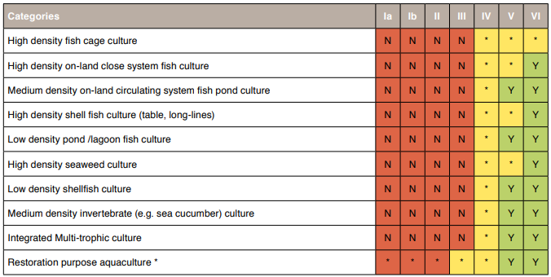Key: N = No; N* = Generally no, unless under special circumstances; Y = Yes; Y* = Yes because no alternative exists; * = Possible if the activity can be managed so that it is compatible with protected site objectives.

**Table 2: Sensitivity of specific habitat features in English MPAs (e.g. Poole Harbour EMS) to pressures from bottom shellfish aquaculture, demersal trawling and maintenance dredging**

’Genetic modification and translocation of indigenous species’ and the ‘Introduction of microbial pathogens’ are peculiar to aquaculture and therefore these were not comparable across marine activities.

***5.2.4) Refining compatibility assessments for mariculture and MPAs***

Additional steps necessary for refining compatibility assessments for mariculture and MPAs include: establishing local baselines in feature condition; predicting the effects of proposed mariculture species and technologies through extrapolations from other comparable areas; accounting for the location and spatial scale of proposed operations; understanding interactions between mariculture and other competing marine pressures and uses (alongside the conservation of protected features) (Le Gouvello et al., 2017; IUCN, 2020). In offshore areas there is additional scope to optimise conditions for mitigating aquaculture impact based on guidelines for minimum water depth (twice the depth of mariculture infrastructure) and minimum water flow rates (>0.05 m/s) (Belle and Nash, 2008; Froehlich et al., 2017).

There is considerable uncertainty relating to the condition (favourable or non-favourable) and extent of some MPA features in England and the rest of the UK, which confounds the assessment of potential impacts on MPAs from marine activities. This is particularly the case for sedimentary habitats, which represent the areas of highest fishing activity in England and the rest of the UK (JNCC, 2020) and, based on generic sensitivity matrices, have greatest potential for mariculture development. UK Government has committed to an ambitious programme of condition monitoring for all designated sites.

Where sites lack condition assessments, an alternative approach will be to use feature × activity ‘vulnerability assessments’ (outlined above), but these don’t account for background factors, such as storm events. Vulnerability assessments began with the designation of Marine Conservation Zones (under the UK Marine and Coastal Access Act) in Tranche 1 in 2016. Inshore Fisheries Conservation Authorities (IFCAs) have completed 74 assessments of feature/activity interactions (focusing mainly on fishing activities) while a further 186 are currently in progress or at quality assurance stage. In future, a lower reliance will be placed on vulnerability assessments, as further monitoring surveys take place to inform understanding of the condition of the features within the network (DEFRA, 2018b).

Substantial work is also required to understand and quantify environmental interactions between mariculture developments and feature within MPAs, and to quantify uncertainty when extrapolating from one MPA to another (IUCN, 2020).

### ***5.2.5) Transformative policies and approaches for enabling sustainable mariculture development in and around MPAs***

There is a long history of sustainable management of mariculture in MPAs through the use of Regulating Orders and Several Orders and Byelaws administered by the IFCAs (Seafish, 2016). However, the development of new mariculture sites in and around MPAs is highly challenging due to the precautionary approach currently taken to protect all designated features from significant adverse effects.

Transformative policies and approaches for enabling sustainable mariculture development in and around MPAs will hinge on differentiating sites and constituent features based on their conservation importance and sensitivities to different forms of mariculture. This will allow for the sharing of space within compatible sites, sub-zones and/or peripheral buffer zones (i.e. Allocated Zones for Aquaculture ‘AZA’ and Allowable Zones of Effect ‘AZEs’), in which mariculture presents insignificant risks to the achievement of MPA conservation objectives (Sanchez-Jerez et al., 2016).

Publication of Defra’s (2012) ‘revised approach’ for the assessment and management of fishing activities in European Marine Sites represented a key milestone in policy development which is highly relevant to mariculture development (DEFRA, 2012). Rather than placinga blanket ban on fishing in MPAs, the revised approach focused on regulating activities most likely to impact on the most vulnerable sites and features, with reef features and bottom-towed gear being identified as priorities (JNCC, 2020). In areas where fishing activities are deemed to be compatible with MPAs according to DEFRA’s matrix of fishing gear types and European Marine Site protected features (**Appendix 2**), an ‘ecosystem-based approach’ is advocated to ensure MPA conservation objectives are met without disproportionately impacting on fishing activity (Levin et al., 2018). This can be achieved using a both a ‘zonal’ approach and ‘adaptive risk management’ (**Table 3**), which adapts fisheries management based on ongoing monitoring and assessment in areas where the evidence of impacts is uncertain.

Adaptive risk management takes into account: conservation feature extent and distribution; feature condition and sensitivity to the specified activity; spatial distribution and intensity of the activity; evidence on other background pressures on conservation features; trends indicating whether features are progressing towards achieving their conservation objectives. The zonal approach is entirely consistent with whole-site ecosystem-based approach for preserving the integrity, structure and function of MPAs alongside mariculture developments (**Table 3**).

Despite the transformative potential of these policies and approaches, it is unlikely that the current levels/frequencies of feature condition monitoring undertaken by JNCC and Natural England will meet the necessary spatio-temporal monitoring resolution required for adaptive management or zonal management.

**Table 3: Complementary elements of adaptive risk management and zonal management relating to sustainable mariculture development in and around MPAs**

|  |  |
| --- | --- |
| **Adaptive risk management** | **Zonal management** |
| ***Relies on ability to monitor and detect change in order to inform adaptive measures*** | ***Relies on ability to identify MPA zones that are compatible with different forms of mariculture*** |
| Conduct monitoring, modelling and mapping of conservation feature extent and distribution | Account for the geographic coverage of habitat features within MPAs |
| Gather information/evidence on feature condition and sensitivity to different forms of mariculture | Where possible locate mariculture activity in large areas of continuous feature rather than smaller, fragmented areas |
| Gather information/evidence on activities - spatial distribution and intensity | Zoning should be designed in a transparent and inclusive manner engaging all stakeholders |
| Determine trends – whether features are progressing towards achieving their conservation objectives | Maintain long-term monitoring at key sites to evaluate positive and negative impacts on MPAs/ features |
| Gather information/evidence on other background pressures on conservation feature | Combining monitoring evidence with experiments such that decisions about changing measures through adaptation are not only made on a site by site basis. |

Adaptive and zonal management represent refinements to feature-based approaches for managing MPAs and activities within them (including mariculture). All approaches require ongoing monitoring to detect changes in habitat feature condition, and to determine whether or not changes are attributable to specific activities (or background factors e.g. climate change).

## **5.3) Case study**

### ***5.3.1) Mapping of existing mariculture sites in SW England***

Mapping of existing shellfish and seaweed mariculture sites in SW England has shown that over 70% of aquaculture sites are located within MPAs. Collectively these MPAs contain the full range of habitat features listed in Annex 1 of the Habitats Directive (**Table 4**). The majority (~90%) of sites located within MPAs were licenced prior to MPA designation. Apart from current concerns around Invasive Non-Indigenous Species (i.e. feral Pacific oysters, *Magallana gigas* populations in the Tamar and Yealm estuaries), mariculture operations in general in SW England have not been shown to impact negatively on MPA features. This is according to feature condition monitoring or site vulnerability assessments conducted by Natural England. Mariculture has been shown to be compatible with some designated habitat features. For example, Poole Harbour has supported a thriving shellfish mariculture industry, managed via a Several Order since 1915. Currently 24% of the Poole Habour MPA (Special Protection Area, SSSI, Ramsar Site) is leased for bottom-culture of shellfish (blue mussels, Pacific oysters, edible cockles and Manilla clams) – the development exists on sub-tidal mud, away from sensitive species and habitats such as seagrass beds (*Zostera marina*), peacock worms (*Sabella pavonina*) and internationally important populations of intertidal wading birds.

Despite the considerable precedent for the long-term sustainable operation of shellfish mariculture sites in MPAs, licencing of new aquaculture developments in these areas is impeded by rigid regulation founded on the precautionary principle (**Section 5.2.1**).

**Table 4: Proportion of SW Mariculture sites located within MPAs with habitat features (listed in Annex 1 of the Habitats Directive)**

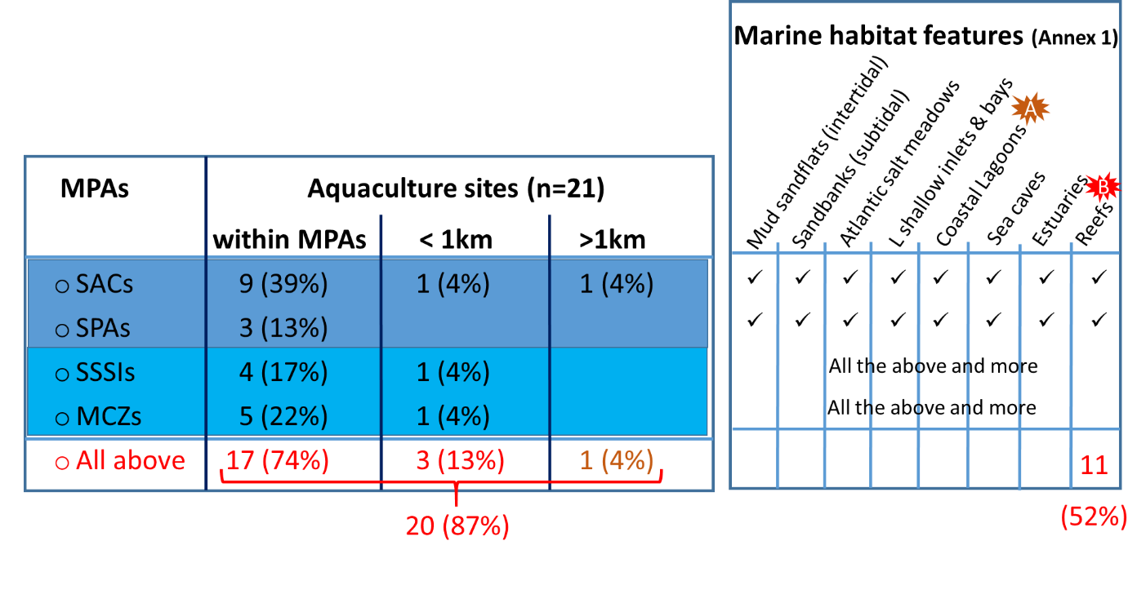

### ***5.3.2) Detailed mapping of areas suitable for mariculture development along the Dorset and East Devon coastline by CEFAS***

CEFAS undertook to identify and map areas best suited (and with least conflict) to specific types of sustainable marine aquaculture, within the boundaries of the Dorset and East Devon Fisheries Local Action Group (FLAG) area, extending from Beer Head to Poole Entrance, out to 6 nm limit from the coast. A comprehensive set of spatial data, from a number of different sources, was compiled for analysis, processing and mapping of aquaculture suitability extents within the area; these included a range of environmental suitability criteria taken from the Horizon 2020 ‘AquaSpace’ project (Boogert et al., 2018). Environmental variables underpinning aquaculture suitability (water depth, substrate, exposure to currents, water quality etc.) were classified in optimal, suboptimal and unsuitable ranges based on published literature. Mariculture potential was then determined for each culture species based on an appropriate culture method for the area. Where areas suitable for mariculture overlapped with other marine activities (anchorages, transport routes, leisure, communication, dredging, historical sites, sewage effluent discharges etc.), these were treated as exclusion zones, including buffer zones ranging from 0.5 to 2 km around the activity (depending on the scale of activity). Suitable areas were not excluded when they overlapped with fishing areas or MPAs; here it was assumed that developments would need to be assessed on a case by case basis. Stakeholder consultation workshops (additional to the original project scope) were undertaken to review draft maps of areas with potential for aquaculture within the FLAG district. Feedback from these has been incorporated into both final maps of aquaculture potential available on Dorset and East Devon Aquaculture site <https://www.dorsetaquaculture.co.uk/opportunities/new/map/>; the CEFAS data hub <http://data.cefas.co.uk/> and a final report (Kershaw et al., 2020).

This CEFAS report adds significantly more resolution to previous work to identify areas of aquaculture potential in English waters (Heal and Capuzzo, 2019) and addresses many of the recommendations made in a critical review of the initial MMO report (Franco et al., 2017). Whilst some work has begun on clarifying the compatibilities of mariculture and MPAs, there is an ongoing recommendation for further work to define compatibilities with different habitat feature types within MPAs (Kershaw et al., 2020).

As a minimum, the distribution of habitat features within the FLAG area and individual MPAs was defined using the JNCC UKSeaMap 2018 broad-scale vector layer. Habitats included Annex 1 habitats (intertidal substrate & foreshore (mud, sand, gravel, boulders, rock); mudflats; saltmarsh; maritime cliffs & slope; coastal vegetated shingle; coastal sand dunes). In some areas the location and extent of habitat features was captured to a higher resolution by multi-beam echo sounding, drop camera, diving and remote grabbing surveys e.g. in the Lyme Bay and Torbay SAC ID UK0030372‎ (31248 ha)‎ (Munro & Baldock, 2012; Wood, 2007) and the DORset Integrated Seabed study incorporating the Studland to Portland SAC ID UK0030382 (33191 ha) <https://www.dorsetwildlifetrust.org.uk/doris>.

Currently less than 0.3 % of the sea area in the East Devon and West Dorset FLAG area (to 6 nautical miles offshore) is used for aquaculture production. Notwithstanding other competing resource and planning constraints and within the resource limitations of the project, and on the basis of detailed research from best available information and modelling work reported on here; 68% of the total sea area within this FLAG sea area was found to have optimal aquaculture potential for one or more marine species and ~28% of suitable area occurs within MPAs (**Figure 2**). There remains a potential conflict between mariculture and fishing in most of the suitable areas identified.

**Figure 2: Map of MPAs, underlying habitats and areas suitable for mariculture development**

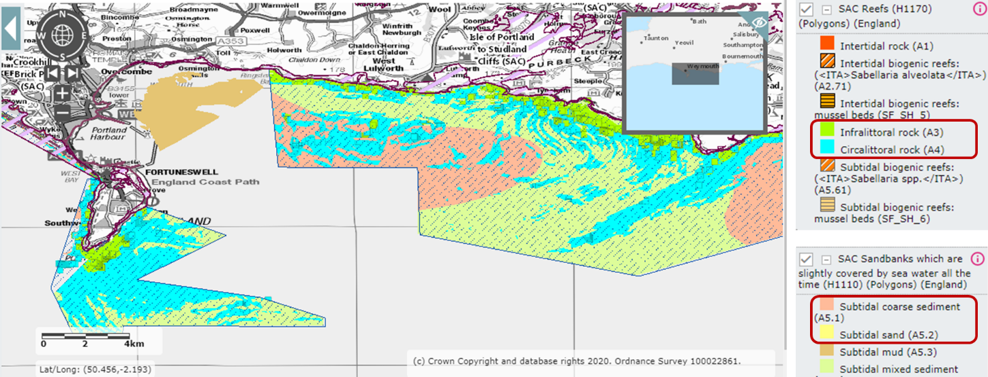

For the purpose of defining the importance of specific sensitive habitat features within MPAs to allow for the compatibility assessment and ‘zoning’ of different forms of mariculture, detailed mapping of conservation features and areas of mariculture potential around the Portland Reefs section of the Studland to Portland SAC (surrounding Portland Bill) (**Figure 3**) were compiled for presentation at the multi-stakeholder workshop (**Section 5.4**). Portland Reef is characterised by flat bedrock, limestone ledges, large boulders and cobbles, which extend underwater to >60m. This mosaic of reef habitats are exposed to extremely strong tides, currents and wave action, and support a diverse range of marine life, including Mussel (*Mytilus edulis*) beds and kelp (*Laminaria* and *Saccharina* forests (Cork et al., 2008), (Dewey et al., 2011), (Natural England, 2009).

In the FLAG mapping exercise, reef habitats were considered to be vulnerable marine ecosystems within the Natura 2000 sites (SACs or SPAs), which are restricted to towed demersal fishing gear according to Marine Spatial Planning guidelines <https://assets.publishing.service.gov.uk/government/uploads/system/uploads/attachment_data/file/841305/191023_MMO1172_Evaluation_of_MPA_Measures_publication.pdf>. Reef areas were excluded from areas defined for aquaculture potential, which instead focused on subtidal sand and gravel (which are not restricted to towed demersal fishing gear).

The concept of deploying mariculture methods, for example, farming of blue mussels, or kelp, in zones occupied by these habitat features within MPAs was discussed at the multi-stakeholder workshop. The need to define acceptable thresholds (benchmarks) for assessing the sensitivity of mariculture practices to reefs was highlighted. Comparative benchmarking could be taken from work undertaken on shellfish potting, which has been shown to have minimal impact on reefs in the Lyme Bay SAC (Rees et al., 2019).

**Figure 3: Mapping of habitat features and areas suitable for mariculture development around Portland Reef**

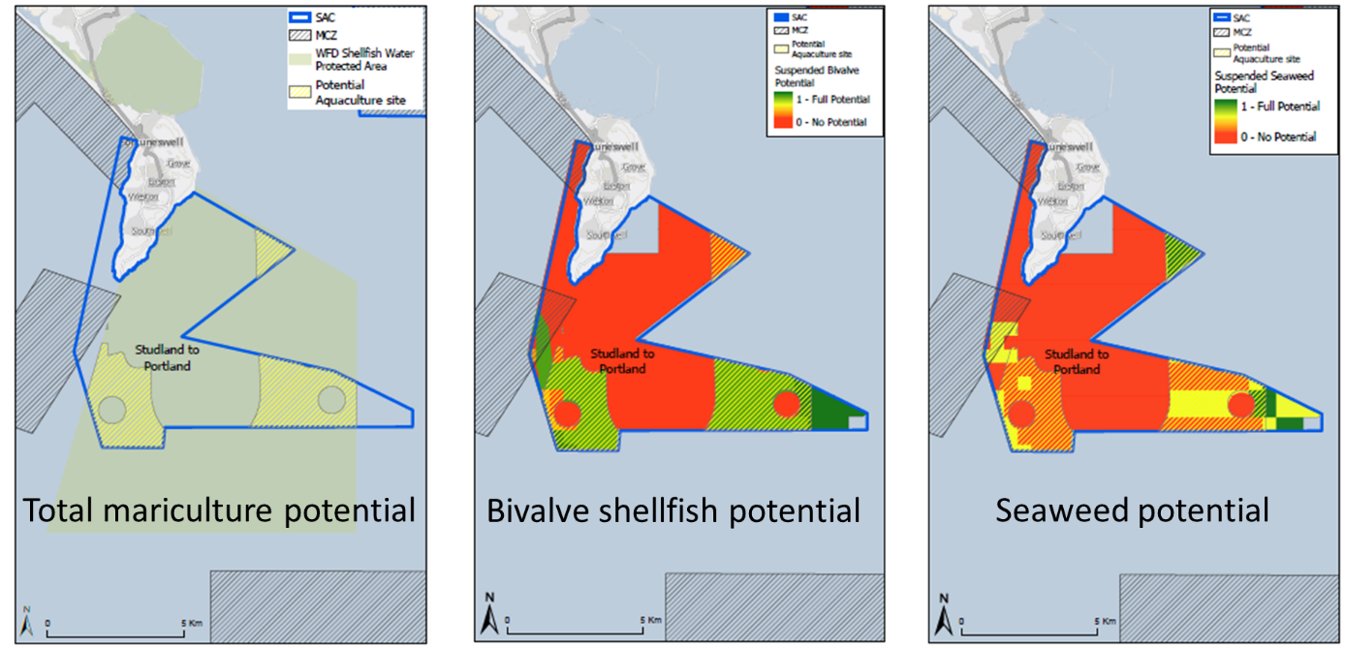

## **5.4) Multi-stakeholder workshop**

Stakeholder consultation during the workshop was based around four illustrative case studies. Case studies focused on SW England and were used to emphasise the evidence and planning issues that need to be addressed to allow for mariculture development across England. Key points are summarised below and reported in detail separately (Daniels et al., 2020).

### ***5.4.1) Case study 1: Seafood 2040 - The English Aquaculture Strategy***

Seafood 2040 provides a strategic framework for sustainable seafood production and consumption in England (SeaFish, 2017), which will be delivered in part through the English Aquaculture Strategy. This strategy will focus on establishing clear channels of communication between marine users (industry and domestic stakeholders) and regulators, in order to ensure that aquaculture development is environmentally and socially sustainable. Mariculture has the potential to restore and enhance marine environments if appropriately located, as well as contribute to local economies. Evidence to demonstrate this potential is required for novel and emerging aquaculture developments, and this may be provided by pilot projects and test beds, though the temporal and spatial scale of these projects and therefore their relevance may be limited. The ability to extrapolate from one area or test bed to another also needs to be considered.

A general conclusion from Case Study 1 was that regulation needs to be adapted to better facilitate mariculture development; a clearer, simpler regulatory process and more human resources are required to allow this to happen.

### ***5.4.2) Case study 2: Sustainable mariculture development - sharing sea space, avoiding conflict & protecting the environment***

The Inshore Fisheries and Conservation Authorities (IFCAs) are responsible for managing sustainable development of mariculture and fisheries within their given districts. The Devon and Severn district is a hive of marine activity, over 1000 permits are issued to commercial and recreational fishermen and there is a squeeze on additional fishing opportunities. New mariculture licences require a thorough assessment of potential conflict and the absence of this information can slow down regulatory processes. To combat this, the IFCA is developing a mariculture strategy that takes into account all influencing factors and evidence on existing space use within the Devon and Severn district. Central to the strategy is the incorporation of up-to-date spatial maps that can be used to highlight opportunities for sustainable development without increasing conflict with other users. These include a potential aquaculture park within Torbay, and other areas within North Devon where there is less fishing pressure.

There is an opportunity for aquaculture businesses to engage with members of the fishing industry early on in order to strengthen applications. Importantly, any developer should to try and engage with local fishers to evidence how they can benefit from the site rather than risk removing fishing opportunities. Remaining transparent and keeping an open mind on how the two industries can integrate is essential.

### ***5.4.3) Case study 3: Mariculture developments in and around MPAs in England***

There is an urgent need to reconcile sustainable development with nature conservation and – in the case of mariculture – understand the impacts and ecosystems services associated with novel and emerging approaches. In SW England over 70% of aquaculture sites are located within MPAs, with sites being zoned to ensure that sensitive habitat features are unaffected. For example, 24% of the Poole Harbour Special Area of Conservation is leased for bottom-aquaculture – the development exists on sub-tidal mud, where activities don’t interfere with wading birds, and they are away from sensitive species and habitats such as seagrass beds and peacock worms. The presence of sensitive marine habitat features can influence the decision to permit a new aquaculture development.

There is a need to understand impacts of mariculture on habitat features, to ascertain where positive and negative impacts may occur. Such data can be used to create a risk matrix with detailed mapping in order to identify areas that are compatible with mariculture development. With this in place, it will be possible to complete relatively rapid assessments of new developments and start developing general rules for initial screening of license applications in and around marine protected areas.

### ***5.4.4) Case study 4: Regulatory processes for aquaculture***

Mariculture licensing sits under Section 66 of the Marine and Coastal Access Act. The licensing process is managed by the Marine Management Organisation (MMO) and includes a number of stages, starting with initial scoping and consideration of impacts on fisheries and other uses of the area, to sensitive sites and archaeological remains. Fish and shellfish mariculture require Environmental Impact Assessment (EIA) screening, whereas the culture of algae is exempt, but licence applications can still be refused on environmental grounds. Applications up to 1 nautical mile from shore, must submit Water Framework Directive Assessment. Furthermore, a Habitats Regulations Assessment is required to assess potential impacts on all conservation features within European Marine Sites. The MMO are moving towards plan-led licensing, with remaining marine plans to be adopted by 2021.

The MMO’s ‘Explore Marine Plans’ tool (https://www.gov.uk/guidance/explore-marine-plans) can be used to locate strategic sites for sustainable aquaculture development in England’s coastal waters. The tool is being further developed to include a broader range of environmental constraints, such as water quality, nutrient load and primary productivity. However, additional spatial resolution and specificity are needed for optimising the use of marine space i.e. distinguishing areas that are suitable for different forms of aquaculture (Kershaw et al., 2020).

# **6) CONCLUSIONS**

* There is considerable potential to develop mariculture in England, as an environmentally sustainable form of food production, however this is restricted by the limited available marine space, particularly in territorial coastal waters, due to extensive MPAs, fishing areas, and other coastal users.
* Shellfish and seaweed mariculture, which utilise natural sources of plankton and nutrients, are compatible with some habitats/ conservation features within MPAs. Mariculture techniques for finfish currently adopted in the UK are less compatible with MPAs, due to the use and potential impact of fish feed and veterinary medicines.
* The majority (>70%) of mariculture (predominantly shellfish mariculture) sites in SW England are located within MPAs and have been shown over time (in some cases for over 100 yrs) to be:
  + Compatible with some habitat features e.g. mud, sand and gravel habitat (having negligible impact on their condition);
  + Sustainably and efficiently managed through a range of fisheries orders and byelaws.
* Habitat features which are considered less compatible with mariculture include reefs, which are classified as vulnerable marine ecosystems in Marine Spatial Plans. The use of towed demersal fishing gear is restricted around these features, but there is accumulating evidence of negligible impact from deployment of static gear, such as crab pots, which are more comparable to suspended mariculture systems.
* Current levels of feature condition monitoring (for assessing MPA status) are generally insufficient for traditional feature-based and alternative zonal ecosystem-based licensing and management of mariculture sites.
* Clearer specification of what constitutes a significant adverse effect on MPA feature condition is required, as well as more accurate tools for quantifying the contribution of mariculture developments towards any (cumulative) adverse effects.
* Licencing of new mariculture sites within MPAs is impeded by traditional precautionary feature-based conservation approaches.

**7) RECOMMENDATIONS**

Licencing of new mariculture sites should be based on zonal ecosystem-based approaches, as advocated in DEFRA’s 25 year plan.

To help identify Allocated Zones for Aquaculture in England’s intensely crowded coastal waters, including within MPAs The following tools need to refined and applied:

* Habitat feature-based sensitivity matrices for prospective assessment of the suitability of different types of marine aquaculture:
* Feature-specific risk assessment should be refined, building on Natural England’s (generic) risk matrices and environmental monitoring data from existing sites quantifying aquaculture × MPA feature interactions.
* General rules for the screening of proposed marine aquaculture developments should be established, based on learning gained from risk matrices and environmental monitoring data.
* Adaptive risk management of ongoing aquaculture developments (pilot studies) and operations:
  + Marine aquaculture developments and site operations in and around MPAs should be informed by evidence gathered from ongoing monitoring of habitat features in relation to planned and implemented aquaculture activities.
  + Comparing evidence from monitoring of aquaculture sites and reference sites (e.g. HRA sites) will help elucidate trends in feature condition and impacts from other (background) pressures.
* Tools quantifying ecosystem service benefits provided by different forms of marine aquaculture, including habitat provisioning, coastal protection, nutrient regulation, carbon sequestration.
* A transparent decision making framework (informed by the above tools) for regulators and prospective marine aquaculture licensees (see Daniels et al., 2020; SeaFish, 2020).

# **ACKNOWLEDGEMENTS**

The authors are very grateful to Roger Covey (Natural England) and Pia Bateman (Southern Inshore Fisheries Conservation Authority) for their expert opinion and guidance and for providing links to a range of conservation planning resources for MPAs and mariculture referenced in this document. We are also grateful to Research England for funding this work through their Strategic Priorities Fund.

# **REFERENCES**

Asche F, Smith MD (2018). Induced innovation in fisheries and aquaculture, Food Policy 76: 1–7.

Belle SM, Nash CE (2008). Better management practices for net-pen aquaculture, in Tucker CS, Hargreaves JA (eds). Environmental best management practices for aquaculture, pp 261–330, Wiley-Blackwell, Oxford, UK.

Boogert FJ, Cubillo AM, Nunes JP, Ferreira JG, Corner RA (2018). Online Environmental Feasibility Application (Deliverable 2.5) and Milestone MS15 Release of on-line Environmental Feasibility Application. URL: http://www.aquaspace-h2020.eu/wp-content/uploads/2018/09/Aquaspace-D2-5-WATER-v2Aug2018.pdf.

Brown AR, Lilley M, Shutler J, Lowe C, Artioli A, Torres R, Berdalet E, Tyler CR (2019). Assessing risks and mitigating impacts of harmful algal blooms on mariculture and marine fisheries. Reviews in Aquaculture 1–26 doi: 10.1111/raq.12403.

CBD, Convention on Biological Diversity (2010). The strategic plan for biodiversity 2011–2020 and the Aichi biodiversity targets. Document UNEP/CBD/COP/DEC/X/2. Nagoya, Japan: Secretariat of the Convention on Biological Diversity.

CEFAS, Centre for Fisheries and Aquaculture Science (2012). Fisheries in European Marine Sites: review of ‘the matrix’ and associated documentation submitted to the Stakeholder Implementation Group (IG). URL (accessed June 2020): <https://assets.publishing.service.gov.uk/government/uploads/system/uploads/attachment_data/file/310814/cefas_matrix_review.pdf>

Clements JC, Chopin T (2017). Ocean acidification and marine aquaculture in North America: potential impacts and mitigation strategies. Reviews in Aquaculture 9(4): 326-341.

Cork M, McNulty S, Gaches P (2008). Site Selection Report for the Inshore Marine SACs Project: Natural England.

Daniels C, Mynott S, Brown AR, Martin J, Ashton IG (2020). Supporting Mariculture Development - Evidence for Informed Regulation. Report for Research England, Strategic Priorities Fund to support Evidenced-Based Policy Making.

Day J, Dudley N, Hockings M, Holmes G, Laffoley D, Stolton S, Wells S (2012). Guidelines for applying the IUCN Protected Area Management Categories to Marine Protected Areas. Gland, Switzerland: IUCN. 36pp.

DEFRA (2012). Revised approach to the management of commercial fisheries in European marine sites in England: Project Implementation Plan. Defra. Available ONLINE http://webarchive.nationalarchives.gov.uk/20140305091040/http://www.marinemanagement.org.uk/protecting/conservation/documents/ems_fisheries/pip.pdf

DEFRA (2015). United Kingdom multiannual national plan for the development of sustainable aquaculture, October 2015. URL (accessed May 2020): <https://assets.publishing.service.gov.uk/government/uploads/system/uploads/attachment_data/file/480928/sustainable-aquaculture-manp-uk-2015.pdf>

DEFRA (2018a). HM Government: A Green Future: Our 25 Year Plan to Improve the Environment Annex 1: Supplementary Evidence Report 145. URL (accessed July 2020): <https://assets.publishing.service.gov.uk/government/uploads/system/uploads/attachment_data/file/673492/25-year-environment-plan-annex1.pdf>

DEFRA (2018b). Marine Protected Areas Network Report 2012 – 2018. Presented to Parliament pursuant to Section 124 of the Marine and Coastal Access Act 2009. https://assets.publishing.service.gov.uk/government/uploads/system/uploads/attachment_data/file/765418/mcaa-mpa-report-2012-2018a.pdf

DEFRA (2019). HM Government: A Green Future: Our 25 Year Plan to Improve the Environment Department for the Environment Food and Rural Affairs, London https://www.gov.uk/government/publications/25-year-environment-plan

Dewey S, Axelsson M, Plastow L (2011). DORset Integrated Seabed Survey (DORIS) Identifying Dorset's Marine Conservation Features, Drop Down camera ground truthing survey report: Sea Star Survey.

EEA European Environment Agency (2107) Aquaculture production - Indicator Assessment ID: IND-25-en (CSI 033 , MAR 008). Published 07 Jun 2018. URL (accessed 6/8/2017): <https://www.eea.europa.eu/data-and-maps/indicators/aquaculture-production-4/assessment>

EC, European Commission (2012). Guidance document on aquaculture activities in the context of the Natura 2000 network. URL (accessed July 2020): <https://ec.europa.eu/fisheries/sites/fisheries/files/docs/body/guidance-aquaculture-natura2000.pdf>

FAO, Food and Agriculture Organisation (2009). Marine Protected Areas as a Tool for Fisheries Management. About MPAs. FI Project Websites. In: FAO Fisheries and Aquaculture Department [online]. Rome. Updated 1 July 2009. URL (accessed June 2020): <http://www.fao.org/fishery/topic/4400/en>

FAO, Food and Agriculture Organisation (2020). The State of the World Fisheries and Aquaculture 2012. FAO Fisheries and Aquaculture Department. FAO. URL (accessed June 2020): <http://www.fao.org/3/ca9229en/ca9229en.pdf>

Franco SC (2017). Developing the MMO model for mapping aquaculture potential. Analysis of model MMO 1040 and recommendations for improvement. Valuing Nature Placement. Deliverable 1. https://www.seafish.org/media/1758345/acig_april2018_aquaassessment_marineplanning.pdf.

Froehlich HE, Smith A, Gentry RR, Halpern BS (2017) Offshore Aquaculture: I Know It When I See It. Frontiers in Marine Science 4:154. doi: 10.3389/fmars.2017.00154

Gentry RR, Froehlich HE, Grimm D, Kareiva P, Parke M, Rust M (2017) Mapping the global potential for marine aquaculture. Nature Ecology and Evolution 1: 1317-1324.

Hall K, Paramour OAL, Robinson LA, Winrow-Giffin A, Frid CLJ, Eno NC, Dernie KM, Sharp RAM, Wyn GC, Ramsay K (2008). Mapping the sensitivity of benthic habitats to fishing in Welsh waters - development of a protocol CCW (Policy Research) Report No: 8/12. Bangor, Countryside Council for Wales (CCW). pp. 85.

Heal R, Capuzzo E (2019). Identification of Areas of Aquaculture Potential in English Waters, MMO Project No: 1184, May 2019, 109 pp.

Humphreys J, Clark RWE (2020). A critical history of marine protected areas. In Eds Humphreys J and Clarke RWE, Marine Protected Areas - Science, Policy and Management 2020, Pages 1-12, Publ. Elsevier, London.

IUCN, International Union for the Conservation of Nature (2020). Aquaculture and Marine Protected Areas: Exploring Potential Opportunities and Synergies. URL (accessed July 2020): <https://www.iucn.org/sites/dev/files/content/documents/aquaculture_and_marine_protected_areas.pdf>

JNCC, Joint Nature Conservation Committee (2019). UK Marine Protected Area network statistics. URL (accessed July 2020): <https://jncc.gov.uk/our-work/uk-marine-protected-area-network-statistics/>

JNCC, Joint Nature Conservation Committee (2020). MPA Fisheries Management Toolkit. URL (accessed May 2020): <http://data.jncc.gov.uk/data/da4ae34c-d0f3-41df-b4fd-79df0a079647/MPA-Fisheries-Management-Toolkit-FINAL.pdf>

Kapetsky JM, Aguilar-Manjarrez J, Jenness J (2013). A global assessment of potential for offshore mariculture development from a spatial perspective. FAO Fisheries and Aquaculture Technical Paper. No. 549. Rome, FAO. 181 pp.

Kershaw, S., Beraud, C., Heal, R., Posen, P., Tew, I. and Jeffery, K. (2020). Mapping of Areas of Potential Aquaculture within the Dorset and East Devon Fisheries Local Action Group (FLAG) area. Cefas Contract C7731, European Maritime and Fisheries Fund (EMFF) grant number ENG3016, pp. 1-187.

Le Gouvello R, Hochart L-E, Laffoley D, Simard F, Andrade C, Angel D, Callier M, De Monbrison D, Fezzardi D, Haroun R, Harris A, Hughes A, Massa F, Roque E, Soto D, Stead S, Marino G (2017). Aquaculture and marine protected areas: Potential opportunities and synergies. Aquatic Conservation: Mar Freshw Ecosyst. 27(S1):138–150.

Levin PS, Essington TE, Marshall KN, Koehn LE, Anderson LG, Bundy A, Carothers C, Coleman F, Gerber LR, Grabowski JH, Houde E, Jensen OP, Möllmann C, RoseK, Sanchirico JN, Smith ADM (2018). Building effective fishery ecosystem plans. Mar. Pol., 92: 48-57.

MSFD (2008). http://ec.europa.eu/environment/marine/eu-coast-and-marine-policy/marine-strategy-frameworkdirective/index_en.htm

MMO, Marine Management Organisation (2018). UK Sea Fisheries Statistics 2017. URL (accessed June 2020): <https://assets.publishing.service.gov.uk/government/uploads/system/uploads/attachment_data/file/742793/UK_Sea_Fisheries_Statistics_2017.pdf>

Möckel (2017). The assessment of significant effects on the integrity of “Natura 2000” sites under Article 6(2) and 6(3) of the Habitats Directive. Nature Conservation 23: 57-85.

Muir J (1992). Water management for aquaculture and fisheries; irrigation, irritation or integration? In Priorities for Water Resources Allocation and Management pp 127-148, Publ. Overseas Development Administration, ISBN: 090 2500 49X.

Munro, C. D., and Baldock, B. M. (2012). Lyme Bay Closed Area - Measuring Recovery of Benthic Species in cobble reef habitats – analysis of data collected by SCUBA divers September 2008, August 2009 and July 2010. A Marine Bio-images report, February 2012, Marine Bio-images, Exeter, Devon, UK, pp 38. URL (accessed June 2020): <https://www.lymebayreserve.co.uk/download-centre/files/Lyme_Bay_Closed_Area_Monitoring_2008-2010_MBI.pdf>.

Natural England (2009). Inshore special area of conservation (SAC) Poole Bay to Lyme Bay pSAC Selection Assessment Natural England.

Rees A, Sheehan EV, Attrill MJ (2018). The Lyme Bay experimental potting study: A collaborative programme to assess the ecological effects of increasing potting density in the Lyme Bay Marine Protected Area. A report to the Blue Marine Foundation and Defra, by the Marine Institute at the University of Plymouth.

Rees SE, Sheehan EV, Stewart BD, Clark R, Appleby T, Attrill MJ, Jonese PJS, Johnson D Bradshaw N, Pittman S, Oates J, Solandt J-L (2020). Emerging themes to support ambitious UK marine biodiversity conservation. Marine Policy 117, 103864.

Rodmell DP, Caveen AJ, Johnson ML (2020). Uneasy bedfellows: Fisheries and the search for space for Marine Conservation Zones in English waters. In Eds Humphreys J and Clarke RWE, Marine Protected Areas - Science, Policy and Management 2020, Pages 92-112, Publ. Elsevier, London.

Ross LG, Telfer TC, Falconer L, Soto D, Aguilar-Manjarrez JA (2013). Site selection and carrying capacities for inland and coastal aquaculture. FAO Fish Aquacult Proc No. 21. FAO, Rome.

Sanchez‐Jerez, P., Karakassis, I., Massa, F., Fezzardi, D., Aguilar‐Manjarrez, J., Soto, D., … Dempster, T. (2016). Aquacultures struggle for space: The need for coastal spatial planning and the potential benefits of allocated zones for aquaculture (AZAs) to avoid conflict and promote sustainability. Aquaculture Environment Interactions, 8: 41–54.

SeaFish (2016). SR695 UK Shellfish Production and Several, Regulating and Hybrid Orders: The Contribution and Value of Orders in Relation to the Sector’s Past Development and Future Growth. URL (accessed May 2020): <https://www.seafish.org/media/publications/FINAL_SRO_REPORT_-_AUGUST_2016_FINAL.pdf>

SeaFish (2017). Sea Food 2040 – A strategic framework for England. URL (accessed May 2020): <https://seafish.org/media/Seafood%202040%20strategic%20framework.pdf>

Solandt J-L, Mullier T, Elliott S, Sheehan E (2020). Managing marine protected areas in Europe: Moving from ‘feature-based’ to ‘whole-site’ management of sites. In Eds Humphreys J and Clarke RWE, Marine Protected Areas - Science, Policy and Management 2020, Pages 157-181, Publ. Elsevier, London.

Southern IFCA, Inshore Fisheries Conservation Authority (2020). Southern Inshore Fisheries and Conservation Authority Poole Harbour Several Order 2015 Management Plan (2020 revision).

Tillin, H.M., Hull, S.C. & Tyler-Walters, H., 2010. Development of a sensitivity matrix (pressures-MCZ/MPA features). Report to the Department of the Environment, Food and Rural Affairs from ABPmer, Southampton and the Marine Life Information Network (MarLIN) Plymouth: Marine Biological Association of the UK., Defra Contract no. MB0102 Task 3A, Report no. 22., London, 145 pp. <http://randd.defra.gov.uk/Default.aspx?Menu=Menu&Module=More&Location=None&Completed=0&ProjectID=16368>

Tillin, H. & Tyler-Walters, H., 2014. Assessing the sensitivity of subtidal sedimentary habitats to pressures associated with marine activities. Phase 2 Report – Literature review and sensitivity assessments for ecological groups for circalittoral and offshore Level 5 biotopes. JNCC Report No. 512B, 260 pp.

Tyler-Walters H, Tillin HM, d’Avack EAS, Perry F, Stamp T (2018). Marine Evidence-based Sensitivity Assessment (MarESA) – A Guide. Marine Life Information Network (MarLIN). Marine Biological Association of the UK, Plymouth, pp. 91. Available from <https://www.marlin.ac.uk/publications>

UK Government Office for Science (2017). Future of the Sea: Trends in Aquaculture. UK Foresight, Government Office for Science. URL (accessed July 2020): <https://assets.publishing.service.gov.uk/government/uploads/system/uploads/attachment_data/file/635209/Future_of_the_sea_-_trends_in_aquaculture_FINAL_NEW.pdf>

Villasante S, Rodríguez-González D, Antelo A, Rivero-Rodríguez S, Lebrancón-Nieto J (2013). Why are prices in wild catch and aquaculture industries so different? Ambio 42 (8): 937–950.

Ware S, Downie A-L (2020). Challenges of habitat mapping to inform marine protected area (MPA) designation and monitoring: An operational perspective. Marine Policy 111: 103717. https://doi.org/10.1016/j.marpol.2019.103717

Westbrook S (2017). The value of aquaculture to Scotland. June 2017 A Report for Highlands and Islands Enterprise and Marine Scotland. URL (accessed July 2020): http://www.hie.co.uk/ regional-information/ economic-reports-and-research/archive/value-of-aquaculture-2017.html

Wood, C. (2007). Seasearch surveys in Lyme Bay, June 2007, A Report to Natural England, 26 pp. URL (accessed June 2020): <https://www.google.co.uk/url?sa=t&rct=j&q=&esrc=s&source=web&cd=1&ved=2ahUKEwjc_r7L4o_mAhVGTcAKHSQsCZcQFjAAegQIBBAC&url=http%3A%2F%2Fpublications>.

**APPENDIX 1: Consultation with CEFAS, Natural England and IFCA on 20 February 2020**

**Developing ‘generic rules’ and targeted advice to facilitate marine aquaculture (mariculture) development around MPAs in SW England**

**Project scoping/planning meeting** with Roger Covey (Natural England), Keith Jeffery (CEFAS), Charles Tyler and Ross Brown (University of Exeter/ SAF).

**Outline**

This is a 2 month pilot/seed corn project proposal, recently submitted to Research England’s Strategic Priorities Fund. The intention is that it will provide a proof of concept (based around the Dorset and East Devon Fisheries Local Action Group (FLAG) area, mapped by CEFAS (2020) that could lead to larger scale project(s) funded via the Seafood Innovation Fund (SIF) and/or Maritime and Fisheries Fund (MFF).

**Project elements**

***1) Initial consultation with policy partners*** – consult with stakeholders up front to collate all relevant info, risk assessment/sensitivity/suitability matrices and mapping tools which can be used as a basis for facilitating aquaculture development around MPAs.

**Action** - All to add names of key stakeholder to Appended list. Invite all stakeholders to a workshop during the project – timing to be agreed.

* + Risk assessment matrix should be based on the Marine Evidence based Sensitivity Assessment (MarESA) <https://www.marlin.ac.uk/sensitivity/sensitivity_rationale> CEFAS contact for environmental suitability matrices – Richard Heal.
  + Mapping will be based on the high res’ mapping of Dorset and East Devon FLAG area, incl. additional detail on the location of key conservation features within MPA habitats. CEFAS contact for mapping – Paulette Posen.

**Action** - Keith to forward mapping report, once approved by Sara Cattahan and Ruth Allin.

***2) Compile a generic matrix indicating the sensitivity to aquaculture for habitats and designated conservation features within MPAs in the FLAG area***

* + Initial (generic) assessment of habitats and designated (sub)features will be made using Marine Evidence based Sensitivity Assessment (MarESA). <https://www.marlin.ac.uk/sensitivity/sensitivity_rationale>
  + The assessment will incorporate:
    - CEFAS’s matrix assessment of the feasibility of aquaculture operations based on environmental conditions (e.g. substrate and bathymetry) across the FLAG area
    - Natural England’s ‘Advice on Operations System’, which includes advice on the sensitivity of designated site features and sub-features to Seaweed, Shellfish and Finfish aquaculture operations. https://designatedsites.naturalengland.org.uk/
    - MMO’s Matrix of fisheries gear types and European marine site protected features. [https://www.gov.uk/government/publications/fisheries-in-european-marine-sites-matrix](https://eur03.safelinks.protection.outlook.com/?url=https%3A%2F%2Fwww.gov.uk%2Fgovernment%2Fpublications%2Ffisheries-in-european-marine-sites-matrix&data=02%7C01%7CRoss.Brown%40exeter.ac.uk%7C8375c422678941fba18908d7b60b8d52%7C912a5d77fb984eeeaf321334d8f04a53%7C0%7C0%7C637178033036413887&sdata=iypTxmghp8ABZGAFQLskr5WKbGjAEYaI8fqM4rU4qOk%3D&reserved=0)
    - Development and application of risk assessment methodologies incl. Retrospective Habitat Risk Assessments and zoning e.g. the Williamsburg Resolution relating to aquaculture and fish movements. <http://www.nasco.int/pdf/far_aquaculture/AquacultureFAR_EnglandWales.pdf>
  + The assessment will also identify where there is insufficient evidence to assess sensitivity for specific conservation (sub)features and aquaculture operations.

***3) Search for missing evidence relating to mariculture-MPA interactions in the FLAG area***

* + Undertake a targeted literature search for evidence following MarESA guidelines (Tyler-Walters, 2018). These sensitivity assessments are generic and NOT site-specific. They are based on the likely effects of a pressure on a ‘hypothetical’ population in the middle of its ‘environmental range’ taking into account the magnitude and duration of the pressure in relation to pressure benchmark levels.
  + Begin to quantify positive/synergistic (as well as negative) interactions of aquaculture operations and habitats and (sub)features.

***4) Undertake site-specific assessments of the sensitivity of selected MPAs and (sub)features to possible (technically feasible) aquaculture operations in the FLAG area***

* + Cover a range of MPAs and (sub)features – varying in complexity from single to multiple habitats and species of conservation concern.
  + Take into account spatial extent and continuity of MPAs and (sub)features – using detailed mapping of MPAs and (sub)features (from CEFAS mapping of the FLAG area).
  + Take into account spatial scales (and temporal scales including recoverability) of interactions with aquaculture systems.

***5)*** ***Establish generic rules/ targeted advice for types and extent of mariculture development around MPAs***

* + Extend Natural England’s ‘Advice on Operations System’ for aquaculture.
  + Include advice/rules on permissible overlapping zones versus non-overlapping buffer zones.

***6) Hold workshop to analyse results with partners and selected stakeholders, including DEFRA***

***7) Produce a policy brief (publish as a short communication)***

**APPENDIX 2: Matrix of fishing gear types and European Marine Site protected features**

**See Fisheries in EMS Matrix:**

<https://www.gov.uk/government/publications/fisheries-in-european-marine-sites-matrix>

Under DEFRA’s revised approach prioritisation of fisheries management in European Marine Sites 12 within nautical miles of the coast will be achieved by the use of a ‘Matrix of fisheries gear types and European marine site protected features’ in which the vulnerability of habitats/features (e.g. Intertidal and subtidal chalk reef) is assessed for different fishing activities.

MATRIX CATEGORIES:

RED - conservation objectives will not be achieved because of sensitivity to a type of fishing irrespective of feature condition, level of pressure, or background environmental conditions

AMBER - doubt as to whether conservation objectives for a feature will be achieved because of its sensitivity to a type of fishing, in all sites where that feature occurs – site-specific assessment and appropriate management required.

GREEN - achievement of the conservation objectives for a feature is highly unlikely be affected by a type of fishing activity, in all sites where that feature occurs, further action is not likely to be required, unless there is the potential for in combination effects.

BLUE - For gear types where there can be no feasible interaction between the gear types and habitat features, a fourth categorisation of blue is used, and no management action should be necessary.