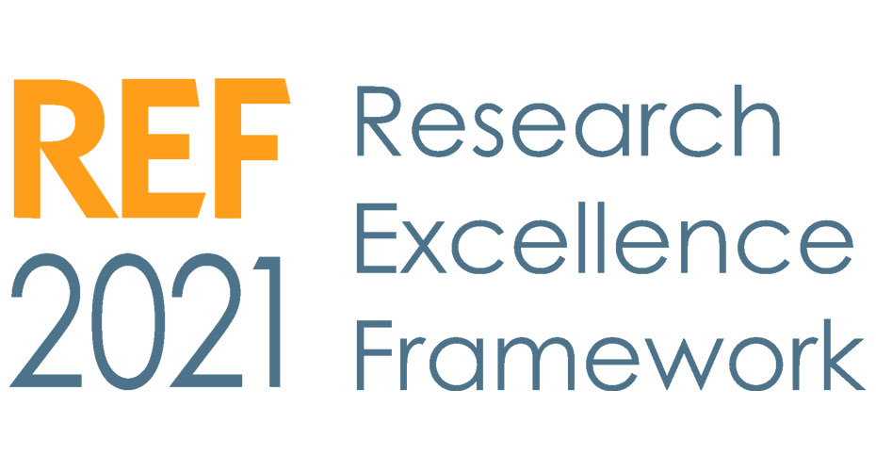
YOUR SIMPLE GUIDE TO REF

What is REF and why does it matter?
How is the REF carried out?
How are REF submissions assessed?
What has changed since REF 2014?
I’m a decision-maker – what do I have to do?
I’m a researcher – what do I have to do?
REF 2021 Results
REF Timeline
More information and further contacts

What is the REF and why does it matter?
The Research Excellence Framework (REF) is a national assessment of the research taking place across UK universities. REF takes place every six years.

The framework is used by the four UK higher education funding bodies (Research England, the Scottish Funding Council, the Higher Education Funding Council for Wales, and the Department for the Economy, Northern Ireland) to assess the quality of research and to inform the distribution of research funding - around £2 billion per year, to UK universities. This funding is known as Mainstream Quality-Related (QR) funding.

In addition to funding allocation, the REF also provides accountability for public investment, so that the benefits of the research being undertaken can be demonstrated, and is significant in benchmarking information that will affect our research reputation.

Over 20% of the University’s research income is from QR funding. As a result of our performance in REF 2014, Exeter received 2.3% of the total REF QR funding.

How is the REF carried out?
The REF looks at three areas of assessment, which together reflect the key characteristics of research excellence:

- Quality of research outputs (accounting for 60% of the assessment)
- Impact of research – its effect on, change, or benefit to the economy, society, policy, culture and quality of life (accounting for 25% of the assessment)
- Research environment – an institution’s research strategy, research facilities, opportunities for collaboration and environment, including research income and research degrees awarded (accounting for 15% of the assessment)

Each University is required to make an institutional submission to REF which is broken down into 34 disciplinary units, known as Units of Assessment (UoAs). These submissions are assessed by an expert panel of academics and industry experts in each UoA. There are four main panels to reflect the following subject areas:

- Main Panel A: Medicine, health and life sciences
- Main Panel B: Physical sciences, engineering and mathematics
- Main panel C: Social sciences
- Main Panel D: Arts and humanities

These panels are appointed by the four UK founding bodies, and oversee the assessment, ensuring that the assessment criteria and standards are consistently applied. These panels supported by the Equality and Diversity Advisory Panel (EDAP) and the Interdisciplinary Research Advisory Panel (IDAP).

How are REF submissions assessed?
The research excellence of each university’s REF submission, is assessed through a process of peer review which is carried out by the expert. The quality of each output (those that make up the institutional submission from the University) is graded as follows:

4* | Quality that is world-leading in terms of originality, significance and rigour.
3* | Quality that is internationally excellent in terms of originality, significance and rigour but which falls short of the highest standards of excellence.
2* | Quality that is recognised internationally in terms of originality, significance and rigour.
1* | Quality that is recognised nationally in terms of originality, significance and rigour.
Unclassified | Quality that falls below the standard of nationally recognised work. Or work which does not meet the published definition of research for the purposes of this assessment.

What has changed since REF 2014?
A major review of REF took place in 2015 and this resulted in a number of changes for REF 2021. The most significant changes include:
- REF2021 will not be a selective exercise - we are now required to include all staff who have a significant responsibility for research
- We are required to submit a pool of outputs produced during the REF period, rather than (normally) four papers per person as in 2014. This will include one paper from every person in post on the census date (31/07/2020) but can also include outputs from staff who have left the University.
- There is a broader definition of impact to emphasise public engagement and to include impact on teaching
- The approach to individual circumstances is more complex.

I’m a decision-maker – what do I have to do?
- Ensure you understand the eligibility criteria on REF 2021 independent researcher status
- Be aware of important deadlines and key meeting dates
- Read the Exeter REF 2021 monthly update for decision makers
- Cascade understanding that eligibility against REF independent research criteria is not a judgement on an individual’s independence of though or ability to work independently.
- Be an advocate for REF 2021 and the University’s collaborative approach to it.

I’m a researcher – what do I have to do?
- Publish your best work
- Register for an ORCID number
- Gather supporting evidence for impact case studies (where applicable)
- Ensure your publications comply with the REF Open Access Policy
- Support your DoRs and DoIs
- Fill in the individual circumstances disclosure form

REF 2021 Results
Due to Coronavirus, key dates are still being finalised.

REF 2021 Key dates
We will have a clear timeline soon, once deadlines are finalised.

More information and further contacts
Contact the Exeter REF team – Exeter-REF-2021@Exeter.ac.uk
Exeter REF 2021 website – www.exeter.ac.uk/research/services/ref/ref2021/
What REF means to me – key questions for academics and researchers (Research England)
Latest information from Research England - www.ref.ac.uk/

