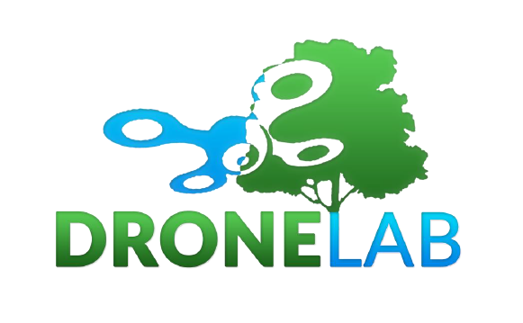

Enquiry form
Please complete this form and send it to DroneLab@exeter.ac.uk

Your name
Contact telephone number/s
Contact email address(es)

Name of project

Site name

Site latitude and longitude

Site elevation

Dominant land cover at the site

Please provide a brief synopsis of your project, site and data requirements below. Please try to explain what you want to do with the drone data – what are your intended project outcomes?

How large is the site and what is the terrain like?

Who owns the land and do you have permission to access the site? Please give as many details as possible regarding site access, permissions and whether you have ascertained if drone flights over the site would be deemed acceptable by the landowner.

Please indicate in the table below what data products you are interested in. Please note that higher spatial accuracy products require more field personnel and a longer processing time, and are thus more costly.

Aerial video  Quality required? | RGB – yes/no  Thermal infra-red – yes/no
Still aerial photographs  Spatial resolution required?  Overlap required? | RGB – yes/no  Thermal infra-red – yes/no  Near infra-red – yes/no
GIS-ready optical orthomosaic

Spatial resolution required?

Spatial accuracy required?

GIS-ready digital surface model (DSM) derived from structure-from-motion photogrammetry  Spatial resolution required? | RGB – yes/no  Near infra-red – yes/no  Point cloud required? – yes/no  Standard accuracy (2-10 m) – yes/no  Enhanced accuracy (2-10 cm) – yes/no  Independent validation? – yes/no

Please use google Earth to draw around your site and paste a screenshot of the area below. Alternatively, you can email us a shapefile or google KMZ file showing the location of your site/s. We need this information to perform our own checks on the site for conflicts with other air traffic and to identify operational issues prior to issuing a quotation.

Please indicate by ticking or highlighting from the below list what you want to receive when we deliver your data:

- Full package (raw data, field observations, data products and a full report written by the dronelab describing all aspects of data capture and processing)

If you do not want the ‘full package’ you can select individual elements from the below list:

- Raw data
- GIS-ready products
- Data processing report (from 3rd party software, e.g. photoscan report)
- Dronelab field and data processing report

If you would like to dicuss something that is not listed above, please provide details below and we can call you.

Thank you and we will be in touch soon!
The DroneLab team

