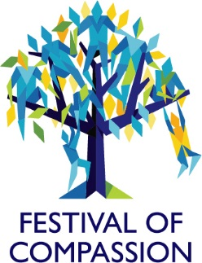

Festival of Compassion – Newsletter #2
This November - look out for talks, walks, discussions, poetry, yoga, mindfulness and so much more for all of us to engage with for free. Together we could help shape a compassionate future where doing something that makes others feel better is celebrated.
I am beyond thrilled to let you know that the program of the University of Exeter Festival of Compassion is now available online here!
The Festival of Compassion is a 10-day event from 19-28 November 2021, open to all, hosting activities online, on campus and in the city of Exeter where we will explore how we can promote and foster a community to be compassionate, to be sensitive to suffering in self and others and commit to try to alleviate and prevent it where we can.
To give you a flavour of the festival, let us take a whistle stop tour through some of the many amazing events.
Liz Lord from Mindfulness in Schools will discuss during an online talk what mindfulness is and isn’t, the research evidence around potential benefits and what it looks like in a school or university context.
A fireside conversation with Professor Beverly Daniel Tatum, a clinical psychologist, author and a sought-after speaker will address racial identity development and higher education leadership.
Daily cafés on campus will explore the different themes of the festival while the Compassionate Cafe in Exeter City will be a celebration of a multicultural community with music, food, book signing, games, conversations, knitting and even LEGO to build a better relationship with nature.
Compassion through poetry with a writing workshops by Sally Flint, campus poetry walks and a poetry reading by Chris Southgate at our Poetry Café.
A BIG DAY OUT! With over 20 speakers from Independent Thinking coming to Exeter this event promises to deliver an exhilarating collection of live and recorded keynotes and workshops for teachers and school leaders everywhere.
The Education Welfare team will go on tour with their Wellbeing Campervan and will be joining St Petrocs on the Penryn campus to talk to students about their ideas for how best to help others.
There is many more so keep checking our webpage for more amazing events as they get finalised. Did I already mention that all these events are free! Book your places now, as ticket numbers are limited.
For students who would like to gain valuable professional experience you can now apply for a student volunteer role to help run this event. For more information see here.
I am looking forward to continue our shared adventure from the heart to create something that will make a difference – will you join us?
Website: https://www.exeter.ac.uk/staff/festivalofcompassion/
Contact: festivalofcompassion@exeter.ac.uk
Maarten Koeners
Senior Lecturer, Project Lead

