Date: 28/02/2020
To: Michael Wykes, Fiona Kugele, Tim Quine, Jonathan Critchley, Ian Blenkharn, Nicola Sinclair
From:
Andrew Farquhar
Policy, Planning and Business Intelligence
Issue:
HESA publish their (PIs) annually in three tranches. This analysis deals with the second tranche of data, looking at non-continuation rates between 2017/18 and 2018/19. This is the most recent data which we can compare against the sector as it is based on the latest HESA return.
Tables T3a-c and T4 of this release are based on a revised methodology and UK Performance Indicators population including alternative providers. HESA have updated the data for academic entry years 2014/15 through 2017/18 to include the alternative providers. This briefing has therefor updated the data for those years, which has meant a change to the sector average scores. Table T5, which shows projected outcomes, is based on the previous method of calculating the UK Performance Indicators and does not include alternative providers. It should also be noted that HESA, as with the widening participation PIs, have moved to use POLAR 4. This briefing uses the updated POLAR 4 data for the 4 most recent years.
Please note that our OfS Access and Participation plan targets are monitored against OfS datasets. Although they use HESA data, the methodology used for compiling the data is slightly different to that used by HESA for the below PIs.
Background:
This file covers non-continuation and projected outcomes which were published by HESA on 27th February 2020. This second tranche of data measures non-continuation rates and projected outcomes. For non-continuation rates, a lower score is better, so we are aiming to score lower than the benchmark. The opposite is true for Table 5 which looks at projected outcomes.
Note: Tranche 1 of the HESA PIs measured performance against location adjusted benchmarks, however, Tranche 2 tables do not adjust benchmarks for location.

Headlines:

- Our overall non-continuation rate is 3.1%. This has increased from last year’s score of 2.6%. This score remains around 5% better than sector average and 1% better than Russell Group median. See table T3a below.

- The small increase seen at overall level is reflected in the young split, where the rate has worsened to 2.5% (from 2% last year). We remain below our benchmark, and both the sector average and Russell Group median. See table T3a below.

- Non-continuation rates have increased for mature students by 0.2% to 11.5%. We are also above the benchmark for the mature split (by 0.4%), and 2.3% worse that the Russell Group median. We are however better than the sector average of 13.6%. See table T3a below.

- Non-continuation for Young UK domiciled first degree students it’s higher for LPN students (3.8%) than those that are from a non-LPN area (2.4%). The gap between the two however has closed since last year, where it was 4.7% for LPN and 1.8% for non-LPN. See table T3b below.

- Non-continuation for mature students with a previous HE qualification has increased from 2.3% last year to 15.7% this year. It should however be noted that these percentages are based on very small figures. The non-continuation rate for mature students without a previous HE qualification is lower at 10.7%, and this has dropped from 12.9% last year. See table T3c below.

- The percentage of students who have resumed study after a year out has improved in the latest year of data, to 17.4% (from 13.6%). There is also improvement of 0.1% in the percentage not in HE for two years (1.6%). We are better than the sector average and Russell Group median in this measure. See table T4a below.

- Our projected learning outcomes data has worsened slightly, to 91.1% from 92.4% last year. This data projects the outcomes for each entry cohort of UK domiciled full-time students. See table T5 below.

- Distance from the benchmark was not statistically significant in any of these tables and despite some slight decreases in score, we perform better than benchmark for all tables where a benchmark is provided other than the mature splits.

- Many of the tables below refer to very small actual numbers of students, therefore, although the percentages may show a big change, this may only refer to a total population of <100 FTE and an increase/decrease of 5 or 10 students who did not continue their studies.

- Non-continuation is an area of strength for Exeter as our proportion is very low. We outperform the sector average and Russell Group median in all tables except mature splits.
Key considerations:

T3A: Non-continuation following year of entry: UK domiciled full-time first degree entrants 2014/15 to 2017/18

All students
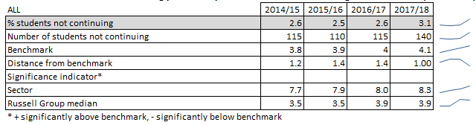
The percentage of entrants who did not continue studying following their year of entry was 3.1%, an increase on last year. The benchmark has increased slightly to 4.1%, so although our score remains better than benchmark the gap has closed.
Our proportion of students not continuing is 5.2% lower than the sector, showing we are one of the top performers in this metric. The inverse of this metric (i.e. Continuation rate) is used in the TEF and is consistently one of our best scoring metrics at institutional and subject level when looking at absolute score, although we do not score significantly above the benchmark, due to the very low benchmark. (In order to receive a significance flag, the z score must exceed 1.96 and the score itself must be >2% from benchmark. Since our benchmark is 4.1%, this would mean we require a non-continuation score <=2% which would be incredibly low.)
This is the most recent HESA data which we can compare against the sector, but it does have a time lag as it measures non-continuation between 2017/18 and 2018/19.
The data shows a worsening in our non-continuation rate, however more recent, internal data for 2018/19 (UG ASER report, see MI hub here), indicates that the non-continuation rate has improved slightly by 0.7%. Although these internal figures aren’t directly comparable with the HESA PI, (due to the inclusion of international students, and the way we treat transfers to other institutions), this does suggest we may see a small improvement in next year’s HESA PI performance.

% Young
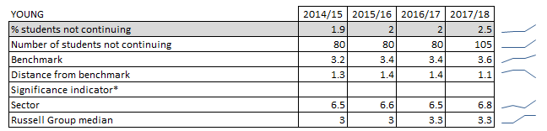
The percentage of young entrants who did not continue has slightly increased from 2% to 2.5%. We perform better than the benchmark, sector, and RG median although the gap to each has declined.

% Mature

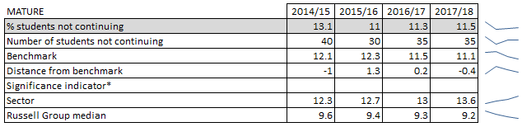
The percentage of mature students not continuing has increased slightly from last year, by 0.2% to 11.5%. For this split of the data we are performing worse than both our benchmark and the Russell Group median, though we are still performing better than the sector average. The mature percentage is consistently higher than that for young students, and this remains true in the latest data. However it should be noted that the population size is much smaller.

T3B: Non-continuation following year of entry: UK domiciled young full-time first degree entrants – comparison of LPN and non-LPN continuation rates 2015/16 to 2017/18

LPN
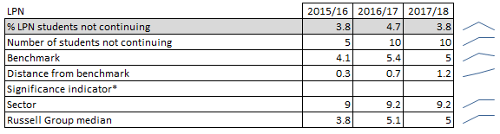
The move the use POLAR 4 by HESA means that there is only 3 years of comparable data available for this split of the data. However we can see an improvement of 0.9% for the percentage of LPN students not continuing, to 3.8% this year. This is better than our benchmark, the sector average and Russell Group median. It remains higher than the non-continuation rate for those not from an LPN area, though the gap has closed since last year.

Non-LPN
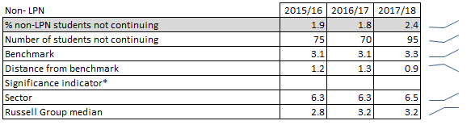
The percentage of students not continuing is lower for students who weren’t from LPN backgrounds than those who were. This effectively means that dropout rates are higher for LPN students than non-LPN, which is mirrored across the sector and Russell Group. Our score in this split has worsened by 0.6%, though it remains lower than benchmark, sector score and Russell Group median.

T3C: Non-continuation following year of entry: UK domiciled mature full-time first degree entrants 2014/15 to 2017/18

Mature with previous HE qualification
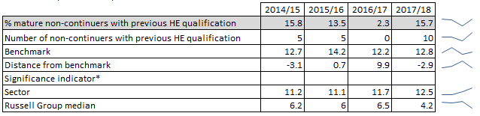
Although our score has worsened significantly compared to last year, and is now above the sector average and Russell Group median, it should be noted that this is based on a very small number of students (~10) so the percentage scores can fluctuate wildly between years.

Mature without previous HE qualification
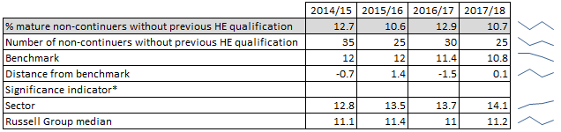
Our performance is better than our benchmark, the sector and RG median for mature students without a previous HE qualification, although percentages are still based on low student numbers (~25).
Note: No data available for Tables 3d or 3e

T4: Resumption of study in 2017/18, after year out of HE in 2016/17: UK domiciled full-time first degree entrants 2014/15 to 2016/17
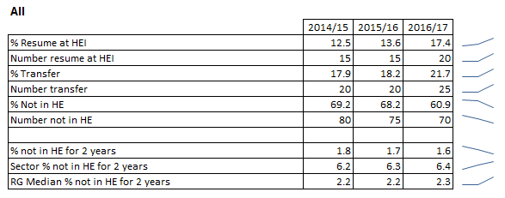
The percentage of students who resumed study at Exeter after a year out has increased for the second year of comparable data, although it is worth noting that numbers are very low (~15 to 20), so it may only be an increase of a maximum of 9 students. The proportion who transferred to another institution has increased to 21.7%, which means that the proportion not in HE has dropped by 7.3% to 60.9%.
Although benchmarks are not available for the top set of data in the above table, HESA do provide comparable data for the percentage of students in not in HE for 2 years after entry. We perform better than both the sector average and Russell Group median in this measure.
Note: No data is available for Table 4b.

T5: Projected outcomes: UK domiciled full-time students starting first degree courses 2016/17
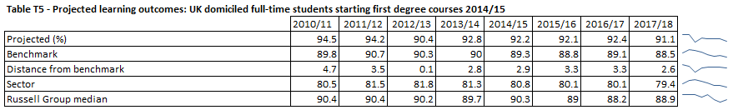
The percentage of students projected to complete their degree is 91.1% for 2017/18 entrants. This is a decrease of 1.3% versus last year, and the first time since 2012/13 that we have been below 92%. However we remain well above the sector average and Russell Group median.
Although this shows 8.9% of students are not projected to achieve their course aim, 3.4% of these are expected to transfer to another institution and 1.4% are expected to receive another (lower) award.
This data is used by both the Times Good University Guide and Complete University Guide in their institution level rankings, although they both include the transfer category in their positive score calculation. On the basis of the calculation used by the league table compilers our score has dropped from 95.8% to 94.6%.

Conclusion:
Performance has generally weakened versus previous years, though only by small percentage changes in most cases.
Performance remains better than benchmark in all tables except for mature student splits. Non-continuation remains an area of strong performance for Exeter as we outperform the sector and the Russell Group median in most indicators.
The weakening of the projected outcomes score will impact negatively on the next round of league tables using this metric (Times and Complete) to be published, though overall performance will rely on performance across a range of indicators included in the tables.
Internal estimates suggest that next year’s non-continuation rate improve slightly.

Next steps
HESA are releasing their PI data in 3 tranches:
- Tranche 1: WP indicators published in February 2020 (covered in earlier briefing)
- Tranche 2: Non-continuation indicators (covered in this briefing)
- Tranche 3: Employment indicators will be published in April or May 2020 (exact dates tbc). These indicators will be based on the new Graduate Outcomes survey, and therefore will not be directly comparable to previous years.
Data Source: HESA PI Publication 27th February 2020

