Student Communications toolkit
7 October 2022
Hi
This is your Student Comms toolkit for 7 October 2022. We send these around every two weeks, providing you with information and messages you can use in your channels to students.
Further down the email you’ll find useful messages for student-facing staff, which will help them to signpost information to students.
We’d love to hear your feedback as to how to improve this to make it more helpful for you, and/or if you have any further questions or stories to share, please contact studentcomms@exeter.ac.uk

MESSAGES FOR STUDENTS

- Are you registered with a local doctor?

Images
Alt text: medical building illustrated icon on dark green background

Alt text: medical building illustrated icon on white background

Newsletter article
DEVON version
While you’re at Uni, it’s really important that you register with the Student Health Centre or a NHS doctor's surgery near to where you live. That way you can get treatment if you have a health problem, need medication, or want to arrange to have vaccinations, such as the recommended Meningitis MenAWCY vaccine. You can still see your usual doctor, as a guest, when you go home for holidays.
Find out more about the Student Health Centre here.

CORNWALL version
While you’re at Uni, it’s really important that you register with a NHS doctor's surgery near to where you live. That way you can get treatment if you have a health problem, need medication, or want to arrange to have vaccinations, such as the recommended Meningitis MenAWCY vaccine. You can still see your usual doctor, as a guest, when you go home for holidays. Penryn Surgery offer consultations on Penryn Campus, and you can find details of local doctors here.

Facebook post Note different links for Devon and Cornwall
Don’t forget to register with a local NHS doctor while you’re at Uni. That way you can get treatment, medication or vaccinations, such as the recommended Meningitis MenAWCY vaccine, when you need them. You can still see your usual doctor, as a guest, when you go home for holidays.
Cornwall Visit @penryncampushealth or see details of local doctors at https://fxplus.ac.uk/student-support/support-wellbeing/health-and-doctors-surgeries/.
Devon See details of the Student Health Centre at https://www.exeterstudenthealthcentre.co.uk/

Instagram post Note different text options for Devon and Cornwall
Don’t forget to register with a local NHS doctor while you’re at Uni. That way you can get treatment, medication or vaccinations, such as the recommended Meningitis MenAWCY vaccine, when you need them. You can still see your usual doctor, as a guest, when you go home for holidays.
Cornwall text: Use the link in our bio details of Penryn Surgery and other local doctors
Link in bio : Cornwall https://fxplus.ac.uk/student-support/support-wellbeing/health-and-doctors-surgeries/.
Devon text: See details of the Student Health Centre at the link in our bio
Link in bio Devon https://www.exeterstudenthealthcentre.co.uk/
Instagram hashtags to be included as the first comment on the post
#Exeter #ExeterUni #ExeterUniversity #LoveExeter #ExeterForever #UofE #UniversityOfExeter
Plus for Cornwall #Cornwall #PenrynCampus as appropriate
Twitter post
Devon
Don’t forget to register with an NHS doctor near where you live while you’re at Uni so you can get treatment and medicine. You can register online for the Student Health Centre at www.exeterstudenthealthcentre.co.uk
Cornwall
Don’t forget to register with an NHS doctor near where you live while you’re at Uni so you can get treatment and medicine. See details of Penryn Surgery and other local doctors at
fxplus.ac.uk/student-support/support-wellbeing/health-and-doctors-surgeries

- Deadline for exam adjustments 7 November
Images
Alt text: Student at desk writing
Newsletter article
Cornwall version
Act now for accessibility adjustments for your exams
If you need adjustments for future exams, you’ll need to act now and contact the Accessibility team. Supporting evidence has to be completed before Monday 7 November and you’ll need time to arrange it.
Even if you previously had adjustments at school - they don’t carry over to Uni. Adjustments may have included:
- Extra time
- Using a laptop
- Taking your exam in a different room
- Having a scribe
If you think that might apply to you – or you’re not sure – get in touch with Accessibility as soon as possible.

Devon
Act now for accessibility adjustments for your exams
If you need adjustments for future exams, you’ll need to act now and get in touch with our team. Supporting evidence has to be completed before Monday 7 November and you’ll need time to arrange it.
Even if you previously had adjustments at school - they don’t carry over to Uni. Adjustments may have included:
- Extra time
- Using a laptop
- Taking your exam in a different room
- Having a scribe
If you think that might apply to you – or you’re not sure – get in touch with Wellbeing Services as soon as possible.

Facebook post Note different text options for Devon and Cornwall
Adjustments for exams – APPLY NOW!
If you had exam adjustments in place at school or college, these don’t automatically transfer to university. These adjustments may have included:
extra time
using a laptop
taking your exam in a different room
having a scribe
The deadline for arrangements for the next exams taking place (January 2023) is Monday 7 November and you need to have sent your supporting evidence to Accessibility before this date.
Cornwall: If you think this applies to you – or you’re not sure – please get in touch with the Accessibility team as soon as possible. Visit: https://studyhub.fxplus.ac.uk/accessibility-inclusion/ilps/exams-exeter
Devon: If you think this applies to you – or you’re not sure – please get in touch with Wellbeing Services as soon as possible. Visit: https://www.exeter.ac.uk/students/wellbeing/resources-and-services/exams-and-ilps/

Instagram post Note different links for Devon and Cornwall
Act now if you need adjustments for future exams. Supporting evidence has to be completed before Monday 7 November and you’ll need time to arrange it.
Even if you previously had adjustments at school - they don’t carry over to Uni. Adjustments may have included:

extra time
using a laptop
taking your exam in a different room
having a scribe
If you think that might apply to you – or you’re not sure – follow the link in our bio for to get in touch as soon as possible.

Links in bio:
Cornwall: https://studyhub.fxplus.ac.uk/accessibility-inclusion/ilps/exams-exeter
Devon: https://www.exeter.ac.uk/students/wellbeing/resources-and-services/exams-and-ilps/
Instagram hashtags to be included as the first comment on the post
#Exeter #ExeterUni #ExeterUniversity #LoveExeter #ExeterForever #UofE #UniversityOfExeter
Plus for Cornwall #Cornwall #PenrynCampus as appropriate

Twitter post Note different links for Devon and Cornwall
Need adjustments for your exams? Maybe you need to use a laptop, use a different room or have extra time? You’ll need your supporting evidence in place by 7 November, so get in touch now at
Cornwall: https://studyhub.fxplus.ac.uk/accessibility-inclusion/ilps/exams-exeter
Devon: https://www.exeter.ac.uk/students/wellbeing/resources-and-services/exams-and-ilps/

- iExeter app
Background note: This aims to encourage students to download the iExeter app, and make full use of its functions, for their convenience. If there are particular functions in the app that are particularly relevant to students in your dept, you could highlight them here too.
Images
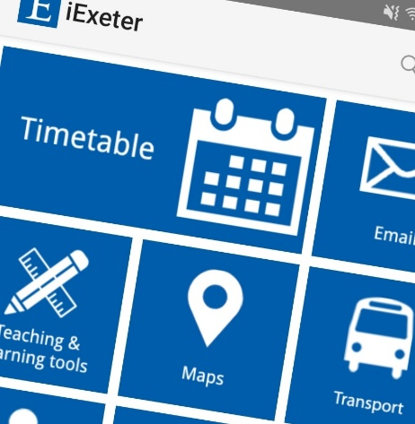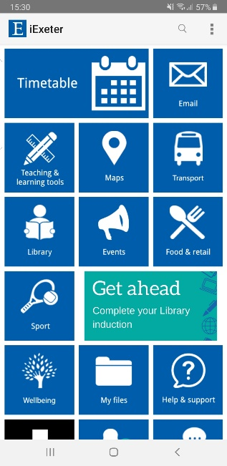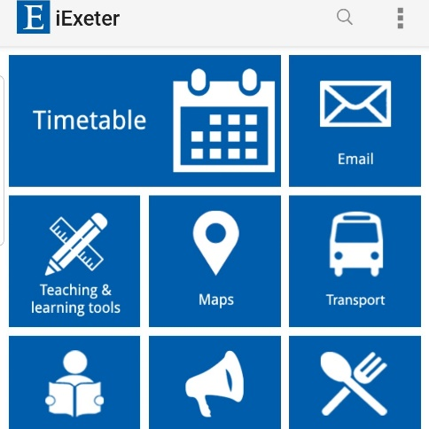
Alt text: iExeter on mobile phone screen

Newsletter copy
iExeter - Your Uni in an app
Note: delete as applicable; Students' Guild is for Devon / Students' Union is for Cornwall
Have you got iExeter on your phone or desktop? With so much more than just timetables, iExeter is your convenient, pocket-sized portal to your Uni in one handy app.
Simply sign in with your Uni login and you can,
- See your personal timetable
- Access your email, library and career zone accounts
- Book study space on campus
- Find the help, support and feedback channels available
- Access teaching and learning tools including ELE, Teams, BART submissions, absence reporting and past papers
- See what’s happening around campus with events, food, retail and transport information.
- See maps of all campuses, and get directions using GPS
- Check out your Students' Guild/Students' Union and loads more.
If you’re not already using iExeter, download it now, free from iTunes App Store or Google Play and find out more on the University website.
Twitter
Have you got iExeter on your phone or desktop? It’s your handy, pocket-sized portal to your Uni in an app. Sign in with your Uni login and get access to your timetable, Uni accounts and loads of study, sport and social info. Download it now at www.exeter.ac.uk/students/iexeter/
Facebook – DELETE Students’ Guild/Students’ Union as appropriate for each campus
Have you got iExeter on your phone or desktop? With so much more than just timetables, iExeter is your convenient, pocket-sized portal to your Uni in one handy app.
Simply sign in with your Uni login and you can,
- See your personal timetable, email, and other Uni accounts
- Book study space on campus and get access to teaching and learning tools
- See what’s happening around campus with events, food, retail, transport, sports and social info
- See maps of all campuses, and get directions using GPS
- Find the help, support and feedback channels available to you
- Check out the Students' Guild/Students' Union pages and loads more.
If you’re not already using iExeter, find out more and download it now at http://www.exeter.ac.uk/students/iexeter/
Instagram
Have you got iExeter on your phone or desktop? With so much more than just timetables, iExeter is your convenient, pocket-sized portal to your Uni in one handy app.
Simply sign in with your Uni login and you can get access to your timetable, Uni accounts and loads of study, sport and social info.
Find out more and download iExeter at the link in our bio.
Instagram hashtags to be included as the first comment on the post:
#Exeter #ExeterUni #ExeterUniversity #LoveExeter #ExeterForever #UofE #UniversityOfExeter
If posting on accounts associated with our Cornwall campuses, please also include #Cornwall #PenrynCampus as appropriate
Link in bio: http://www.exeter.ac.uk/students/iexeter/

STAFF INFORMATION – (Not for publication to students)
SOCIAL MEDIA
Don’t forget to like and share posts from our central social media accounts
If you have questions about these, please contact the social media team (corporate/Exeter students) on socialmedia@exeter.ac.uk or the Cornwall comms team (Cornwall accounts) on cornwallcomms@exeter.ac.uk
Exeter students  www.facebook.com/exeterunistudents  twitter.com/exeter_students  instagram.com/uniofexeterstudents | Corporate  www.facebook.com/exeteruni  twitter.com/UniofExeter  Instagram.com/uniofexeter | Cornwall students  www.facebook.com/uniexecornwall  twitter.com/uniexecornwall  Instagram.com/uniexecornwall

Messages to look out for coming up include …
World Mental Health Day 10 October
Cost of living support
Black History Month, and
‘Sport Wednesdays’ take-overs from a different sports team each week.

MESSAGES FOR STAFF
- International students’ check in requirements

From 10 October there is a new requirement for International Tier 4 or Student Visa holders to check in with the Uni, in person twice a month, to confirm their continued attendance. This is to meet new visa requirements from the UK Home Office. To do this, students must bring their Uni Card to one of the designated service desks below:

- Streatham Campus, Career Zone, Forum or Reception desk in Building One, Business School. Monday to Friday 9am to 5pm
- St Luke’s Campus: Haighton Library, Monday to Friday, 10am to 2pm
- Penryn Campus: Pod 9, The Exchange, Monday, Tuesday and Thursday 12pm to 2pm.

The check ins must be spread across the month, students can’t check in twice in the same week.
For October only, students must book their check in time here

Full details, including exempt students who do not need to check in, are in the emails sent to affected students studying in Exeter, and studying in Cornwall.

- Mitigation – changes
There was a letter sent out to students this week, outlining some changes to the mitigation policy. You can see the letter sent to students here.
Full details are published on the Frequently Asked Questions and mitigation web pages

- Cost of living support
We know students may be feeling anxious about the rising cost of living, and managing their money at University. A special task force has been set up, working with The Students’ Guild and Students’ Union to explore all the ways in which we can help, and we are looking at measures to reduce the burden on those students who need it the most.
The Vice-Chancellor has written to students setting out the action that the University is taking. You can read it here
There is lots of support available for those who are struggling, and information and advice to help them updated regularly on the website. Please direct students to: https://www.exeter.ac.uk/students/costofliving/

- Deadlines for exam adjustments – 7 November
If your students had adjustments for their exams at school, because of their particular needs, or feel they may need adjustments in place for January exams, they’ll need to get in touch now in order to get their plans in place by the deadline of 7 November.
Adjustments may include, using a laptop, having a scribe, being given extra time or taking the exam in a different room.
Those studying in Exeter should contact Wellbeing Services here
Those studying in Cornwall should contact the Accessibility Team here

- Signposting to students
Looking to signpost services or information to your students? Take a look at our A-Z guide for students, which is packed with relevant links and should help you find the info you are looking for. If you think there’s something missing, please contact studentcomms@exeter.ac.uk

Share stories with us
The Student Comms and Social Media teams are always on the lookout for good student stories, particularly any which relate to our education offer. These might be used on social media, as website articles or as podcasts (subject to permissions). Share your ideas at studentcomms@exeter.ac.uk and/or socialmedia@exeter.ac.uk

