Student Communications toolkit
26 May 2022
Hi
This is your Student Comms toolkit for 26 May 2022. We send these every two weeks, providing you with information and messages you can use in your channels to students.
Further down the email you’ll find useful messages for staff, which will help them to signpost information to students.
We’d love to hear your feedback as to how to improve this to make it more helpful for you and/or if you have any further questions please contact studentcomms@exeter.ac.uk

MESSAGES FOR STUDENTS
Subject 1: Students moving out Note different versions for Devon and Cornwall
Background: Special support to help students dispose of unwanted items responsibly when they move out at the end of the year. Note there are different schemes and information for students on our Devon or Cornwall campuses.
Newsletter copy:
Devon version
Students on the Move
Having a sort out before you move out?
Students on the Move, from your Community Wardens Team, can help you responsibly dispose of anything you no longer want or need when you move out:
- Extra waste collections - If you live in private accommodation, they’ve arranged for Exeter City Council to put on free extra collections for your non-recyclable waste, on dates in June and July. You’ll need to book your move out date in advance.
- Glass recycling – if you live in private housing and can’t get to a recycling point, they may be able to transport your glass recycling for you. Book in advance, first come first served.
- Donate to charity shops - Before throwing things away, remember you can donate things you no longer want, or need, through local charity shops. As part of Students on the Move, there’s a partnership with British Heart Foundation, CoLab Exeter and TurnTable. You can take your items to their stores, or book a collection via their web pages.
- Donate unwanted food to a Community Larder – Drop off your food donations to St Katherine’s Priory Community Centre (EX4 7JY) on Fridays 10am- 12pm or contact the team to transport it for you.
Get more details on these Students on the Move services, and how to contact the Community Wardens Team, on the Community page.
Image:
Alt text: Students walking down a residential street in Exeter

Facebook copy:
Having a sort out before you move out?
Students on the Move, from your Community Wardens Team, can help you responsibly dispose of anything you no longer want or need when you move out of your private housing in the city. Organise an extra rubbish collection on moving out day, get help recycling your glass, or donating your unwanted household items and food to local charities. Find out more and how to book these services from your Community Wardens Team at https://bit.ly/3PA3hnT

Twitter copy:
Having a sort out before you move out? Dispose of your stuff responsibly, with Students on the Move. Extra rubbish collections, help recycling glass, and help donating things to local charities. Find out more and book at https://bit.ly/3PA3hnT

Instagram copy:
Having a sort out before you move out?
Students on the Move, from your Community Wardens Team, can help you responsibly dispose of anything you no longer want or need when you move out of your private housing in the city. Organise an extra rubbish collection on moving out day, get help recycling your glass, or donating your unwanted household items and food to local charities. Find out more and how to book these services from your Community Wardens Team – link in bio.
Link for bio linktree: https://bit.ly/3PA3hnT
Instagram hashtags to be included as the first comment on the post
#Exeter #ExeterUni #ExeterUniversity #LoveExeter #ExeterForever #UofE #UniversityOfExeter #StudentsOnTheMove

Cornwall version
Newsletter copy:
Pack for good
Having a sort out before moving out? You can donate your unwanted items including books, household goods and clothes to divert them from landfill. Collection bags for the British Heart Foundation’s Pack for Good campaign have been provided in halls and are available to pick up from Glasney Lodge.
Fill your bags and take them to the collection points around student accommodation areas, on and off campus, including a main point at Glasney Lodge Reception.
If you have any unopened, non-perishable food left over when you move out, you can also donate this to the local food bank. Just take it to Glasney Lodge and put it in the food collection trolley.
Find out more
Image:
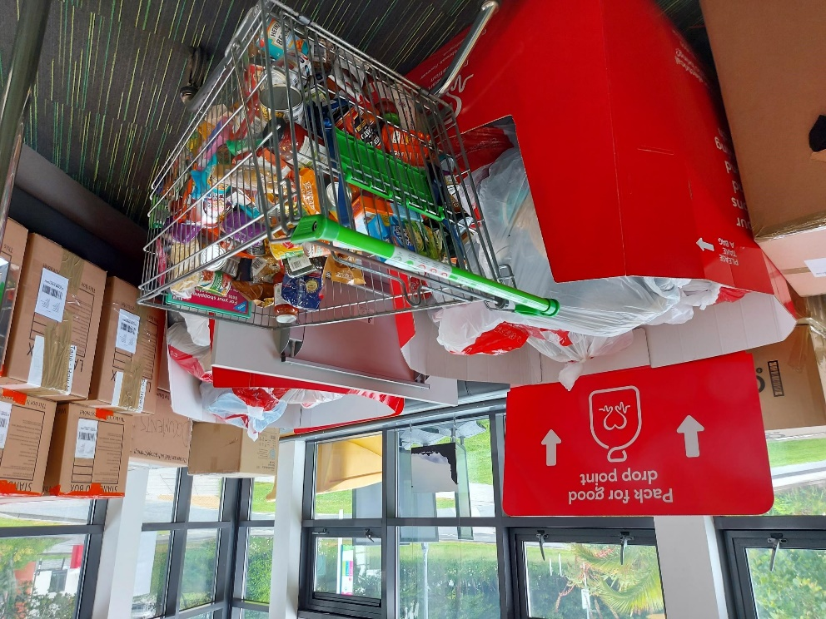
Alt text: Pack for Good and food bank drop off point in Glasney Lodge
Facebook copy:
Pack for good
Having a sort out before moving out? You can donate your unwanted items including books, household goods and clothes to divert them from landfill. Look out for the collection bags for the British Heart Foundation in your halls, or pick one up from Glasney Lodge.
Fill your bags and take them to the collection points around student accommodation areas, on and off campus, including Glasney Lodge Reception.
If you have any unopened, non-perishable food left over when you move out, you can also donate this to the local food bank. Just take it to Glasney Lodge and put it in the food collection trolley. Find out more at https://bit.ly/3wDvP8l
Twitter copy:
Having a sort out before moving out? Donate unwanted stuff to @theBHF. Get a #PackForGood bag from your halls, or pick one up from Glasney Lodge, where they’re also taking donations for the food bank. More at https://bit.ly/3wDvP8l
Instagram copy:
Having a sort out before moving out? You can donate your unwanted items including books, household goods and clothes to divert them from landfill. Look out for the #PackForGood collection bags for @the_bhf in your halls, or pick one up from Glasney Lodge.
Fill your bags and take them to the collection points around student accommodation areas, on and off campus, including Glasney Lodge Reception.
If you have any unopened, non-perishable food left over when you move out, you can also donate this to the local food bank. Just take it to Glasney Lodge and put it in the food collection trolley. Link in bio to find out more
Link for bio linktree: https://bit.ly/3wDvP8l

Instagram hashtags to be included as the first comment on the post
#Exeter #ExeterUni #ExeterUniversity #LoveExeter #ExeterForever #UofE #UniversityOfExeter #Cornwall #PackForGood

Subject 2: Tourism Podcast
Newsletter article:
Exploring Devon and Cornwall
Need to unwind after a busy exam period? Here in the South West, we are lucky to be surrounded by wonderful coastlines and countryside. Why not spend some of your summer discovering what Devon and Cornwall have to offer?
If you are unsure where to start, we've got you covered with a recent episode of the University podcast, Exeplore. We sat down with two local experts to discuss the top destinations across the region accessible via public transport. We also delve into some of the wellbeing benefits gained by spending time in the counties' areas of natural beauty. You can listen on Apple or Spotify and learn more about the top destinations and how to reach them at Visit Cornwall and Visit Devon.
Exeplore is our regular podcast, which features conversations on a broad range of topics that celebrate the richness of life within the University's global community. There are many more subjects to Exeplore, and we are always looking for suggestions for interesting topics, so if there's something or someone you'd like to hear more about, let us know at studentcomms@exeter.ac.uk.
Twitter:
Celebrate the end of exams by exploring Devon and Cornwall this summer. We’ve put together a tourism special of our podcast Exeplore to give you some ideas of top destinations to visit across our region. You can find out more and listen here: https://bit.ly/3sUE7GK
Facebook:
Are you spending some time in the South West this summer and need some ideas for days out? Check out our recent tourism episode of Exeplore. In this podcast, we caught up with two local experts from Visit Cornwall and Dartmoor National Park to chat about the best areas to visit across Devon and Cornwall, which you can reach on public transport. We also discuss the importance of spending time in nature and the wellbeing benefits gained from doing so.
Listen on
Spotify: https://spoti.fi/3lAFpCN
Apple: https://apple.co/3wPb4W4

Instagram:
Celebrate the end of your exams by exploring Devon and Cornwall this summer. Spending time in nature can have a positive impact on wellbeing, but sometimes it can be tricky to find a good spot to visit. If you don't know where to start, check out the tourism episode of our Exeplore podcast, where we take a whistle-stop tour and discuss the benefits of travelling around the counties with two local experts. Whether it's a day on the beach in Falmouth or a walk on Dartmoor, there are many things to discover across the region.
Link in bio to listen on
Spotify: https://spoti.fi/3lAFpCN
Apple: https://apple.co/3wPb4W4
Instagram hashtags to be included as the first comment on the post
#Exeter #ExeterUni #ExeterUniversity #LoveExeter #ExeterForever #UofE #UniversityOfExeter #Cornwall #Devon
Images:
Alt text: Exeplore podcast graphic
Alt text: Swanpool beach, Falmouth
Alt text: Dartmoor
SOCIAL MEDIA
For the latest messages from the University and its partners, please like and share posts from our student and corporate social accounts.
If you have questions about these, please contact the social media team on Socialmedia@exeter.ac.uk
Students  www.facebook.com/exeterunistudents  twitter.com/exeter_students  instagram.com/uniofexeterstudents | Corporate  www.facebook.com/exeteruni  twitter.com/UniofExeter  Instagram.com/uniofexeter | Cornwall  www.facebook.com/uniexecornwall  twitter.com/uniexecornwall  Instagram.com/uniexecornwall

Posts coming up:
30 May – Tips to prepare for graduation
2 June – The Queen’s Platinum Jubilee

MESSAGES FOR STAFF
- Student communications basics – training sessions online
If student communications is part of your job role, you can see training sessions on the basics, now online on the student communications webpage. Student comms basics covers writing for newsletters and other formats such as podcasts and videos, along with basic accessibility considerations and how your Student Communications team can help. Introduction to Podcasts looks at considerations when researching, recording, editing and publishing a podcast. There are more sessions to follow from the Social Media team and the Design Studio. Let us know if there’s something you’d like help and guidance on, studentcomms@exeter.ac.uk

- University Updates
See University Updates, the student e-newsletter. It is sent to students weekly (Mondays) during term time.
If you have an event or possible story for inclusion please email studentcomms@exeter.ac.uk. The final edition for this term will be published on Monday 6 June. Deadline will be 5pm on Tuesday 31 May.

- Explaining APACs (Assessment, Progression and Awarding Committees)

To explain how degree qualifications are awarded, we have put together a webpage and video about the work of the Assessment, Progression and Awarding Committees (APACs), and how they ensure assessment marking and the qualification awarding processes are fair.

- Success for all – fair access and widening participation podcast

If you want to know more about how the University is supporting students from all backgrounds to study and succeed here, listen to the latest Exeplore podcast from the Student Communications Team. We talk to Nicola Sinclair, Head of Widening Participation about fair access, social mobility and support for all. Listen on Spotify or Apple Podcasts.

- A-Z of student support and services
Looking to signpost services or information to your students? Take a look at our A-Z guide for students, which is packed with relevant links and should help you find the info you are looking for. If you think there’s something missing, please contact studentcomms@exeter.ac.uk

- Industrial action FAQs
The University creates student facing webpages with information should there be any period of planned industrial action. This page is live now with an update on the current UCU mandate for strike action and action short of a strike: https://www.exeter.ac.uk/students/industrial-action/
If students have specific questions please ask them to email industrialaction@exeter.ac.uk

