Education Board
2023_20204
SharePoint User Guide

I would like to....
- Access the Education Board (EdB) SharePoint site:
  - You can access this here: Education Board SharePoint, OR
  - You can also access this via the Education Board Webpage (scroll to the bottom)

- Bookmark/Favourite the EdB SharePoint site:
  - Open your web browser (Chrome, Edge, etc).
  - Go to the EdB Webpage (link above).
  - Click the star icon on the right side of the address bar.
  - Name the bookmark.
  - Select the folder you want the webpage to be saved to.
  - Click “Done” to bookmark the webpage.

- Access: a) the papers for the meeting, b) a previous meeting, c) minutes, d) the action log, e) the Terms of Reference (ToR), f) paper templates/coversheets:
  - Education Board SharePoint Document Library for 2023/2024

- Access the papers / minutes / action log from 2022/2023:
  - Education Board SharePoint Document Library for 2022/2023

- Access the papers prior to 2022/2023:
  - Education Board Webpages

- Open documents on my Desktop?
  - Navigate to the document you wish to open using the steps above.
  - Click on the document to open it in your browser.
  - Click on “Editing” on the top right-hand side of your document.
  - Then click “Open in Desktop App”.
  - A pop-up may show. If it does, click “Open”.

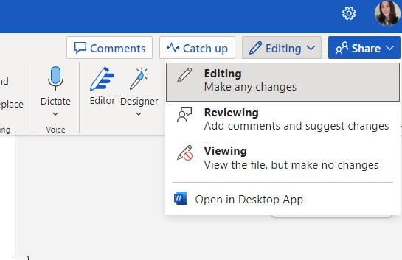

- Download all the papers for the meeting:
Important: We do not recommend you download files. Please use the “live” versions where possible, to ensure you are looking at the most up-to-date versions.
  - Go to the EdB SharePoint site for 2023/2024
  - Go to the meeting date you would like to download papers for and select the circle to the left of the folder.
  - Click the “Download” button from the menu bar.
