Welcome to the January EduExe newsletter!

The EduExe newsletter is an initiative for all colleagues involved in education, focusing on news, updates and all things education development and enhancement. This monthly newsletter includes relevant articles and resources according to the time of the academic year, updates on strategic projects, reminders of key deadlines (i.e. for module amendments) and much more!
If you experience any accessibility issues with this email, you can download a word version on the Educator Development website
This issue we have updates, articles and resources on:
- Guidance on Marking for Online Exams
- Updates to mitigation process
- Gathering feedback on roll out of new GenAI and assessment guidance
- Study Zone update
- Reminder: ELE Module Page Template
- New and Improved Padlet Guidance
- Experimentation microgrants
- New Modules, Module Amendments and Module Withdrawals for 2025/26
- Recommendations for Engaging your External Examienrs
- Education Board Update– 27 November 2024
- Undergraduate and Postgraduate Degree Classifications Data for 2019/20 to 2023/24 Now Available
- EduExe survey – call for feedback
- Upcoming events
- THE Campus call for contributions
- On EduExe socials this month
- Submit to the EduExe blog
- Interesting article



Guidance on Marking for Online Exams
With January exams in progress, you may be thinking about how you might approach marking and providing feedback to your students.
If your exam is being run through a Quiz activity, the ETQ (ELE Timed Quiz) Setup Guide takes you through post-exam steps you need to follow. You can also visit the Staff ELE Training Course for guidance on reviewing Quiz results and marking.
If your exam is being run through a Coursework activity, you can visit the academic-facing Hub guidance page for guidance on marking and feedback.
To help students effectively view their marks and feedback for a Coursework activity-based exam, staff are strongly recommended to signpost them to the student-facing Hub guidance page.
For queries on Quiz activity-based exams, please see the ETQ (Exam Timed Quiz) Setup Guide for the relevant contacts. For queries on Coursework activity-based exams, please contact your Hub team.

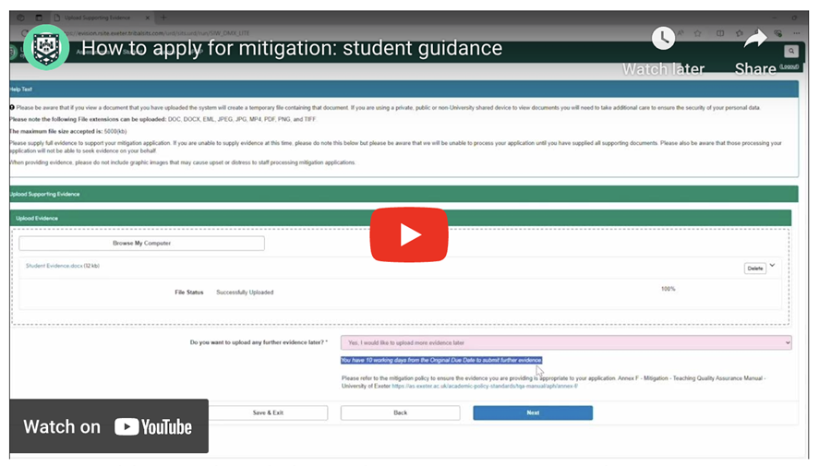

Updates to mitigation process
Our mitigation process supports students through unexpected situations that affect their ability to complete an assessment or exam - such as illness or a family crisis. This term, we are making significant improvements to the process for applying for evidence-based mitigation.
From Monday 13 January we have introduced our new online tool for all evidence-based mitigation requests. This will make it easier and faster for students to apply, while giving them the ability to track the progress of their mitigation requests.
These improvements will help the University to significantly reduce processing time, increase compliance, and build a better picture of how students are using mitigation so we can further improve the student experience.
From 13th January 2025, students will be able to access the mitigation tool for all new applications from the Student Record System link in the MyExeter app, or from the Hubs Mitigation page. Any ongoing applications will continue to be processed, but will not appear in the new tool.
There is no change to the types of evidence that should be submitted to support an evidence-based mitigation request.
Students can also still apply for short, evidence-free extensions on coursework assignments directly from ELE 2.
Please note that the current mitigation process will continue in the short term for Degree Apprenticeships, Online Programmes, BMBS, CEDAR and INTO – details can also be found on the Hubs Mitigation page. Further rollout of the online tool to these groups will be planned in due course with appropriate communication.



Gathering feedback on roll out of new GenAI and assessment guidance
The GenAI and assessment guidance pilot was developed in consultation with a task and finish group academic and PS colleagues and SACOs in Summer 2024. The use of three categories for how Gen AI is implicated in assessments, and student declarations for assessment brings us in line with the rest of the sector in our response to GenAI.
We are now seeking formal feedback from staff on the guidance and its rollout through an anonymous survey, to help us improve and continue to iterate the pilot. This survey will be open until the end of the term 1 assessment period and will be reviewed by a new AI and assessment working group.
Student feedback will be gathered as part of a separate exercise.
Give feedback on the GenAI and assessment guidance



Study Zone Update
Due to ongoing integration with Library services and some recent staffing changes, the Study Zone service at the Exeter campuses is altering from this term onwards. Penryn services remain unchanged. There is a brief transitional period and slightly reduced service in January whilst new staff undertake training and induction; the service will be fully operational from the w/c 27th January. Student drop-ins will be delivered from the Forum Library foyer and Cross Keys at St Lukes initially, then from the newly refurbished St Lukes Library. Maths and Stats drop-ins will continue in the Forum Library foyer. For full details, see the service updates page.
Over the rest of this academic year, we will be reviewing the service and making changes as we increase availability and make the service more visible.
If you have concerns about a student's progress, you can refer them to the team for longer appointments as normal via the online form. This is also linked to on the EduExe Toolkit.
If you have requests for teaching, please send these to the Study Zone email address: studyzone@exeter.ac.uk and one of the team will get back to you to confirm availability.

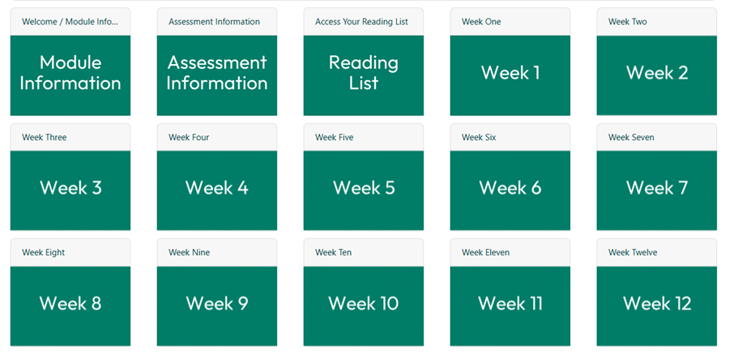

Reminder: ELE Module Page Template
For those teaching modules starting in January, this is a reminder about the ELE module page template, introduced for Term 1. Developed by the Digital Learning team, the template supports the creation of accessible and inclusive module content, with Universal Design for Learning (UDL) principles at its core.
The template provides a consistent framework with embedded guidance to streamline course design, improve accessibility, and reduce cognitive load for students and staff. Its structure ensures content is predictable and easy to navigate.
Aligned with the University’s Strategy 2030 and the Transformative Education Framework, the template addresses goals for inclusive education. It supports teaching colleagues to "unhide the curriculum" and meets accessibility needs highlighted in the Access Insights Report 2023.
You can learn about the pedagogy of the template, and preview it in the 'Grid' format or the 'Topics' format. You can import it to your module page using the ELE Rollover Wizard, following guidance on the Staff ELE Training Course.
If you have a question about the template, you can contact the team at digital-learning-support@exeter.ac.uk. If you need help using the Rollover Wizard, you can book at 1:1 through the Book Time with Digital Learning service.

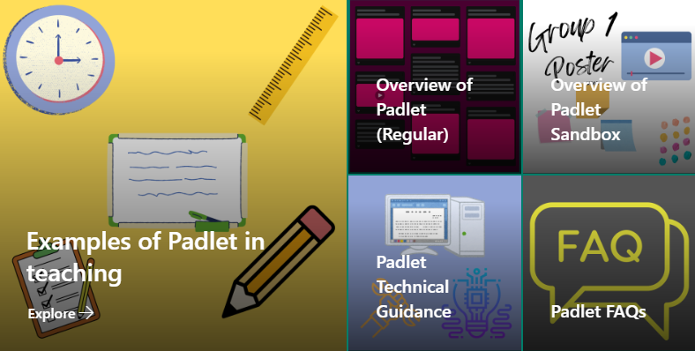

New and Improved Padlet Guidance
Thanks to hard work from members of the Digital Learning team, you can now view the new and improved Padlet guidance.
You’ll find an overview of what Padlet is and how it can be used, as well as equivalent guidance for the recently introduced Padlet Sandbox. This versatile feature allows you to create more ‘freeform’ collaborative digital canvases, with a variety of drawing, writing and multimedia options for synchronous and asynchronous activities.
More detailed technical guidance is available for accessing, setting up and sharing a Padlet, including information on the new ELE Padlet activity, which makes it quick and easy to share a Padlet on your ELE page. There’s no need for you, or your students, to sign in to Padlet – ELE will do this for you.
If you need inspiration on how to use Padlet in your teaching, you’ll find a useful bank of examples. These demonstrate how Padlet can assist with peer review, reports, breakout groups, glossaries, lab reports and more.
The guidance also includes a series of Padlet FAQs. If you have a question that’s not addressed, you can contact the team at digital-learning-support@exeter.ac.uk.



Experimentation Microgrants
Applications for the Experimentation Grants, offering up to £500, are open to the University of Exeter educator community. These small-scale grants support experimentation with learning and teaching challenges, helping you to ideate, test, and develop solutions. Grants will be awarded on a rolling basis over the 2024-2025 academic year.
Learn more about Global Classrooms and Exeter Education Incubator experimentation grants.
If you have any questions about our microgrants, please contact Kerry Deacon at k.r.deacon@exeter.ac.uk or Re Oakley at r.oakley@exeter.ac.uk.
Apply here

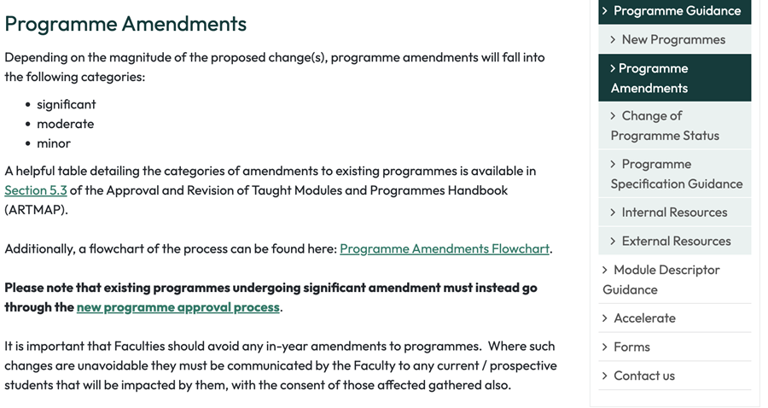

New Modules, Module Amendments and Module Withdrawals for 2025/26
Deadlines for the submission of all module amendments for 2025/26 are:
- Undergraduate years 2, 3 and 4: 21st February 2025
- Undergraduate year 1 and Postgraduate Taught: 18th April 2025
Please see the guidance note for further information, which includes deadlines for setting up new modules and module withdrawals.
Programme Amendments (Process Flowchart)
All programme amendments are categorised according to the size of the change. which also dictates the deadline. All minor and moderate changes for 2025/26 should be completed by:
- Undergraduate: 31st January 2025
- Postgraduate: Mid-March 2025
Significant amendments follow the same process as new programmes.
“With Proficiency” proposals for 2025/26
- Completed proposals should be submitted by the end of January 2025 to ensure the modules are included in Online Module Selection for 2025/26.
Programme Design and Quality Enhancement (PDQE) website
Our recently refreshed website includes guidance and overviews related to new programmes, modules and amendments. We are continuing to develop these pages and supporting information.
Please contact us for further information or advice any of the above.
Recommendations for Engaging with Your External Examiners
The start of the new calendar year is great opportunity to engage with your External Examiners (EEs) to keep them updated on any developments within the programme and to ensure they feel included in programme activity.
If you have not already, now is the ideal time to provide them with:
- Programme Specifications
- Programme Handbooks
- Details of their key contacts within the programme team and the Hub team
- Details of the module and associated assessments they will be reviewing
- Indicative dates of when they will be given access to samples to review
- Clear information about how they will access the assessments
- Details of times when opportunities could be made for them to observe practical assessments / meet the students and programme team
- Dates of when the APACs are to take place (in order that they can plan their commitments)
Further information is available in the External Examining Handbook.
If your programme is not covered by an approved external examiner appointment for the current academic year, or if you are unsure whether an EE is in place, please contact qualityandstandards@exeter.ac.uk urgently.

Education Board Update – 27 November 2024
The Education Board meeting was held on the 27 November 2024.
A number of key items were on the agenda including:
- Taught Degree Classifications Report (approved for onward submission to Senate)
- Curriculum for Change UG programme review and design principles were considered again, generating great discussion.
- Accessible Teaching & Learning Policy (draft policy considered)
- Education Priorities for 2024/25 (highlighting key areas of focus for the year)
A minor in-year amendment to the TQA Assessment, Progression and Awarding Handbook, Chapter 12; Academic Conduct and Practice had been requested. This concerned non-credit bearing portfolios only, e.g. for Degree Apprenticeships, and the Chapter will be updated accordingly.
Dates of the 2024/25 Education Board meetings are available on the website along with the relevant paper deadlines.
The next meeting of the Education Board is to be held on the 12 February 2025. The deadline for agenda items is the 24 January 2025.
If you have any queries about the Education Board or have an item for inclusion on the agenda, please contact Education Policy, Quality and Standards (EPQS) via email educationpolicy@exeter.ac.uk.

Undergraduate and Postgraduate Degree Classifications Data for 2019/20 to 2023/24 Now Available
At their meeting of 27 November 2024, the Education Board received a report on the taught degree classifications for the five academic years up to and including 2023/24. The purpose of annually reviewing and reporting on the University’s degree outcomes, as set out in Chapter 13 of the Assessment, Progression and Awarding Handbook, is:
- To provide academic assurance in relation to credibility of Exeter awards over time, including compliance with Conditions B4 (assessment and awards) and B5 (sector -recognised standards) of the University’s registration with the Office for Students (OfS); and
- To provide oversight of degree awarding trends and degree awarding gaps between different student groups, in accordance with the University’s strategic commitment to ensuring success for all its students and closing awarding gaps between different groups of students.
The data underpinning this report is available at institutional, faculty and programme level and can be accessed by all colleagues via the Degree Classifications page on the MI Hub. Programme Directors, Directors of Education and Student Experience and colleagues with roles and responsibilities in relation to Success for All are encouraged to review this data regularly and use it to inform teaching, learning and assessment practices, dialogues with External Examiners, interventions to support student attainment and the updating of Teaching Excellence Action Plans.

EduExe survey – call for feedback
As part of our ongoing evaluation of our support for educators, we are inviting feedback on the communications and resources we deliver under the EduExe umbrella - including but not limited to the newsletter, blog, training and development, the EduExe toolkit, Microsoft Teams site and Festival.
We would really appreciate it if you could take a few minutes to fill in this survey and offer us your feedback, so that we can continue to develop and improve the support we offer our educators.
Fill in the survey



Upcoming Events
- The Race Institute x UUK - Anti-Racist leadership from the top: University executives challenging the status quo Thursday 30 January, 2:00–3:00 PM
- GSI Assembley - How can we embed sustainability and climate change in the curriculum? Wednesday 5 February 14:00-16:00, Roborough Studios, Streatham campus, University of Exeter
- NotebookLLM for teaching and learning hackathon, 19th February 1-5pm - the Educator Development and Learning Design teams are running an exploratory hackathon on usingNotebookLLM and other tools in our teaching and learning, and share practice from across the university. The event will run in person on Streatham and online. If you would like to attend, please contact k.preece@exeter.ac.uk.
- The Race Institute x UUK Early career professionals: Agents of change in anti-racist leadership Wednesday 26 February 2025, 2:00–3:00 PM
- The Race Institute x UUK Today’s students, tomorrow’s Vice-Chancellors: Anti-racist leaders in the making Wednesday 26 March 2025, 2:00–3:00 PM
- The Race Institute x UUK Reciprocal mentoring as a bridge for anti-racist leadership Wednesday 30 April 2025, 2:00–3:00 PM



THE Campus call for contributions
Through our partnership with THE Campus, we receive regular calls for content, as well as a rolling call for contributions on THE Campus key topics. The current calls for content are on:
- The evolution of 'authentic' assessment - Deadline for content: 27th January
- From lab to life: how to demonstrate research excellence - Deadline for content: 10th February
- Making good mental health a university priority - Deadline for content: 24th February
If you are interested in contributing to THE Campus, please contact eduexe@exeter.ac.uk with your pitch and download the Campus editorial guidelines.



On EduExe socials this month
On the EduExe Blog this month
- Designing to Facilitate Engagement: Putting Tutors at the Heart of Online Asynchronous Courses
- Exploring Pedagogical Frontiers: A Case Study in Higher Education Mathematics
If you are interested in contributing to the EduExe blog this academic year, please contact us on eduexe@exeter.ac.uk!
Read the EduExe blog
Don't forget you can follow us on LinkedIn for updates!

Submit to the EduExe blog!
We have a new process for colleagues to submit posts to the EduExe Blog. If you have a post you would like to share, please use our online form!
Submit to the EduExe blog



Interesting article
Colleagues may be interested in the article 'Educationally authentic assessment: reframing authentic assessment in relation to students’ meaningful engagement' by Kathleen Quinlan et al. for the journal Teaching in Higher Education
Read Educationally authentic assessment: reframing authentic assessment in relation to students’ meaningful engagement

Interested in contributing to the newsletter?
We will have rolling deadlines for submissions each month, so please get in touch with eduexe@exeter.ac.uk if you would like to contribute!
We want your feedback!
The EduExe newsletter is a new initiative, and we would love to hear from you if you have any feedback! You can share it with us anonymously on our feedback form or by email to eduexe@exeter.ac.uk.

Follow us on social media or visit our website to find out more about educator development and enhancement at Exeter!


Join the EduExe teams site to connect with educators across the University

