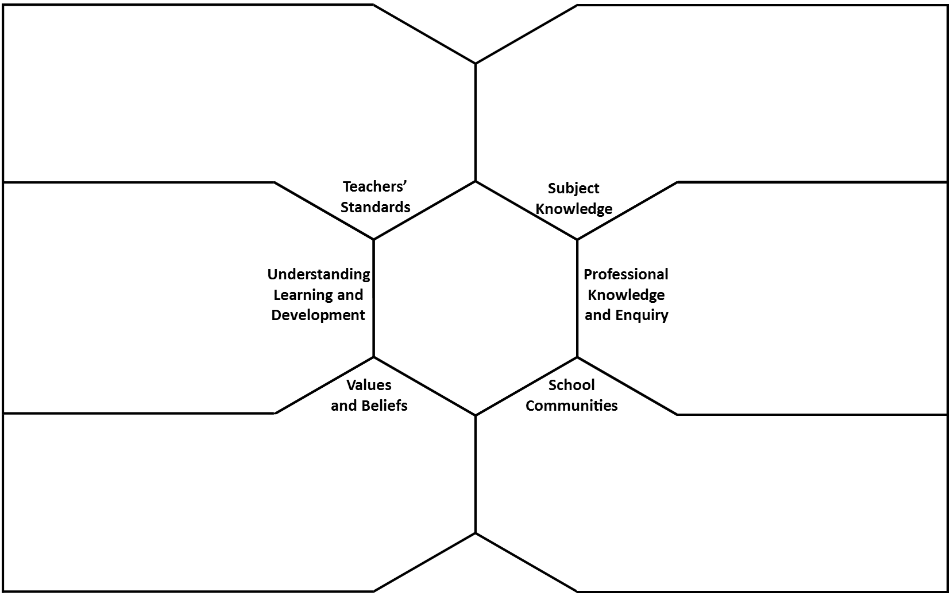
Professional Behaviours Framework Task
Professional Behaviours Expected from PGCE Trainees
Why is high attendance important for a trainee teacher?

How will I take responsibility for strengthening my subject knowledge?

How will I approach giving and receiving feedback in a way that is respectful, constructive, and focused on improving my practice?

How will I use my reflections, notes, and feedback to help develop my understanding?

How will I build positive, respectful relationships within my university & school communities – and why are these important?

Which core values and beliefs will guide my behaviour as a trainee teacher?

