Fundamental Skills Mathematics Audit
Initial Teacher Education providers are required by the DfE to quality assure the English and Mathematics skills of all trainees, and we can only award qualified teacher status to trainees who consistently meet the expected standards. With regards to Mathematics, the DfE note that:
- Teachers should use data and graphs to interpret information, identify patterns and trends and draw appropriate conclusions. They need to interpret pupil data and understand statistics and graphs in the news, academic reports and relevant papers.
- Teachers should be able to complete mathematical calculations fluently with whole numbers, fractions, decimals and percentages. They should be able to solve mathematical problems using a variety of methods and approaches including: estimating and rounding, sense checking answers, breaking down problems into simpler steps, and explaining and justifying answers using appropriate language.
See here for details.
While we are required to assure these skills, the DfE also make clear that “it is the trainee’s responsibility to secure fundamental English and mathematics”. Whilst you are on the course, you will carry out a task that enables you to develop your ability to interpret pupil data.
Before you begin in September you should:
- Go to: https://www.nationalnumeracy.org.uk/challenge/ and create an account.
- Complete the check-up and save the ‘Essentials of Numeracy’ certificate. Please keep this safe as you will be asked to upload it to your electronic portfolio of evidence during the first few weeks of the course.
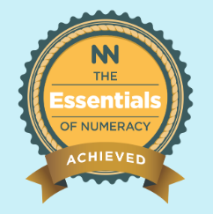
The certificate should say ‘Congratulations! You’ve got the Essentials of Numeracy!’ and have this badge on it. If it has a different badge then you have not reached the required standard.

Note: If you do not achieve the level required for the certificate, do not worry, the website will offer you support and you can retake the check-up as many times as you need in order to meet the required standard.

