Blog Platform Guide

Logging in
To login go to: http://sites.exeter.ac.uk/ and enter your username and password (Note: this is the same as your main University credentials).

Adding a story
In the left-hand menu go to Posts
In the top left click Add New
Replace the text Add title with the title of your post as you want it to appear on the live site.
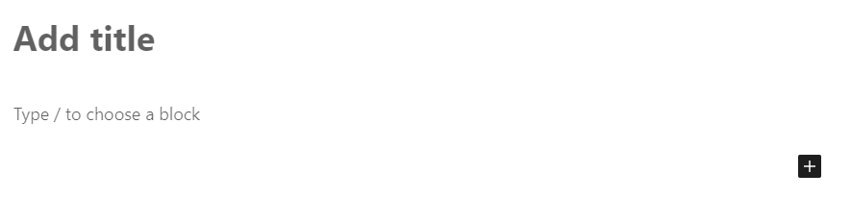
Your post can be built up using different ‘blocks’ of content, there are many to choose from but some useful ones include:
- Paragraph (normal text)
- Quote
- Image – See Featured image below for instructions on how to upload images to the Media Library.
- Gallery
- Youtube video (embed a video in your post by pasting in the URL)
- Twitter (embed a tweet in your post by pasting in the URL)
To add a block, click the black plus icon and select the block you want (click ‘Browse all’ if you can’t see it)
Use multiple blocks of content to build up your post.

Previewing
Click preview in the top right to view how your post will appear on the live site.

Post settings
There are various settings in the panel down the right of the screen that you will need to set before making your post live.
Visibility – set to ‘Public’ as default which means it will appear live on the web. The only other setting which may be useful is ‘Password protected’ if you wish to share a post with a colleague who does not have access to the platform prior to it going live.
Publish – Here you can schedule a date and time for the post to go live. Unlike t4, WordPress will publish post to the web immediately.
URL – Here you can override what the URL of the story will be which can be useful for stories with very long titles. If using this, ensure that you only use lower case letters and no special characters. It may help SEO to include the key words from the story within the title. Avoid using a story URL that already exists.
Author – By default your own name will appear as the author of stories you add, however you can select any user with access to the site from the drop-down.
Categories – The categories control how posts are grouped together on the site and where they appear on the University website. Select all categories that apply, if selecting multiple categories then you will need to select one ‘primary category’.
Tags – Tags can be used to link together posts on themes or topics. To ensure that tags remain useful for both the user we recommend keeping a master list of tags in a shared spreadsheet and not adding too many. Also be careful not to create duplicate tags that are named slightly differently e.g. ‘International’ and ‘Global’.
Featured image – Ensure that all stories have a featured image set as this is the image that is used for any feeds and will appear at the top of your story by default.
- Images first need to be resized to 930 x 500 pixels (see guide below). Save files with a short file name that describes the image with no special characters or spaces.
- Click ‘Set featured image’ – this will bring up the media library.
- Click ‘Upload files’ in the top left and drag in your image or select it from your computer.
- Give your image an ‘Alt text’ description – this is for users who may be visually impaired and need a description of the image read out by a screen reader.
- Give your image a ‘Caption’ if required – this will appear in italics under the image on the live site.
- Click ‘set featured image’.

Publishing
When you are ready click ‘Publish’ in the top right. WordPress will give you a quick summary of your settings (including confirmation of publish date and time if not immediate) and then you are ready to hit publish again to make it live.

Resizing images
All featured images on the site need to be 930 x 500. It is possible to have additional images in each story that are other sizes however for consistency we would recommend using 930 x 500 where possible.
There are 3 ways to resize images:
- Asset Bank - https://exeter.assetbank-server.com/assetbank-exeter/action/viewLogin - good for University images already on there.
- EasyPicSizer - http://exeter.easypicsizer.co.uk/ - good for resizing landscape images.
- Pixlr.com - https://pixlr.com/x/ - good for turning portrait images landscape.

Asset Bank
If you’re using a photo from Asset Bank you can resize it before you download it. To do this:
- Navigate to the image you want and click ‘Download’ in the top right.
- From the ‘Quick download’ drop-down select ‘T4 / Website’
- Leave the ‘Size’ dropdown at the default ‘Standard responsive site image (W930 x H500)’
- Click on the text ‘Select crop area’ and in the window that opens drag your curser over the portion of the image you want to retain. Click ‘Crop and close’.
- Click ‘Download now’.

EasyPicSizer
EasyPicSizer is useful if your image is not from Asset Bank but is still a landscape image at the incorrect dimensions. It will automatically crop and resize images to 930 x 500 at the correct resolution.
- Click ‘Upload photo’ and select your image from your computer, you will now see the image on the site.
- Drag your cursor over the image to select broadly the area you want to crop (it doesn’t need to be exact, and you can just select the whole image).
- Underneath your image you will now see the drop-down ‘Select the image set required’ – choose ‘Responsive site’.
- Give your resized image a file name in the ‘Enter picture name’ box and click ‘Generate files’.
- When the page reloads, scroll to the bottom and you will see your resized image. Right click on it and save it to your computer.

Pixlr.com
If your image is a portrait photo of a person and you need it to be the featured image you can add strips to the left and right of the image, for example:

Pixlr is a free web-based image editing site that can be used for this.
- Head to https://pixlr.com/x/ and in the centre of the screen click on the text ‘Create new’.
- Toward the right-hand side of the box that opens enter ‘930’ for the width and ‘500’ for the height.
- Toward the top right of the screen that opens you will see a Layers panel with 2 boxes. Click on the one with the ‘+’ to add a layer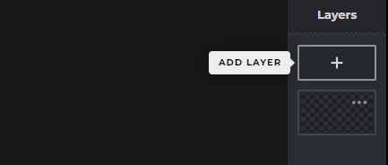
- In the dialogue box that opens click ‘Image’ and then select the photograph from your desktop. Depending on the size of image you are working with it’s likely that your photo will appear very large and most of it will run off the edge of the canvas
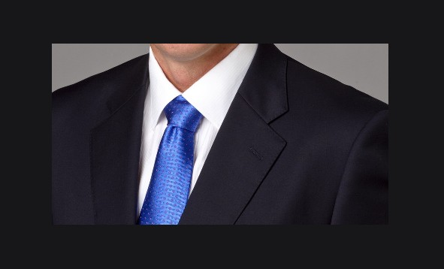
- With ‘Arrange and style’ selected from the tools panel (top left)

click on the image and you should see a blue boundary box around it. Use the white square corners to drag the image so it fits within your canvas window.
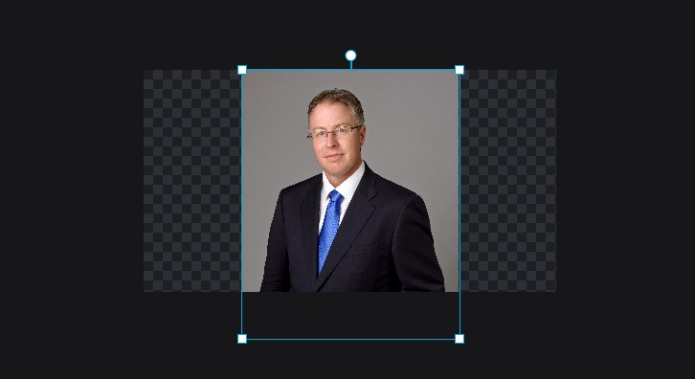
- Head back up to the Layers panel and add another layer by clicking on the ‘+’ icon again. This time select ‘empty’.
- You’ll now see a new empty layer in top right above the thumbnail of your image. Click on the thumbnail and drag it down below the thumbnail of the photo.
- Back in the tool panel click the third icon down called ‘Layout and template’
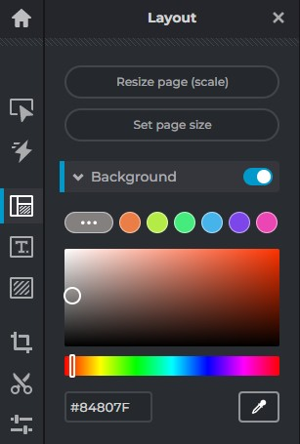
Click on the three dots next to the colours to reveal the eyedropper tool (bottom right) and click on it.
- Now hover over the background of your photograph and select the predominant colour.
- Your background colour should now change. Repeat the process choosing different colours until you are happy with the results.
- In the bottom right click ‘Save’

