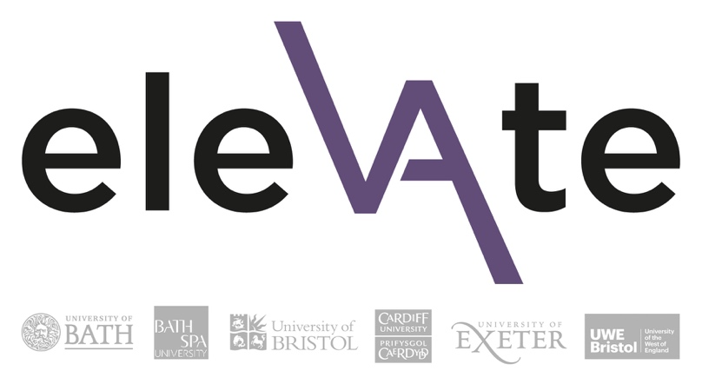
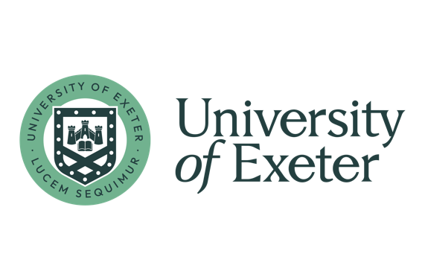

Elevate Programme 2025
Programme applications: Information for Line Managers
This information is intended for line managers supporting a team member who is applying for the Elevate programme. This includes information about the application process, the Elevate programme, and the line manager workshops.
For further information, please see the Elevate webpages

Line Manager Endorsement
Each applicant’s current line manager must give their support for the application by completing a separate Line Manager Endorsement Form.
- The applicant will email you the link to the Line Manager Endorsement Form.
- Complete the form by answering two questions:
  - Please outline your reasons for supporting the individual in this application (up to 350 words)
  - How else are you investing in this person’s development? What support will you give them beyond this programme? (up to 200 words)
- Add the budget code/budget code that will be used to pay the programme fee.
- Finally, click Submit. After you submit, you have the opportunity to download your responses for your reference.
- Please note: you must submit the ‘Line Manager Endorsement Form’ before the deadline. Deadline: Midday on Friday, 1 November 2024
- Inform the applicant that you have completed your form.

The Selection Process:
- Completed applications are anonymised and reviewed by the Selection Panel.
- The final selection ensures a mixed cohort with a balance of participants across each of the participating universities.
- Applicants and line managers will be notified of outcomes by the end of November.
- Line managers will be responsible for following up with unsuccessful applicants to identify alternative opportunities to support their development with guidance provided by the People Development and EDI team.

Time Commitment:
As a guide, the overall time commitment to engage effectively with the programme averages approximately 1.5 days per month (including scheduled and unscheduled activities).
Participants are expected to attend all sessions of the programme. Dates are available on the Elevate webpages.
Programme Structure
The programme comprises:
- three days of in-person workshops
- two online sessions, half day
- four 2-hour online Action Learning Groups, plus an introductory session
- a professional development or leadership project
- approx. four sessions with a mentor
Programme fees
Each participant's Faculty/Division will need to contribute to a participatory programme fee of £1350 to cover costs.
Normally, the programme fee will come out of a staff development budget within your faculty / school / division / department. If you are unable to fund this from a local budget, please do get in touch with us at edi@exeter.ac.uk .
Elevate line manager/sponsor workshops
Elevate is a leadership programme like no other, centring the lived experiences of participants and creating space for deep reflection and transformative conversations.
Managers and supervisors of participants (or ‘Elevatees’) play an important role as part of the Elevate community, whose active engagement facilitates the success and sustained impact of the programme.
These complementary workshops give you the opportunity to engage directly with Elevate in your role as a line manager/sponsor, experiencing for yourself the context of this transformative learning environment. They will be led by the Elevate programme facilitators: Dr Peggy Warren and her experienced team from the Ubele Initiative.
This will enable you to:
- Enhance your ability to effectively and confidently support the development and wellbeing of your Elevatee
- Deepen your own awareness of the impacts of organisational culture and equity
- Explore some of the systemic and social barriers experienced by women of colour
- Embed working cultures which embrace, value, and celebrate difference in the multiple ways it presents
- Connect with a fellow sponsors, contributing to a supportive peer learning community and sharing knowledge and practices
Who should attend these workshops?
Elevate applicants will be asked to confirm their identified sponsor as part of the application process. This should be someone who has direct responsibility and influence with regards to the individual’s work, career progression, development and wellbeing. This would normally be their line manager, but an alternative sponsor may be identified if more appropriate to the context/local structure.

Line Manager workshop details
Date | Time | Content | Location
Tues 21 January | 10am-1pm (with lunch provided 1pm-2pm) | Line Manager Workshop 1 | In person, Engineers House, Bristol
Weds 14 May | 10am-1pm | Line Manager Workshop 2 | Online

Workshop 1: Elevate programme overview
Enhancing equity through examining, reviewing, and revising organisational practices which consciously and unconsciously contribute to inequities.

Workshop 2: Equity, reflexivity and me (as a leader)
When it comes to difference, what am I willing to approach, what do I generally avoid? Where next?

