Production without Medicalisation

Workshop on AMR, One Health and Aquaculture, Dhaka
February 12-13th 2019

University of Exeter
Phone
Email
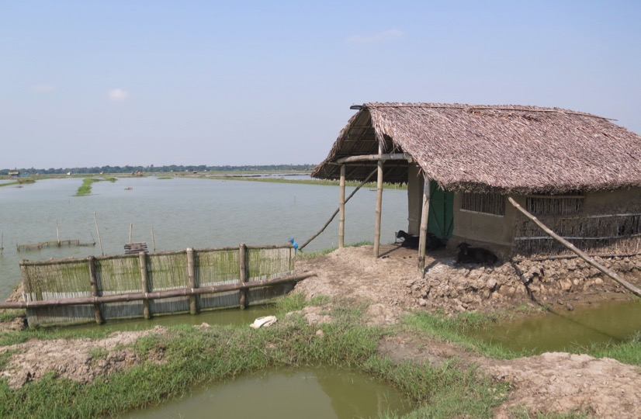






Background
Antimicrobial resistance (AMR), or the ability of microbes to resist the effects of medicines and other chemicals that are used to control them, presents a formidable threat to health and sustainable development. Antimicrobial treatments and medicines are used within human health and in terrestrial and aquatic food production to manage infection and sometimes to improve farm production. Resistance can emerge in people, in animals and in the environment, and may spread between people and animals.

AMR is a ‘one health’issue wherein the health of people, animals and the environment are interlinked. The development of resistance in one location and in one setting can affect the health of people and animals more broadly. Likewise, efforts to combat resistance require efforts in all areas. In Bangladesh the burden of infectious disease is significant across all sectors and there is need for a joined up approach to health promotion and to managing AMR risks. Where recent progress has been made there are also lessons to learn and to share within and outside the country.

Aquaculture is recognized as a key site for the emergence and transmission of AMR. The risk will relate to a number of issues including disease burden and health management practices; direct and indirect, purposeful and inadvertent use of antimicrobial treatments; feed practices, the use of waste materials and inputs from other farming sectors; transfers of water and so on.

Workshop Aims
The workshop followed two UK-funded research projects on the microbial dynamics of disease within Bangladeshi aquaculture and on disease management practices on farms and in hatcheries. It preceded the development of Reference Laboratory capacity within CEFAS, the Animal and Plant Health Agency (APHA) and the Veterinary Medicines Directorate (VMD) in the UK and a pilot project on engaging with farmers on AMR. The workshop aimed to disseminate and discuss relevant lessons from these projects and to develop priorities for future work and interventions.

Key aims of the workshop:
- To share and develop greater understanding of the key practices, disease issues and drivers of resistance risks within Bangladesh and within Bangladeshi aquaculture.
- To engender a One Health approach to tackling AMR in Bangladesh and initiate new initiatives.
- To discuss the utilisation of this knowledge in any public/ farmer campaign aiming to raise AMR awareness.
- To identify data needs and approaches for future characterisation of AMR issues in Bangladeshi aquaculture.
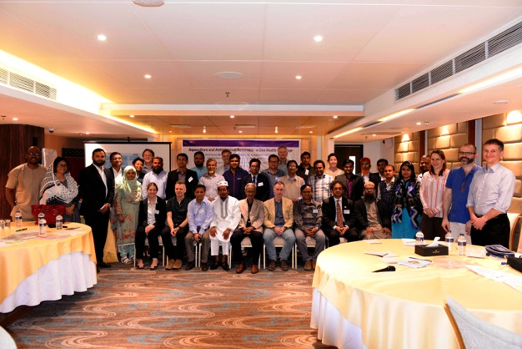Photograph: Workshop attendees: Dhaka 14/02/19 – Credit: WorldFish

Summary
- Food production in Bangladesh faces key challenges in terms of demand for increased productivity, endemic and emerging diseases, environmental changes and loss of productive land to development.
- Increasing productivity without reliance on the dwindling resource of antimicrobial treatments and without adding to the burden of antimicrobial resistance is a global and One Health challenge (affecting human, animal and environmental health).
- Research findings suggested that developing situation-specific best practice management interventions can produce sizable and scalable improvements in production.
- In the poultry sector cleaning and removing biofilms from feeders produced substantial reductions in re-infection rates, leading to reduced dependence on antibiotic treatments.
- In aquaculture, fish stress and associated disease outbreaks can be reduced by managing oxygen levels. Pumps used to aerate ponds can be optimised for night time use, when oxygen stress is high.
- In aquaculture, best practice management needs to be tailored to the farmers’ environmental and economic situations. Measures need to reduce rather than exacerbate the severity of the financial risks faced by producers.
- Awareness of the potential commercial and health threats of inappropriate antimicrobial uses in food production is relatively low. Developing a reporting structure whereby farmers seek appropriate help and expertise would start to shift current practices.
- There are no reliable records for antimicrobial sales in aquaculture and no established monitoring of resistance (the focus to date has been on antibiotic residues for export produce).
- Regulations exist to combat AMR (for example the Farm Animal and Fish feed Act, 2010), but a key issue is available resources to improve awareness, monitor progress and ensure compliance.

Workshop Recommendations
- Capacity: A sustainable approach to training key personnel, and ‘training the trainers’, is required in order to service key needs within the laboratory and agricultural extension services.

- Surveillance: A coordinated programme of surveillance of both antimicrobial sales and resistance is required in order to provide good baseline data and informed interventions.

- Awareness: campaigns and approaches need to be tailored to context – it may not be effective to try to raise awareness or educate every potential user of antimicrobials. Instead, developing a process whereby farmers, shopkeepers etc. are advised to check with local officials before using antibiotics can have the dual benefit of increasing reporting and shifting the perceived importance of antimicrobial treatments.

Photograph: Rapid assessment, Dhaka Sub-district: Credit David Verner Jeffreys
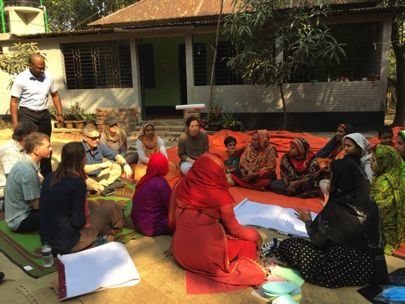

Attendees
In addition to guest of honour, Mr. ASM Rashedul Haque, Director General, Department of Fisheries, Government of Bangladesh, his deputies and several key members of the Bangladeshi policy community, over sixty delegates attended the two-day workshop.

Representing Bangladeshi and UK government, intra-government, non-government, commercial, academic research and practitioner communities, people from the following organizations attended:

- Animal and Plant Health Agency (APHA) UK
- Bangladesh Agricultural University
- Bangladesh Aqua Product Companies Association
- Bangladesh Department of Fisheries (DoF)
- Bangladesh Fisheries Research Institute (BFRI)
- Bangladesh Frozen Foods Exporters Association
- Bangladesh Open University
- Bangladesh Shrimp and Fish Foundation
- Bluegold Bangladesh
- Centre for Fisheries and Aquaculture Sciences (CEFAS) UK
- Chittagong University, Veterinary and Animal Sciences
- Feed organisations
- Finfish and shellfish farmers, hatchery organisations and shopkeepers
- Fish Inspection and Quality Control (FiQC)
- Fisheries and Marine Resource and Technology Discipline, Khulna University
- Noakhali Science and Technology University, Bangladesh
- The United Nations Food and Agricultural Organisation (FAO)
- University of Exeter, UK
- Veterinary Medicines Directorate (VMD) UK
- Winrock International
- World Health Organisation (WHO)
- WorldFish Bangladesh

Opening talks
The workshop was addressed by the director general of the Bangladeshi Department of Fisheries, and his deputy, as well as by the WorldFish Bangladesh country director, Dr Malcolm Dickson. They highlighted the challenges facing Bangladesh as it seeks to sustainably intensify food production. The challenges could only be met through collaboration across sectors and states. Dr Muhammad Meezanur Rahman (WorldFish) noted that it was encouraging that top-level officials were supporting the workshop and the issue of both antibiotic uses and resistance risks was high on the government’s agenda.

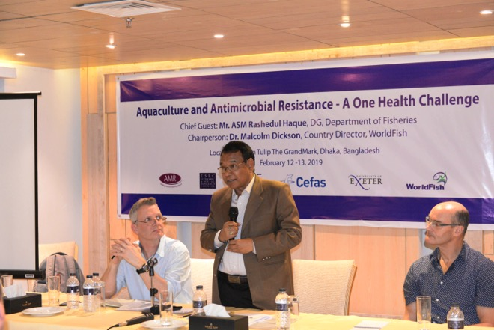
Photograph: Guest of Hounour Mr ASM Rashedul Haque address the workshop. Credit: WorldFish

List of talks

Speaker | Title
Dr Muhammad Meezanur Rahman (WordFish, Bangladesh) | Introduction to aquaculture in Bangladesh, and The National Strategy for Fish Health Management
Professor Stephen Hinchliffe (University of Exeter) Dr David Verner-Jeffreys (CEFAS) | Introduction to One health and AMR issues
Professor Charles Tyler (University of Exeter) | The Challenge of Disease in Extensive in Aquaculture
Professor Stephen Hinchliffe (University of Exeter) | Production without medicalization: social drivers of disease and AMR
Dr. Md. Zillur Rahman Deputy Director (Aquaculture) Department of Fisheries (DoF) | AMR and Fisheries Perspectives in Bangladesh
DoF-FAO-WorldFish joint initiative to explore finfish farming systems and existing challenges | Rapid Rural Appraisal of finfish issues
Partho Debnath (WorldFish) | Tilapia Epidemiology and health economics: preliminary results on abnormal health and antibiotic use
Dr Roderick Card and Kate Newton (APHA) | AMR Surveillance and International Reference Centre for AMR
Md Ashikur Rahman (BFRI) | Fish disease and health management: Vaccination of Koi
H M Rakibul Islam Senior Scientific Officer (BFRI) | Present Status of Pathogenic Agents (Virus/Bacteria) causing Shrimp/Prawn Disease in Bangladesh
Dr Kelly Thornber (University of Exeter) | Introduction to AMR awareness project

Key issues raised in opening presentations

- Food production and production from aquaculture in particular have been key components of Bangladesh’s economic success in recent decades
- Bangladesh is the world’s third largest inland producer of fish and shellfish
- Aquaculture production may need to double in the next 30 years to keep up with demand
- Aquaculture is characterised by wide species diversity and commercial heterogeneity
- Consolidating and improving aquaculture productivity faces disease challenges, losses of available land to development and a range of environmental threats
- In this context, a key challenge for Bangladesh is to secure production without medicalisation
- AMR is a ‘one health’ challenge, requiring action within the sector in terms of direct and indirect antibiotic uses, and upstream environmental resistance risks
- Bangladesh is a Fleming Fund supported country, and the fund has been established to help low- and middle-income countries tackle AMR, with a specific focus on surveillance or antibiotic uses, resistant bacteria and their genes and AMR risks

Key findings from reported research

- Reducing disease in aquaculture can be a major component in an AMR strategy, and key findings from Newton and UKRI funded projects include the need to help farmers manage the physical parameters of ponds (particularly oxygen levels); the need to develop useful diagnostics and increase resilience. The pathobiome concept, or the role of pond chemistry and microbial communities in modulating pond and fish health, may be a key component of a future for pond diagnostics, providing early warning of production issues.
- Drivers of disease include on farm practices, market structure and governance as well as environment. Antibiotic use in aquaculture is often related to ‘desperate measures’ to save a harvest, as farmers bear a number of acute market risks. This context of medicine use can shape future antibiotic awareness campaigns. It can also inform efforts to tailor Best Practice Management (BPM) to production conditions. Guidelines for the latter need to be aware of the socio-economic as well as biophysical contexts of farming.
- Initiatives being taken by the DoF and other concerned authorities to combat AMR included awareness and training of farmers to avoid indiscriminate use of antibiotics, better management practices, sharing of information/networking with relevant parties, inclusion of AMR surveillance in the National Fish Health Management Strategy and establishment of the National Residue Control Plan (NRCP). Regulations include the Fish Feed Act (2018) and the Hatchery Act (2011). DoF use three QC laboratories (Dhaka, Chittagong and Khulna) to carry out chemical and microbiological tests. Recommendations by the DoF are to survey the use of antimicrobial agents and their effects, action research in AMR risk reduction and development of monitoring systems along with the establishment of government regulations and awareness campaigns. DoF are aiming to establish a surveillance and diagnostics laboratory and they have requested that Pharmacology is included in the university curriculum for Fisheries Science.

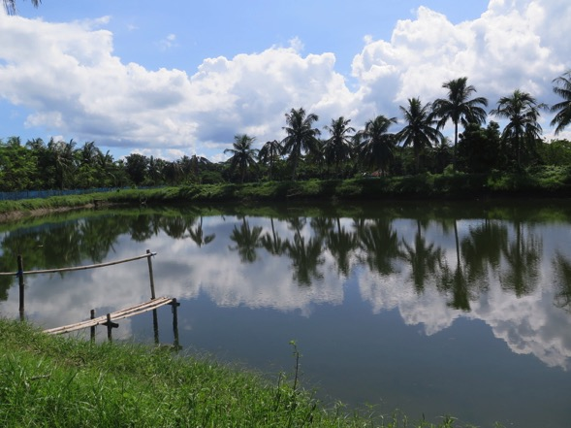
Photograph: Semi-intensive shrimp farm, Katakhalia, SW Bangladesh. Credit Andrea Butcher

Working Group Session 1: Main uses of Antimicrobial and sources of Resitance Risk in Bangladeshi aquaculture

Groups were organised into shrimp, finfish or integrated livestock interests, and asked to consider the following questions and report back (summary below).
- Which antimicrobial medicines are used in your sector?
- How are they used (for example, mixed with feed)?
- When are they used (for example, routinely to prevent disease, to treat disease (which ones), as a last resort…)?
- How often (very rare, very often, by all farmers, by few…)?
- How available are antimicrobial medicines/ treatments?
- How affordable are they to farmers?
- Are sales and use recorded?
- Who makes treatment decisions and choices (farmers, shopkeepers, others)?
- Are antimicrobial treatments of good quality, substandard, counterfeit…?
- Are people aware of antimicrobial resistance risks, residue issues, dangers?
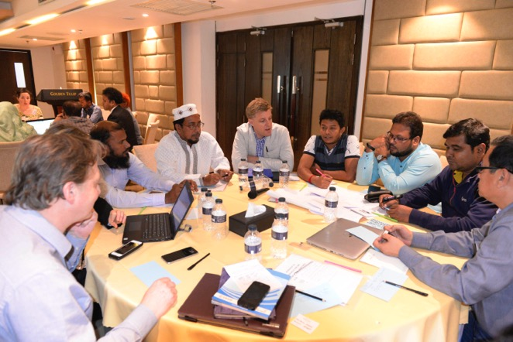
Photograph: Workshop attendees discussing shrimp and AMR. Credit: WorldFish

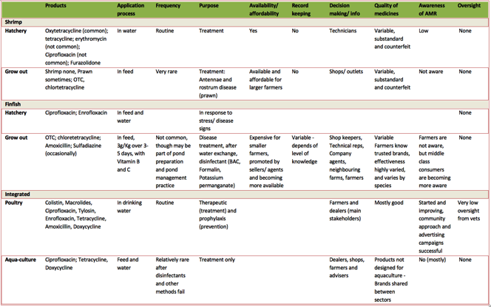
Table 1: Workshop output – key features of antimicrobial uses in Bangladesh aquaculture and poultry
Key messages included:
- Antimicrobials are used relatively sparingly in Bangladeshi aquaculture for treatment, usually after disease signs, with some cohort treatment (metaphylaxsis)
- Use is comparatively rare in some sectors (shrimp), more common in others (finfish and to a lesser extent prawn) but still comparatively minor in comparison to livestock (poultry) use
- There is little or no veterinary oversight or record keeping
- Medicines are affordable for larger farmers and freely available over the counter
- Medicines are becoming more common, and shops are under pressure to stock treatments and advise farmers to use them
- Quality of medicines and treatments is variable; substandard as well as counterfeit medicines are common, and medicines are rarely designed specifically for aquaculture use
- Some locally made feeds may contain antimicrobials

Working Group Session 2: Generating AMR Awareness

Groups discussed a prospective awareness campaign that would involve an animation and targeted messages. The discussion aimed to develop greater understanding of the context for developing an effective communication tool. The focus on changing practices of farmers and shopkeeper in terms of seeking local fishery officers advice was a key output.
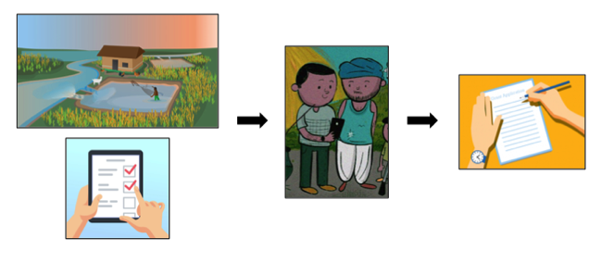
Figure 1: Plan for project to raise awareness of AMR in aquaculture through creating an animation.
An animation explaining the risks of AMR and AMU in aquaculture is being developed, along with a survey to obtain feedback from farmers. A team from WorldFish will visit farmers, show them the animation and conduct the survey immediately afterwards. If successful, data from this pilot project will be used to develop an application for funding for a larger public engagement exercise.

The following were highlighted as key messages for the animation:
- Farmers should seek to improve the pond environment
- They should seek help to diagnose a problem or disease
- They should consult professionals when using antibiotic treatments
- Buy medicines and treatments from reliable sources
- Use appropriate medicines that have been approved for aquaculture
- Inappropriate use of antibiotics can be harmful to family, to the pond and to consumers of produce

Discussion emphasized the need for a campaign to highlight a process for seeking diagnoses and treatment advice, using local fishery officials and the need to check carefully the ingredients of any treatments used on the farm.

strategies for surveillance and tackling of AMR risks

Working Group Session 3: Data needs and surveillance of Antimicrobial uses and AMR Risks

The soon to be ratified National Strategy for Fish Health Management in Bangladesh included the following key areas: improvement of diagnostics for early detection of disease; antimicrobial sensitivity testing for relevant treatment; improvement of practices to prevent and control diseases; development of surveillance, monitoring and information management systems to review and report AMR.

Topics to highlight in relation to AMR were:
- The need for surveillance of production, diseases and resistant pathogens
- The need for laboratory capacity, for training and human resource development
- Investment in health management practices (prevention and control)
- Greater and more effective testing and regulation of medicines
- Greater regulatory compliance and more control on products
- Coordination of training, education and extension activities
For the
A joint application made to the FAO by Cefas, APHA and VMD and funded by Defra and The Fleming Fund was now in place to support capacity development, facilitate implementation of National Action Plans and enable international engagement to support action on AMR.

AMR surveillance was justified in terms of:
- Providing information for action
- Providing data for response to rare or emerging patterns of resistance
- Providing baseline data against which policy or other interventions can be measured

In the UK, the relevant agencies and directorates adopted the following structure. Veterinary pathogens were subject to non-statutory passive (scanning) surveillance, with clinical samples from diseased animals (1000s of samples per annum) sent to the national reference laboratory. Zoonotic pathogens, and indicator bacteria, were sampled actively in an EU coordinated fashion (100s p.a.).

Figure 1: Structure for surveillance of antibiotic uses and resistance

The workshop attendees were asked to develop ideas on a possible partnership approach, using the following questions as prompts:

- What are the main difficulties in setting up One Health surveillance for antimicrobial use and resistance in Bangladesh?
- What existing monitoring programmes could be used for One Health AMR surveillance?
- What are the priorities for a programme of One Health surveillance?
- Are there AMU and AMR hotspots and key sites for surveillance efforts?
- Responsibilities – who will do the surveillance and what capacity exists for the work?

The following points were highlighted:
Sales and Usage Surveillance
Current issues to consider in Bangladesh
- Awareness and knowledge of medicines remains low, with one term (Oshoud) being used by farmers to describe all medicines (probiotics, disinfectants, antibiotics, vitamins and so on)
- There is little openness about uses, or at least caution with respect to revealing uses, especially in the export sector
- Where disease burdens are high (for example in shrimp and prawn hatcheries) there is high dependency on cycling antibiotics
- There are numerous available products, many of which may not be registered with Directorate General for Drug Administration (DGDA).
- There are over 200 pharmaceutical companies in Bangladesh, most marketing at human health but some cover human and veterinary markets. 500 companies are involved in importing medicines.
- Many medicines are imported, only some of which under licence from the DGDA. Some products may be imported as feed additives under business licenses.
- There are many counterfeit products that are difficult to survey.
- Counterfeit medicines create a legal difficulty – when produce contains impurities or illegal compounds, companies can claim that it is not their product and avoid prosecution.
Key positive developments or enablers to consider
- DGDA has a publicly available list of approved medicines, this might be developed as an accessible resource for local fisheries officers, shopkeepers and other relevant actors
- Shopkeepers sell to multiple sectors suggesting an opportunity for combined surveillance/ awareness raising
- Promoting a system whereby local fisheries officers are telephoned and informed of antibiotic sales can increase knowledge and potential advice points
- There are lessons to learn from success in the poultry sector, and opportunities to develop demonstration projects and promote appropriate uses via social media
Resistance surveillance
Current issues to consider in Bangladesh
- Laboratory capacity, quality and human resources were key issues.
- Complex value chains mean that it is difficult to trace produce to farmers.
- Passive surveillance is limited by lack of on farm capacity and little or no incentive for submission of samples.
- The current cost of tests is high (2000 BTK) and of little benefit to farmers, so uptake will be low.

Key developments or enablers to consider
- With less than 5% of farmed produce being directly sold to consumers, wholesale markets, where produce is pooled, were identified as good sites for surveillance.
- There are several potential laboratories and organisations that can assist with monitoring – including the Department of Fisheries (DoF), Bangladesh Fish Research Institute (BFRI), Fish Inspection and Quality Control (FIQC), International Centre for Diarrhoeal Disease Research, Bangladesh (ICDDR, B), National Institute of Biotechnology (NIB), Bangladesh Livestock Research Institute (BLRI), Directorate General of Drugs Administration (DGDA), Central Disease Investigation Laboratory (CDIL) and the private sector – but there needs to be coordination.
- Coordination between the Institute of Epidemiology Disease Control And Research (IEDCR) (public health), The Department for Livestock (including the BLRI/ FAO) (Poultry) and DoF (Aquaculture) may be an optimum approach.
- Current testing is highly developed and focussed on food safety and export markets with the NRCP testing for antibiotic residues (as well as other toxicity tests). This could be used to develop more comprehensive surveillance of resistance.
- Priorities could include a monitoring programme for Vibrio species that are important pathogens of shrimp and people (e.g. V. cholera, certain strains of V. parahaemolyticus and V. vulnificus). In finfish, a potential monitoring programme on Streptococcus agalactiae (or Group B Streptococcus – GBS) a pathogen of tropical and subtropical fish species may be a priority. Certain strains of GBS also have significant zoonotic potential, with GBS one of the leading causes of neonatal infections.
- E. coli monitoring is growing in the poultry sector, and public health sector surveillance is growing with numerous research projects and outbreak investigation (passive surveillance). E. coli has been identified as an indicator organism that can be used as part of One Health AMR surveillance activities. It is proposed that E. coli will be recovered from pondwater samples and potentially wider environmental samples on the farm (e.g. inlet water).
- Development of a biobank would be beneficial in terms of developing a data set of current diseases and identifying any emerging issues.

Working Group Session 4: Identifying key interventions

In the final session, groups were asked to evaluate the following groups of strategies:
- What are opportunities and possible limitations of the following interventions?
- Who is responsible for making effective interventions?
- What opportunities are there for one health collaborations?
- Which ones are a priority in Bangladesh?

- Education/ awareness campaigns
- Training (in what form and what are the priorities?)
- Registration of all antimicrobial (AM) products in the relevant sector
- Regulation (restrictions on availability, quality controls)
- Restriction on critically important AMs?
- Licensing of medicine companies, sellers
- Taxes, market tools
- Para/ Veterinary oversight
- Water treatment/ sanitation/ hygiene
- Biosecurity on farms
- Vaccines, alternative treatments

Key outputs from discussion (in addition to points raised above)
- DoF should be encouraged to develop a specific unit dedicated to regulation of medicines and compliance with regulations
- DGDA can deputize fish health inspectors to act on their behalf in terms of monitoring and regulating medicine uses.
- An FAO-adopted approach of training the trainers can help to generate greater awareness, stimulate take up and foster compliance
- The example of BARA (Bangladesh Antimicrobial Resistance Alliance) is a unique example of raising an informed public around the issue. Membership is conferred following an accessible and creative training event. The aim is to develop a one health alliance in country to develop and share good practice.

Concluding Comments
The workshop was closed with responses from farmers, and Dr. Malcolm Dickson (Country Director, WorldFish).
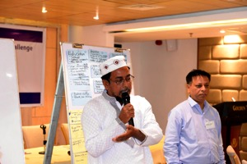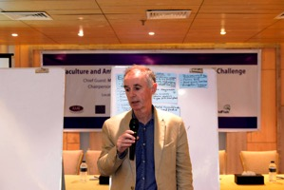
Photographs: Concluding speeches. Credit WorldFish.

- AMR is part of a global challenge, and food production in the future needed to operate in ways that reduced reliance on or unintentional exposure to antimicrobials.
- To meet this challenge required both incentives and regulation – or carrots and sticks. Punitive measures alone would not succeed in Bangladesh.
- The relationship between the DoF and DGDA would be key in regulating medicines and in making in roads into the need for better and more accurate data.
- Any policies needed to appreciate the intense commercial pressures in the industry, but also take advantage of market incentives. For example, sales of Bangladeshi produce might look to increase market share on the basis of limiting and limited antimicrobial uses.
- Marketing would require access to information and better data. Linking of local service providers, and clusters of farms, with suppliers would facilitate better information and develop better value chain governance.
- For domestic markets, where the vast majority of Bangladeshi aquaculture produce are sold, the development of market signals may be less pronounced.
- One Health approaches also needed to move beyond antimicrobial uses and address contaminant issues (including contamination with bacteria that show resistance traits). Again a key driver will be quality of produce and food.

The following recommendations would all be required in order to ensure that Bangladesh’s food system and rural economies could be sustained with quality produce without endangering future human, animal or environmental health.
- Capacity: A sustainable approach to training key personnel, and ‘training the trainers’, is required in order to service key needs within the laboratory and agricultural extension services.

- Surveillance: A coordinated programme of surveillance of both antimicrobial sales and resistance is required in order to provide good baseline data and informed interventions.

- Awareness: campaigns and approaches need to be tailored to context – it may not be effective to try to raise awareness or educate every potential user of antimicrobials. Instead, developing a process whereby farmers, shopkeepers etc. are advised to check with local officials before using antibiotics can have the dual benefit of increasing reporting and shifting the perceived importance of antimicrobial treatments.

Acknowledgements

Thanks to the farmers and others working in the sector who contributed to the research and attended the workshop and patiently sat through presentations. Their participation in this research is key to any future progress of the industry.
Thanks to Himangshu Biswas (WorldFish, Khulna Office) for assisting with the organization of the workshop
The organisers would like to thank the UK Economic and Social Research Council for funding the workshop. The research and the workshop were funded by the ESRC under the cross UK Research Council “Tacking Antimicrobial Resistance” programme–grant number ES/P004008/1 (Production without medicalisation: a pilot intervention in global protein production).
Cover Photograph: Andrea Butcher

