Student Communications toolkit
13 February 2023
Please take a minute to answer three quick questions about how you use these toolkits, in this User Feedback questionnaire.
Hi
This is your Student Comms toolkit for 13 February 2023. We send these around every two or three weeks, providing you with information and messages you can use in your channels to students.
Further down the email you’ll find useful messages for student-facing staff, which will help them to signpost information to students.
We’d love to hear your feedback as to how to improve this to make it more helpful for you, and/or if you have any further questions or stories to share, please contact studentcomms@exeter.ac.uk
MESSAGES FOR STUDENTS
- Career Zone
Background: Now that we’re mid-way through the second term, students might not have had the time, space or motivation to think further about their career. Now is a good time to remind them about the Career Zone – and that it’s never too early or too late to explore opportunities beyond your degree.
Images

Facebook sized image, Alt text: Career Zone

Twitter sized image, Alt text: Career Zone

Square/Instagram image, Alt text: Career Zone

Newsletter copy: Note separate links for Devon and Cornwall below
If you are career planning, whatever stage you are at, you need to speak to the Career Zone. Whether it's a case of not knowing the sector you’re interested in yet or the options that your degree offers you, or maybe you are very clear on your chosen career, want to skip those early stages and get help with your applications, the super friendly team at the Career zone is there to help you.
Through the Career Zone website, My Career Zone Digital, or Handshake You can:
- Search for jobs and opportunities, sign up for events and skills session on Handshake
- Live chat with a member of the team for bespoke support through the Career Zone website
- Build and check your CV, put together an elevator pitch or cover letter, or practice your interview technique through our video interviewing software at My Career Zone Digital.
And whilst you’re exploring, why not follow the team on TikTok, Twitter, Instagram, Facebook (Devon) or Facebook (Cornwall)

Twitter copy:
Whatever stage you’re at in your career planning, our friends @UoECareers are here to help. From part-time jobs to landing your dream graduate role, they’ve got the info and advice to get you where you want to go. Find out more http://ex.ac.uk/cz22 #Exetah #ExeterUni (emojis - green heart, student, prize)

Facebook copy: Note separate links for Devon and Cornwall below
Whatever stage you’re at in your career planning, our friends in the Career Zone are here to help. (tag @ExeterCareerZone for Devon campuses, or @CornwallCareerZone for Cornwall campuses.)
They can help with everything from finding a part-time job, to landing a graduate role with your dream employer, or getting into the postgraduate course that’ll launch your career.
(emoji - green heart, student, prize)
If you need help with your -
(tick emoji) CV
(tick emoji) cover letter
(tick emoji) application form
(tick emoji) job interview
They’ve got expert information and advice to help you succeed.
Or if you’re not sure what you’d like to do after University, they can guide you in the direction that’s right for you.
Find out more, and live chat with them on their website http://ex.ac.uk/cz22

Instagram copy:
Whatever stage you’re at in your career planning, our friends @uoecareerzone are here to help.
They can help with everything from finding a part-time job, to landing a graduate role with your dream employer, or getting into the postgraduate course that’ll launch your career.
If you need help with your CV, cover letter, application form or interview they’ve got expert information and advice to help you succeed.
Or if you’re not sure what you’d like to do after University, they can help guide you in the direction that’s right for you. (emoji - green heart, student, prize)
Find out more and live chat with them on their website, search online for Career Zone Exeter or email careers@exeter.ac.uk
#Exetah #ExeterUni #Careers #CareersAdvice #Exeter #Students #Future #StudentJobs #LifeAfterUni

- Education Welfare Support
Background: If a student’s mental or physical health or wellbeing is having an effect on their ability to study, or studying is creating health problems for them, the Education Welfare Advisors and Officers, based at the College Hubs/Info Points, can offer advice and support to students. They are also able to signpost to specialist advice, support services and self-help materials.
Image

Alt text: some of the Wellbeing team at the University of Exeter Wellbeing Campervan

Alt text: illustration of a tree, wellbeing icon.
(Note different text and links for Devon and Cornwall)

Newsletter copy
If your mental or physical health or wellbeing is impacting on your ability to study, or your studying is creating health problems for you, our helpful and experienced Education Welfare Team is here to help.
DEVON version Based in your Info Point/Hub, the team can offer short- or longer-term support. If you have a question, you can ask on Instant Chat on the website. A member of the team is online every weekday, between 12.30 and 2pm.
CORNWALL version
To find out how you can get in touch with the team and more about how they can help, see the website.

Facebook copy
If your mental or physical health or wellbeing is impacting on your ability to study, or your studying is creating health problems for you, then our helpful and experienced Education Welfare Team is here to help.
Devon version
Based in your Info Point/Hub, they can offer short- or longer-term support. A member of the team is online every weekday, between 12.30pm and 2.00pm, on instant chat, so if you have a question go to https://www.exeter.ac.uk/students/wellbeing/talk/welfare/ . Watch this video to find out more about how they can help https://www.youtube.com/watch?v=H-ie5o5TPIE&t=1s
CORNWALL version
To find out how you can get in touch with the team go to https://www.exeter.ac.uk/students/wellbeing/cornwall-student-welfare/ and watch this video to find out more about how they can help https://youtu.be/zo304HsHoR4
Twitter copy
Devon
If you’re feeling stressed about your studies or upcoming deadlines, the Education Welfare can provide support and advice. Talk to the team via Instant Chat on the website, every weekday between 12:30 and 2pm. https://www.exeter.ac.uk/students/wellbeing/talk/welfare/
Cornwall
If you’re feeling stressed about your studies or upcoming deadlines, the Education Welfare Team can provide support and advice. Go to https://www.exeter.ac.uk/students/wellbeing/cornwall-student-welfare/ to get in touch with the team and find out how they can help.

Instagram copy
Devon
If you’re feeling stressed about your studies or upcoming deadlines, the Education Welfare Team is here to provide support and advice.
You can talk to a member of the team via Instant Chat on the website, every weekday between 12:30 and 14:00. See the link in our bio.
Add this link to linktree in your account’s bio:
https://www.exeter.ac.uk/students/wellbeing/talk/welfare/
Instagram hashtags to be included as the first comment on the post:
#Exeter #ExeterUni #ExeterUniversity #LoveExeter #ExeterForever #UofE #UniversityOfExeter #WelfareSupport

Cornwall
If you’re feeling stressed about your studies or upcoming deadlines, the Education Welfare Team is here to provide support and advice. See the link in our bio to find out more about how they can help you and to get in touch with the team.
Add this link to linktree in your account’s bio:
https://www.exeter.ac.uk/students/wellbeing/cornwall-student-welfare/
Instagram hashtags to be included as the first comment on the post:
#Exeter #ExeterUni #ExeterUniversity #LoveExeter #ExeterForever #UofE #UniversityOfExeter #WelfareSupport #Cornwall

- National Student Survey (NSS)
Background: The National Student Survey 2023 is live for final year undergraduate students from 16 January until 30 April 2023. Eligible students should have received an email from independent research agency Ipsos with their unique code to take part, or can go to thestudentsurvey.com to take the survey. There are strict regulations about how we promote the NSS to students without inappropriate influence or bias. Please read our guidance carefully.
Please do share articles and posts from our central accounts or just putting a graphic on would be fine! Sample images are below, and you can get additional images, including different sizes for social media channels, from us at studentcomms@exeter.ac.uk. If you are planning to create your own messaging please ensure you have read the Inappropriate Influence Help card available from www.exeter.ac.uk/staff/nss/ under ‘How can I help promote the NSS?’ and speak to the social media team at socialmedia@exeter.ac.uk . Please only share the Help Card with those promoting the NSS and not with students

Images:
Note: different images for Devon and Cornwall campuses (using either the SU or Student’s Guild logos)
DEVON
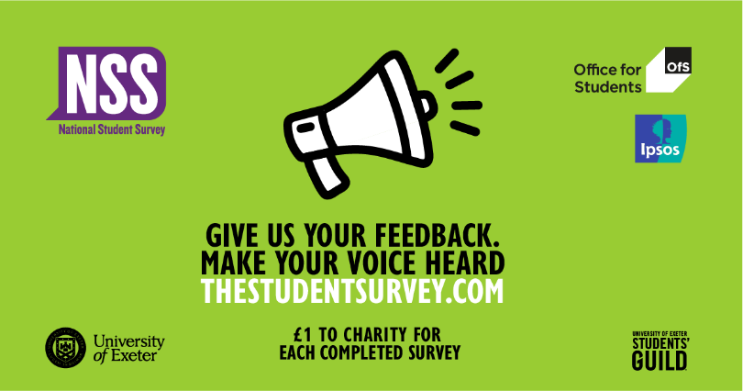
Alt text: illustration of a loudhailer, ‘Give us your feedback, make your voice heard. TheStudentSurvey.Com £1 to charity for each completed survey’.

Alt text: illustration of prize draw. ‘NSS. Enter the prize draw with a chance to win £500 cash. £1 to charity for each completed survey.’
NSS video on You Tube – Devon: https://www.youtube.com/watch?v=sfEi-dT24L8
CORNWALL
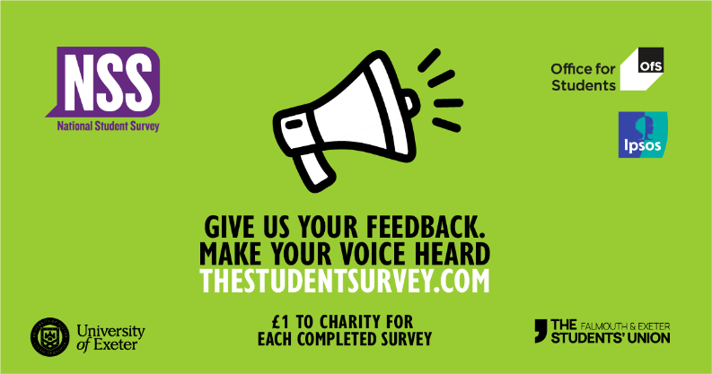
Alt text: illustration of a loudhailer, ‘Give us your feedback, make your voice heard. TheStudentSurvey.Com £1 to charity for each completed survey’.
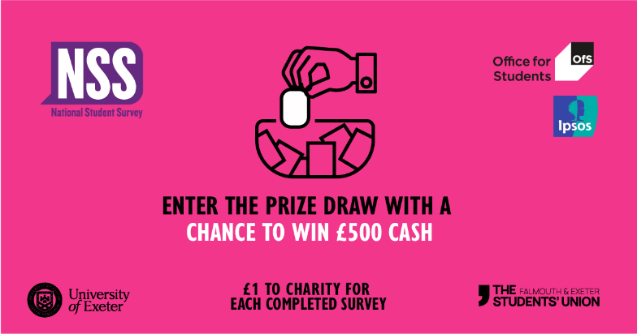
Alt text: illustration of paper being put in a pot. ‘NSS. Enter the prize draw with a chance to win £500 cash. £1 to charity for each completed survey.’
NSS video on You Tube – Cornwall - https://www.youtube.com/watch?v=CTGjTZ3ly-A

Newsletter copy
Final year students – tell us your views in the NSS
The National Students Survey (NSS) is open to final year undergraduate students. It’s voluntary and provides us with very valuable feedback, which we read carefully. This helps us to make future plans.
It takes up to ten minutes to complete and is the chance for you give your honest opinion of your entire University experience, just as students before you have done.
Eligible students can also choose to enter a prize draw with a top prize of £500 and ten further prizes of £50 each. Plus £1 is donated to charity for every completed survey.
The NSS is anonymous and run by research agency Ipsos. You should’ve received a unique code from them but you can also complete it by following this link to the survey.
Facebook post
Final year undergrad? It would be great if you could fill out the #NSS which is anonymous and run by research agency Ipsos.
It makes a real difference, and we read all the comments! That helps us make future plans and improve the student experience. The #NSS has been running for more than 15 years and so students before you fed back too.
You can also choose to enter a prize draw with a top prize of £500, plus for every completed survey £1 will go to charity. Complete the survey online at www.thestudentsurvey.com
Thank you!
Instagram post
Did you know that we read all the comments put forward in the #NSS and they help us to make improvements? This anonymous survey is open for final year undergrads. We’d love it if you could fill it out and give us your honest opinion on your Uni experience! It’s been running for more than 15 years and students before you gave their views too. Complete the survey online at www.thestudentsurvey.com or use the link in our bio.
LINK IN BIO: https://www.thestudentsurvey.com
Twitter post
Don’t forget the #NSS is open for final year undergrads! It helps us make future improvements. Students before you gave their views and it would be great if you could fill it out too. www.thestudentsurvey.com

STAFF INFORMATION – (Not for publication to students)
SOCIAL MEDIA
Don’t forget to like and share posts from our central social media accounts
If you have questions about these, please contact the social media team (corporate/Exeter students) on socialmedia@exeter.ac.uk or the Cornwall comms team (Cornwall accounts) on cornwallcomms@exeter.ac.uk
Exeter students  www.facebook.com/exeterunistudents  twitter.com/exeter_students  instagram.com/uniofexeterstudents | Corporate  www.facebook.com/exeteruni  twitter.com/UniofExeter  Instagram.com/uniofexeter | Cornwall students, staff & external  www.facebook.com/uniexecornwall  twitter.com/uniexecornwall  Instagram.com/uniexecornwall

Messages to look out for coming up include:
- Industrial action Q&As on Instagram
- Your voice: All student talk and Q&A with the Guild, SU and Leadership Team
- Sports Wednesdays

MESSAGES FOR STAFF

- UCU Industrial Action
Members of the Universities and Colleges Union (UCU) are taking national strike action, and/or action short of a strike. We would be grateful if you could familiarise yourself with the FAQs on the industrial action webpages so you are able to share this information with students should they have any questions.
Please signpost students to the following online resources for all enquiries relating to the planned strike period:
- Latest communications sent to students
- Website information and FAQs for students, www.exeter.ac.uk/students/industrial-action/
- Drop in sessions across our campuses for students to ask their questions and raise any issues, www.exeter.ac.uk/students/industrial-action/support
If you receive any questions or enquiries that you are unable to answer, please ask the student to email their question to: industrialaction@exeter.ac.uk

- Accommodation available now (Exeter)
The Exeter Accommodation office has some vacant properties in Birks Grange Village studios, which are available for students and visiting researchers for a minimum of 4 week lets, up until 24 June 2023.
If you know of students or researchers who need accommodation now or in the remainder of this academic year, please ask them to contact the Accommodation team – through SID Online for registered students, or researchers should email ExeterAO@exeter.ac.uk.

- National Student Survey (NSS)
The National Student Survey (NSS) 2023 is running for University of Exeter students from 16 January to 30 April 2023. The NSS is a nationally recognised annual survey of mostly final year undergraduates in the UK. The survey provides students with an opportunity to give their honest opinion of their time at the University. The survey is administered by Ipsos, an independent market research agency, so answers remain anonymous at all times.
You can find information about how the student survey is being run here at Exeter on our staff NSS webpage, which contains advice and guidance on how you can help promote the NSS, how to avoid inappropriate influence and who to contact about the NSS, including contacts in your faculty.

- Cost of Living advice and support
You may be approached by students about issues they’re having with money or where to get help.
- Direct students to the Cost of Living webpages:
There is lots of support available for those who are struggling, and information and advice to help them, which is updated regularly on the website.
https://www.exeter.ac.uk/students/costofliving/
- Refer students to the Step Change Debt Advice service
We’re working with the UK’s leading debt advice charity, Step Change, to provide our students with free, impartial and personalised support with their money and debt worries.
There is a quick referral form you can complete with your students, to put them in touch with Step Change. They will receive a link by text or email to start getting the support they need.
You can find out more about the charity and how to use the referral form in our e learning module on LearnUpon. Search 'Referrals for debt advice' in the LearnUpon course catalogue to enrol on the training: https://exeter.learnupon.com/catalog/courses/2982923.
- Streatham campus: Refer students for emergency supplies
We’ve established a Community Larder on Streatham campus, with emergency food and basic hygiene supplies for those students most in need. If you think this may apply to one of your students please signpost them to one of our support teams (eg Wellbeing, Hubs, SID, Estate Patrol etc) across the University who will be able to help them, not only with details of the larder but also explore whether they are in need of any additional help.

- Signposting to students
Looking to signpost services or information to your students? Take a look at our A-Z guide for students, which is packed with relevant links and should help you find the info you are looking for. If you think there’s something missing, please contact studentcomms@exeter.ac.uk

Share stories with us
The Student Comms and Social Media teams are always on the lookout for good student stories, particularly any which relate to our education offer. These might be used on social media, as website articles or as podcasts (subject to permissions). Share your ideas at studentcomms@exeter.ac.uk and/or socialmedia@exeter.ac.uk

