Student Communications toolkit
17 November 2022
Hi
This is your Student Comms toolkit for 17 November 2022. We send these around every two weeks, providing you with information and messages you can use in your channels to students.
Further down the email you’ll find useful messages for student-facing staff, which will help them to signpost information to students.
We’d love to hear your feedback as to how to improve this to make it more helpful for you, and/or if you have any further questions or stories to share, please contact studentcomms@exeter.ac.uk
MESSAGES FOR STUDENTS
- Mitigation
Images:

Alt text: students reading in library

Alt text: a person reading on the bed
You tube video on mitigation:
https://youtu.be/-_l3lJrogVc

Newsletter copy
Need more time for your assessments?
Sometimes things don’t go to plan. Unexpected situations may affect your ability to complete an assessment or exam - such as illness or a family crisis. Our Mitigation process can support you by giving you extra time for your assessment or allowing you to postpone an exam. The Cost of Living crisis is causing unexpected difficulties for some of you, so we’ve worked with the Students’ Guild and Students’ Union to change our policy to include financial circumstances as one of the reasons you can apply for mitigation this year. Find out more about mitigation and how it could help you.

Facebook post
If an unexpected situation - such as illness or a family crisis - affects your ability to complete an assessment or exam you may be able to get extra time by applying for Mitigation. This year we’re including financial circumstances as one of the reasons you can apply for Mitigation, as we understand that the Cost of Living crisis is causing unexpected difficulties for some of you.
Find out more about Mitigation and how it could help you at https://www.exeter.ac.uk/students/infopoints/yourinfopointservices/mitigation/
Instagram post
If an unexpected situation - such as illness or a family crisis - affects your ability to complete an assessment or exam you may be able to get extra time by applying for Mitigation. This year we’re including financial circumstances as one of the reasons you can apply for Mitigation, as we understand that the Cost of Living crisis is causing unexpected difficulties for some of you.
Find out more about Mitigation and how it could help you at the link in our bio.
link in bio: https://www.exeter.ac.uk/students/infopoints/yourinfopointservices/mitigation/
Instagram hashtags to be included as the first comment on the post
#Exeter #ExeterUni #ExeterUniversity #LoveExeter #ExeterForever #UofE #UniversityOfExeter
Plus for Cornwall #Cornwall #PenrynCampus as appropriate
Twitter post
If an unexpected situation - such as illness, a family crisis or financial difficulties - affects your ability to complete an assessment or exam you may be able to get extra time by applying for Mitigation. Find out how at https://www.exeter.ac.uk/students/infopoints/yourinfopointservices/mitigation/
(note: shorten the link in Twitter/bit.ly to save on characters)

- Design your campus survey
Background: The Design Your Campus survey, being led by the Strategic Spaces team, is asking students to tell us about their experience of the different teaching, studying and social spaces across our campuses, and what they do and don’t like about them. The findings will inform future projects to make our campuses better for our students. The survey will be live from Monday 21 November to Sunday 11 December. Those taking part can enter a prize draw to win a share of £500 cash (4 x £125 prizes.)

Images

Alt text: Students talk outside at Streatham campus

Alt text: Student walking past the Exeter stone at St Luke’s Campus

Alt text: Students walking towards Peter Lanyon building on Penryn Campus

Newsletter article
Design your campus
Tell us your views for a chance to win a share of £500
Tell us about your experience of the campus’ teaching, studying and social spaces, and help us create better facilities that work best for you. Share your ideas in the Design Your Campus online survey and you can enter a draw to win a share of a £500 prize pool.
The survey should take no longer than 10 minutes. There are four cash prizes of £125 up for grabs, and we’ll use the findings from the survey to develop future campus projects.
Take the survey now.

Facebook post
What do you think of your campus study spaces?
Take the Design Your Campus survey and help us understand your experience on campus, so we can create better facilities that work best for you.
Whether you like to be on campus, or prefer to study elsewhere, we want to hear from you. The survey only takes around 10 minutes, and we’ll use the findings to develop student-centred projects to make your campus better. Plus when you take part you can enter a draw to win one of four £125 cash prizes. Take the survey now at https://www.research.net/r/DesignYourCampus. Closes Sunday 11 December.
Instagram post
What do you think of your campus social spaces?
Take the Design Your Campus survey now and help us understand your experience on campus, so we can create better facilities that work best for you.
Tell us about the places that work for you on campus, and those that don’t. The survey only takes around 10 minutes, and we’ll use the findings to develop student-centred projects to make your campus better. Plus when you take part you can enter a draw to win one of four £125 cash prizes.
Take the survey now, the link’s in our bio. The survey closes on Sunday 11 December.
Link in bio: https://www.research.net/r/DesignYourCampus
Instagram hashtags to be included as the first comment on the post
#Exeter #ExeterUni #ExeterUniversity #LoveExeter #ExeterForever #UofE #UniversityOfExeter
Plus for Cornwall #Cornwall #PenrynCampus as appropriate
Twitter post
Tell us what you think of your campus. It’ll help us create facilities that work best for you and there’s a chance to win a share of a £500 cash prize. Complete the survey at https://www.research.net/r/DesignYourCampus Closes 11 December.

- Safezone app
Background: Safezone is a free app for students and staff that connects you quickly to Estate Patrol on the Devon campuses and Campus Security at Penryn Campus. Using the app, they can locate you in real time and quickly get help to you if needed. We are encouraging everyone to download the app to help our campus users feel safe and be able to quickly call for help when on campus.
Images: note different images for Devon and Cornwall
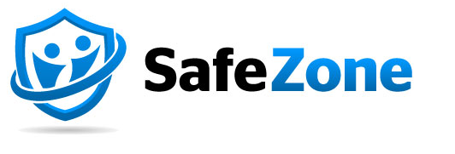
Alt text: Safe Zone logo
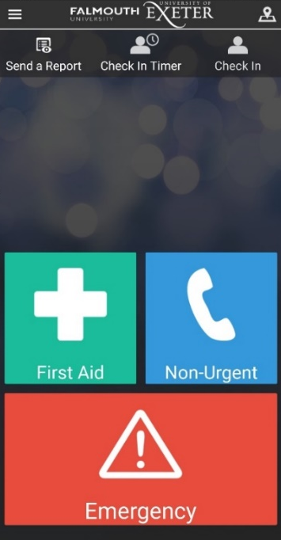
Alt text: Cornwall Campus Safe Zone app
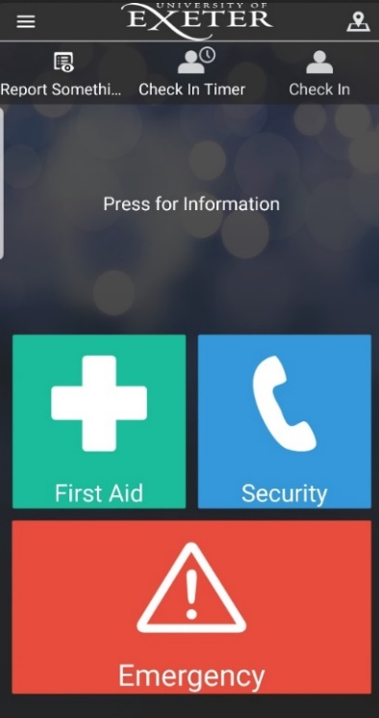
Alt text: Devon Campus Safe Zone app

Newsletter copy:
Cornwall version
Download The SafeZone app, a free way to get help quickly on campus, whenever you need it.
The app provides an instant connection to your Campus Security team 24/7. It allows you to report concerns, with the option of anonymity, and helps Campus Security locate you to help with first aid and emergencies.
To download the app please go to: www.safezoneapp.com and follow the instructions for your device. You will need to register with your Uni email address and add FX Plus as an organisation to make sure the app works on all our campuses.
Devon version
Download The SafeZone app, a free way to get help quickly on campus, whenever you need it.
The app provides an instant connection to your Estate Patrol team 24/7. It allows you to report concerns, with the option of anonymity, and helps Estate Patrol locate you to help with first aid and emergencies.
To download the app please go to: www.safezoneapp.com and follow the instructions for your device. You will need to register with your Uni email address.
Facebook copy:
Download The SafeZone app, a free way to get help quickly on campus, whenever you need it.
- Connect instantly to your campus security team 24/7.
- Report concerns, anonymously if you prefer,
- Helps your security team locate you to help with first aid and emergencies.
To download the app go to: www.safezoneapp.com and follow the instructions for your device. You will need to register with your University of Exeter email address. and add FX Plus as an organisation to make sure the app works on all our campuses. [additional text for Cornwall accounts]
If your message is for DEVON ONLY change ‘Campus Security’ to ‘Estate Patrol’

Twitter copy:
Get SafeZone, a free app to get help quickly on campus. Connect to campus security 24/7. Share your location to get help with first aid and emergencies. Download the app at www.safezoneapp.com and register with your Uni email. Add FX Plus as an org for Cornwall campuses. [additional text for Cornwall accounts]
If your message is for DEVON ONLY change ‘Campus Security’ to Estate Patrol

Instagram copy:
Download The SafeZone app, a free way to get help quickly on campus, whenever you need it.
- Connect instantly to your campus security team 24/7.
- Report concerns, anonymously if you prefer,
- Helps your security team locate you to help with first aid and emergencies.
To download the app go to: www.safezoneapp.com (link in bio) and follow the instructions for your device. You will need to register with your University of Exeter email address. and add FX Plus as an organisation to make sure the app works on all our campuses. [additional text for Cornwall accounts]
If your message is for DEVON ONLY change ‘Campus Security’ to Estate Patrol
Link in bio: https://safezoneapp.com

Instagram hashtags to be included as the first comment on the post
#Exeter #ExeterUni #ExeterUniversity #LoveExeter #ExeterForever #UofE #UniversityOfExeter #SafeZoneApp
If posting to our students in Cornwall please also include the hashtag #Cornwall

- Living life to the full
Background: A series of online wellbeing courses are available to all students, covering a wide range of topics and available in different languages.
Images:

Alt text: four people’s feet running on a beach

Alt text: Views across Dartmoor

Newsletter article

Note different wellbeing links for Devon and Cornwall
Multi-language wellbeing support for all students
Living Life to the Full offers a series of online Cognitive Behaviour Therapy based courses available to you, covering a really wide range of subjects including stress, anxiety, stopping smoking, relationships, living with a long-term health condition, self-confidence, motivation and low mood. Each course is available in a range of different languages, and you can dip-in to the parts most relevant to you.

If you’re concerned about any area of your wellbeing Living Life to The Full is a brilliant place to start accessing support.

Link for Devon See the website for details of all our Wellbeing Services and how to contact us
Link for Cornwall See the website for details of all our Wellbeing Services and how to contact us

Facebook post

Get wellbeing help in the language you choose, with Living Life to the Full, online wellbeing courses. Whether you’re dealing with stress, anxiety, stopping smoking, relationships, living with a long-term health condition, self-confidence, motivation or low mood, you can dip in to the courses most relevant to you. Start accessing support at https://exeter.llttf4.com/

Instagram post
Get wellbeing help in the language you choose, with Living Life to the Full, online wellbeing courses. Whether you’re dealing with stress, anxiety, stopping smoking, relationships, living with a long-term health condition, self-confidence, motivation or low mood, you can dip in to the courses most relevant to you. See the link in our bio to start accessing support.

Link in bio: https://exeter.llttf4.com/

Instagram hashtags to be included as the first comment on the post
#Exeter #ExeterUni #ExeterUniversity #LoveExeter #ExeterForever #UofE #UniversityOfExeter
Plus for Cornwall #Cornwall #PenrynCampus as appropriate

Twitter post
Get wellbeing help in the language you choose. Living Life to the Full offers online wellbeing courses dealing with a range of issues from stress and anxiety to stopping smoking or building your self-confidence. Start accessing support at https://exeter.llttf4.com/

STAFF INFORMATION – (Not for publication to students)
SOCIAL MEDIA
Don’t forget to like and share posts from our central social media accounts
If you have questions about these, please contact the social media team (corporate/Exeter students) on socialmedia@exeter.ac.uk or the Cornwall comms team (Cornwall accounts) on cornwallcomms@exeter.ac.uk
Exeter students  www.facebook.com/exeterunistudents  twitter.com/exeter_students  instagram.com/uniofexeterstudents | Corporate  www.facebook.com/exeteruni  twitter.com/UniofExeter  Instagram.com/uniofexeter | Cornwall students, staff & external  www.facebook.com/uniexecornwall  twitter.com/uniexecornwall  Instagram.com/uniexecornwall

Messages to look out for coming up include COP 27, Sports Wednesdays and cost of living support

MESSAGES FOR STAFF
- Cost of living support
You may be approached by students about issues they’re having with money or where to get help.
- Direct students to the Cost of Living webpages:
There is lots of support available for those who are struggling, and information and advice to help them, which is updated regularly on the website.
https://www.exeter.ac.uk/students/costofliving/
- Refer students to the Step Change Debt Advice service
We’re working with the UK’s leading debt advice charity, Step Change, to provide our students with free, impartial and personalised support with their money and debt worries.
There is a quick referral form you can complete with your students, to put them in touch with Step Change. They will receive a link by text or email to start getting the support they need.
You can find out more about the charity and how to use the referral form in our e learning module on LearnUpon. Search 'Referrals for debt advice' in the LearnUpon course catalogue to enrol on the training: https://exeter.learnupon.com/catalog/courses/2982923.
- Cost of Living task force
We know students may be feeling anxious about the rising cost of living and managing their money at University. A special task force has been set up, working with The Students’ Guild and Students’ Union to explore all the ways in which we can help, and we are looking at measures to reduce the burden on those students who need it the most.
This includes a one-off £150 winter payment made to home UG students with household incomes under £30k; access to the Success for All hardship fund for any student whose financial situation is affecting their ability to study; ensuring there are low cost food options in our outlets; access to hot water and microwave facilities and warm spaces ; free or low cost activities and including financial circumstances as a reason to apply for mitigation.
Full details are on the Cost of Living web pages https://www.exeter.ac.uk/students/costofliving/

- Mitigation
If a student’s unexpected situation - such as illness, a family crisis or financial difficulties – is affecting their ability to complete an assessment or exam, discuss whether Mitigation would be helpful for them. The policy has changed this term, and for this year will include financial circumstances as a reason to apply for Mitigation. The latest details, and some FAQs, are on the website at https://www.exeter.ac.uk/students/infopoints/yourinfopointservices/mitigation/

- Industrial action FAQs
The University creates student facing webpages with information should there be any period of planned industrial action. This page is live now with an update on the current UCU strike action and action short of a strike:
https://www.exeter.ac.uk/students/industrial-action/

If students have specific questions please ask them to email industrialaction@exeter.ac.uk

- Design Your Campus survey
We’re asking students to tell us what they think of their campus learning, studying and social facilities, in the Design Your Campus survey running for three weeks from Monday 21 November to Sunday 11 December. The survey is being led by the Strategic Spaces team, across all of our campuses. The results will be benchmarked against universities across the world, and the findings will help shape future projects to improve our campuses for our students. Participants will also have an opportunity to enter a prize draw to win a share of £500 cash.

If you are able to display a slide in your teaching sessions, promoting the survey, please contact studentcomms@exeter.ac.uk.

- Signposting to students
Looking to signpost services or information to your students? Take a look at our A-Z guide for students, which is packed with relevant links and should help you find the info you are looking for. If you think there’s something missing, please contact studentcomms@exeter.ac.uk

Share stories with us
The Student Comms and Social Media teams are always on the lookout for good student stories, particularly any which relate to our education offer. These might be used on social media, as website articles or as podcasts (subject to permissions). Share your ideas at studentcomms@exeter.ac.uk and/or socialmedia@exeter.ac.uk

