Student Communications toolkit
27 April 2022
Hi
This is your Student Comms toolkit for 27 April 2022. We send these every two weeks, providing you with information and messages you can use in your channels to students.
Further down the email you’ll find useful messages for staff, which will help them to signpost information to students.
We’d love to hear your feedback as to how to improve this to help you and/or if you have any further questions please contact studentcomms@exeter.ac.uk

MESSAGES FOR STUDENTS
1. Subject: Study spaces
Background: Reminder of available study spaces and how to check/book them. Particularly useful in run up to exams for revision.
Newsletter article:
DEVON
Find the right study space for you
Whether you like to study with friends, on your own or in a silent space, we’ve got you covered. Did you know there are a wide range of spaces on our campuses? Have you ever studied in the Sanctuary, or headed to Haighton Library? Are you a fan of the Forum, or an admirer of Amory?

If you’re not sure where all the spaces are, why not look at our list of spaces on our webpages here. You can also study in our on-campus cafés, check out the full list here.
CORNWALL
Find the right study space for you
Whether you like to study with friends, on your own or in a silent space, we’ve got you covered. Did you know there are a wide range of spaces on our campuses? Have you ever studied in the Upper Stannary, explored the Exchange Building, or are you devoted to the Daphne Du Maurier Learning Lounge?

We have a variety of study spaces on our campuses, from silent study to group study areas. You can find out about the range of spaces we offer here.

Facebook
Have you discovered the right study space for you?
We have a wide range of study spaces for you to use. So, whether you like to study with friends, on your own or in a silent space, we’ve got you covered.
To find out more, including a full list of study areas, check out our study spaces webpages.

DEVON https://libguides.exeter.ac.uk/studyspaces/Dropin
CORNWALL https://library.fxplus.ac.uk/studyspace

#Exeter #ExeterUni #ExeterUniversity #LoveExeter #ExeterForever #UofE #UniversityOfExeter

Twitter
Looking for a study space on campus? 📚
You can check availability of study spaces and on campus computers by using the study spaces tile on iExeter or by visiting our study spaces pages.
DEVON https://libguides.exeter.ac.uk/studyspaces/Dropin
CORNWALL https://library.fxplus.ac.uk/studyspace
#Exeter #ExeterUni #ExeterUniversity #LoveExeter #ExeterForever #UofE #UniversityOfExeter

Instagram
Have you discovered the right study space for you?
We have a wide range of study spaces for you to use. So, whether you like to study with friends, on your own or in a silent space, we’ve got you covered.
To find out more, including a full list of study areas, check out our study spaces webpages. Link in bio.
Add these links to linktree in your account’s bio:
DEVON https://libguides.exeter.ac.uk/studyspaces/Dropin
CORNWALL https://library.fxplus.ac.uk/studyspace

Instagram hashtags to be included as the first comment on the post
#Exeter #ExeterUni #ExeterUniversity #LoveExeter #ExeterForever #UofE #UniversityOfExeter
Images:

Alt text: students studying in Penryn Campus library

Alt text: students studying in Penryn Campus library

Alt text: students studying in The Loft, Devonshire House

Alt text: Student reading in Streatham Campus Library

Alt text: a group of students studying in Cross Keys, St Luke’s Campus

Subject 2: SafeZone app
Background: Safezone is a free app for students and staff that connects you quickly to Estate Patrol on the Devon campuses and Campus Security at Penryn Campus. Using the app, they can locate you in real time and quickly get help to you if needed. We are encouraging everyone to download the app to help our campus users feel safe and that they can quickly get the help they need when on campus.
Image:
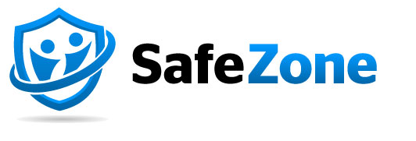
Alt text: Safe Zone logo
Newsletter copy:
Cornwall version
Download The SafeZone app, a free way to get help quickly on campus, whenever you need it.
The app provides an instant connection to your Campus Security team 24/7. It allows you to report concerns, with the option of anonymity, and helps Campus Security locate you to help with first aid and emergencies.
To download the app please go to: www.safezoneapp.com and follow the instructions for your device. You will need to register with your University of Exeter email address and add FX Plus as an organisation to make sure the app works on all our campuses.
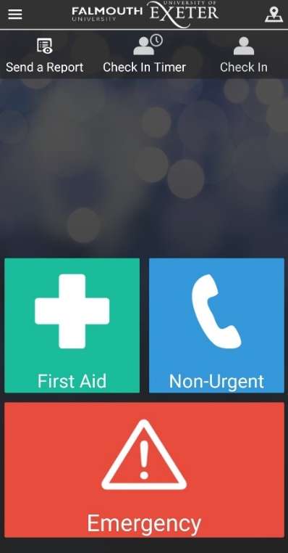
Alt text: Cornwall Campus Safe Zone app
Devon version
Download The SafeZone app, a free way to get help quickly on campus, whenever you need it.
The app provides an instant connection to your Estate Patrol team 24/7. It allows you to report concerns, with the option of anonymity, and helps Estate Patrol locate you to help with first aid and emergencies.
To download the app please go to: www.safezoneapp.com and follow the instructions for your device. You will need to register with your University of Exeter email address.
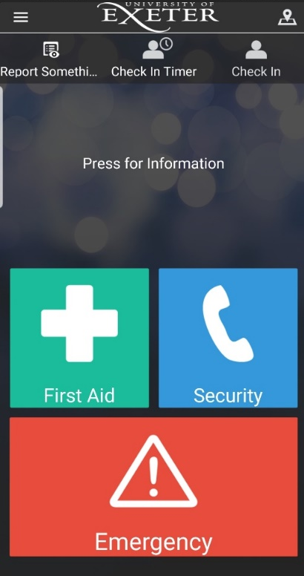
Alt text: Devon Campus Safe Zone app
Facebook copy:
Download The SafeZone app, a free way to get help quickly on campus, whenever you need it.
- Connect instantly to your campus security team 24/7.
- Report concerns, anonymously if you prefer,
- Helps your security team locate you to help with first aid and emergencies.
To download the app go to: www.safezoneapp.com and follow the instructions for your device. You will need to register with your University of Exeter email address. and add FX Plus as an organisation to make sure the app works on all our campuses. [additional text for Cornwall accounts]
If your message is for DEVON ONLY change ‘Campus Security’ to Estate Patrol

Twitter copy:
Get The SafeZone app, a free way to get help quickly on campus, whenever you need it. Connect to campus security 24/7. Share your location to get help with first aid and emergencies. Download the app and register with your Uni email. Add FX Plus as an org for Cornwall campuses. [additional text for Cornwall accounts]
If your message is for DEVON ONLY change ‘Campus Security’ to Estate Patrol

Instagram copy:
Download The SafeZone app, a free way to get help quickly on campus, whenever you need it.
- Connect instantly to your campus security team 24/7.
- Report concerns, anonymously if you prefer,
- Helps your security team locate you to help with first aid and emergencies.
To download the app go to: www.safezoneapp.com and follow the instructions for your device. You will need to register with your University of Exeter email address. and add FX Plus as an organisation to make sure the app works on all our campuses. [additional text for Cornwall accounts]
If your message is for DEVON ONLY change ‘Campus Security’ to Estate Patrol
Instagram hashtags to be included as the first comment on the post
#Exeter #ExeterUni #ExeterUniversity #LoveExeter #ExeterForever #UofE #UniversityOfExeter #SafeZoneApp
If posting to our students in Cornwall please also include the hashtag #Cornwall

Subject 3: Exeplore Podcasts
Background: The Student Communications team’s Exeplore podcast series features a broad range of conversations with staff, students, alumni and partners, reflecting the richness of University life. New episodes are published every few weeks, and we’re always looking for suggestions for new themes and conversations students would be interested to hear.
Newsletter article:
Exeplore new perspectives

Exeplore, the student communications team’s regular podcast, features conversations on a broad range of topics that celebrate the richness of life within the University’s global community. Listen on Spotify or on Apple podcasts for recent episodes including places to visit in Devon and Cornwall while studying here, and Former-student turned Paralympian, Issy Bailey, sharing her journey to the Rio 2016 Paralympics. Or catch up on conversations with the Students’ Guild, Students’ Union and Athletics Union presidents. There are many more subjects to Exeplore and we are always looking for suggestions for interesting topics, so if there’s something or someone you’d like to hear more about, let us know at studentcomms@exeter.ac.uk


Alt text: Exeplore podcast graphic
Twitter:
Exeplore the Uni in a podcast. Hear from graduate turned Paralympian, Issy Bailey or catch up with @TheSUFalExe and @ExeterGuild. Listen on Spotify https://spoti.fi/3vEB1Y4 or Apple Podcasts https://apple.co/3Lf7zhD And tell us who else you’d like to hear @Exeter_Students
Facebook:
Exeplore the Uni from a new perspective in this regular podcast. Hear from former-student, Issy Bailey, on her journey to the Rio 2016 Paralympics, and get tips on the best places to visit while studying in Devon and Cornwall. Or you can catch up on conversations with @ExeterGuild and @TheSUFalExe.
Listen on Spotify https://spoti.fi/3vEB1Y4 or Apple Podcasts https://apple.co/3Lf7zhD And tell us who else you’d like to hear @Exeterunistudents

Instagram:
Exeplore the Uni from a new perspective in these regular podcasts. Hear from former-student, Issy Bailey, on her journey to the Rio 2016 Paralympics, and get tips on the best places to visit while studying in Devon and Cornwall. Or you can catch up on conversations with @exeterguild and @thesufalexe.
Search ‘Exeplore’ on Spotify or Apple Podcasts
And tell us who else you’d like to hear @uniofexeterstudents

SOCIAL MEDIA
For the latest messages from the University and its partners, please like and share posts from our student and corporate social accounts
If you have questions about these, please contact the social media team on Socialmedia@exeter.ac.uk
Students  www.facebook.com/exeterunistudents  twitter.com/exeter_students  instagram.com/uniofexeterstudents | Corporate  www.facebook.com/exeteruni  twitter.com/UniofExeter  Instagram.com/uniofexeter | Cornwall  www.facebook.com/uniexecornwall  twitter.com/uniexecornwall  Instagram.com/uniexecornwall

MESSAGES FOR STAFF
- Study spaces and Exams e mail to students
Student Communications sent these emails to students on Monday 25 April with information on exams and study space ahead of the May exams.
Devon edition | Cornwall edition

- University Updates
See University Updates, the student e-newsletter. It is sent to students weekly (Mondays) during term time. The first issue of this term will be sent after the early May Bank Holiday on Tuesday 3 May.
If you have an event or possible story for inclusion please email studentcomms@exeter.ac.uk (deadline is the Wednesday 5pm prior to the next newsletter going out)

- Estrangement and family circumstances
A student’s family circumstances may change through the academic year. We have support in place for students who are estranged from their family or studying without the support of a family network.

Students can be signposted to contact the Advice Team at the Students’ Guild (Exeter Campuses) or FXU’s Advice Service (Penryn) if they would like more information, require support or have questions about estrangement or their own circumstances at any stage of their course.

More information from the University is at https://www.exeter.ac.uk/students/wp-support/supportfor/estrangedstudents/

- A-Z of student support and services
Looking to signpost services or information to your students? Take a look at our A-Z guide for students, which is packed with relevant links and should help you find the info you are looking for. If you think there’s something missing, please contact studentcomms@exeter.ac.uk

- Explaining APACs (Assessment, Progression and Awarding Committees)

To explain how degree qualifications are awarded, we have put together a webpage and video about the work of the Assessment, Progression and Awarding Committees (APACs), and how they ensure assessment marking and the qualification awarding processes are fair.

